《时间序列分析》

课程论文

**COURSE PAPER**

**题 目:** **基于Horvath Clock的表观基因组学时间序列分析**

*装订线*

**学 号 520731910022**

**学生姓名 李思缘**

**授课教师 罗珊**

基于Horvath Clock的

*装订线*

表观基因组学时间序列分析

中文摘要：

本文利用时间序列分析方法探讨了衰老的生物标志物——CpG位点的DNA甲基化变化。通过分析Gene Expression Omnibus中的多个数据集，运用Horvath Clock来进行表观基因组学的时间序列分析。进一步通过ADF检验处理数据的非平稳性，并运用ARMA和ARIMA模型对数据进行拟合和预测，揭示了CpG位点甲基化水平随时间的变化模式。本文观察到序列期间，每个与年龄相关的 CpG 位点的 DNAm 水平的总体变化很小，还观察到七种主要的 DNAm 变化模式。整体而言部分甲基化序列遵循较为有规律的变化，部分甲基化位点表现出较强的随机趋势。

**关键词：**

*装订线*

生物年龄 时间序列分析 DNA甲基化 表观基因组学 Epigenomic Time Series Analysis Based on Horvath Clock

*装订线*

Abstract：

This study employs time series analysis methods to explore the changes in DNA methylation at CpG sites, a biomarker of aging. By analyzing multiple datasets from the Gene Expression Omnibus and using the Horvath Clock for epigenomic time series analysis, the study addresses data non-stationarity with ADF tests and fits ARMA and ARIMA models to predict changes in methylation levels at CpG sites over time. The study observes that the overall change in DNA methylation levels at age-related CpG sites is minimal during the observed period, and identifies seven major patterns of DNA methylation change. Some methylation sequences follow regular patterns, while others display strong random trends without regard to specific methylation sites.

Key Words：

*装订线*

Biological Age Time Series Analysis DNA Methylation Epigenomics

正文

*装订线*

1. **研究背景**

时间序列是指将某种现象某一个统计指标在不同时间上的各个数值，按时间先后顺序排列而形成的序列。近年来时间序列分析获得了越来越多的应用，“时间”在不同领域的研究视角中也不断被拓宽。

在衰老研究领域，有一个被广泛拒绝的概念是，人类作为生物体的年龄等同于实际经历过的时间。常见的反例如：多个存活同样时长的人有不同的衰老程度；同一个人身上的不同器官尽管经历了相同长度的时间，衰老程度也会有差异；患有早老症（Hutchinson-Gilford Syndrome，常染色体遗传病）的人身体衰老速度比正常人快5~10倍，平均13“岁”就会死于心脑血管等典型衰老疾病。

因此，为了更好地研究衰老的机制，研究者们首先革新了测量衰老的方法，并在领域内形成了使用生物年龄（Biological age, BA）的共识，以区别于历时年龄（Chronological age，CA）。BA被认为有助于预测死亡率、预测寿命、预测与衰老相关的疾病（例如心血管疾病、糖尿病、癌症和阿尔茨海默病），对临床和社区监测以及评估延迟或预防衰老相关疾病和残疾的干预措施有重要意义。

目前有多种计算BA的模型，这些模型被称为“时钟”。按方法可分为MLR、PCA、HocM、KDM、ML、HD等；按测量的对象可分为全机体时钟、器官时钟如皮肤时钟、大脑时钟等；按标志物的来源，可分为基因组生物标志物、表观遗传生物标志物、转录生物标志物、临床生物标志物。其中表观遗传生物标志物主要基于DNA甲基化组。DNA甲基化是一种重要的表观遗传修饰形式，它通过在DNA分子上的甲基基团与胞嘧啶环上的氢原子结合来调节基因的表达和细胞功能。DNA链上各个部分有不同程度的甲基化，我们通过使用具有DNA甲基化位点探针的甲基化测序芯片给出每个位点甲基化的概率。因稳健的相关性而被广泛接受的衰老“时钟”主要有Horvath Clock[1]、Hannum Clock[2]、Lin Clock等，都基于DNA甲基化组。

然而迄今为止，衰老研究领域内还没有一套测量衰老的“金标准”，因为当前的“时钟”多从循证医学的角度衡量自身的可用性，即便在跨数据集任务上表现良好，依然缺乏模型因果性的数学证明。近年Ying[4]的工作使用孟德尔随机化的方法结合了基因组和表观基因组，给出了一套具有因果性的BA模型。

本文将以 year为单位计算BA，并将其设置为时间序列分析中的时间，对与BA相关的重要CpG位点建立pseudo-时间序列，尝试探索这些CpG位点随时间变化的机制。

1. **初步探索**

**2.1 数据来源与质控**

本文使用Gene Expression Omnibus中的GSE41169、GSE40279、GSE51057、GSE42861、GSE51032、GSE73103、GSE69270、GSE64495、GSE30870、GSE52588十个数据集，共计3392个样本，均为Homo Sample，检测方法均使用Illumina HumanMethylation450 BeadChip，具有标准化的485577个CpG位点，通过了Gene Expression Omnibus平台的异质性检验。

**2.2 描述性统计**

分别使用Horvat Clock、Hannum Clock、Lin Clock、Ying Clock对全数据集计算BA， R-square分别为0.8739、0.8624、0.7836、0.8386， 发现Horvath Clock在上述数据中对BA的建模最佳，因此后续采用Horvath Clock作为“时间”。图1以GSE41169为例展示了各Clock的预测结果。

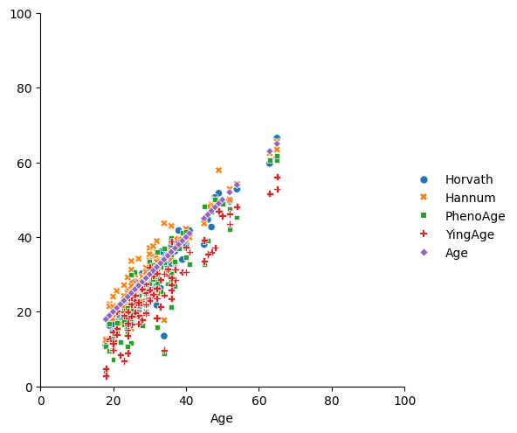

图1：GSE41169中各Clock的预测结果

对3392个样本使用Horvath Clock预测得BA的分布如图2， BA = 1, 2, 3, ……, 90时，前20个CpG位点的描述性统计见表1，完整数据见附录T2。

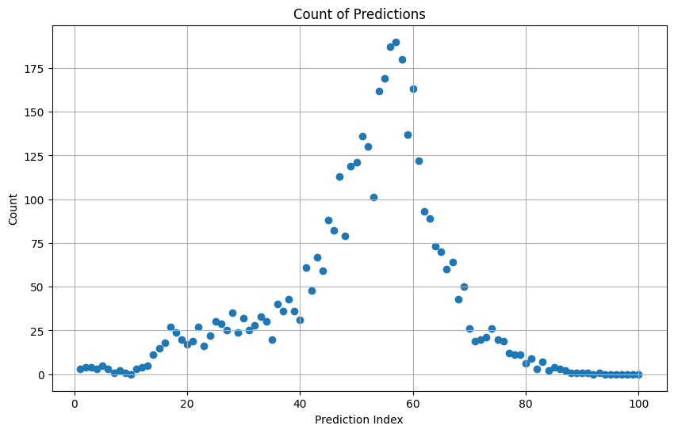

图2：Horvath Clock下样本BA分布

|  |  |  |  |  |  |  |  |  |
| --- | --- | --- | --- | --- | --- | --- | --- | --- |
|  | count | mean | std | min | 25% | 50% | 75% | max |
| 1 | 391 | 0.442655 | 0.287683 | 0.016329 | 0.177067 | 0.380373 | 0.725948 | 0.956129 |
| 2 | 391 | 0.429928 | 0.304412 | 0.005472 | 0.149868 | 0.360846 | 0.72965 | 0.993453 |
| 3 | 391 | 0.42921 | 0.301097 | 0.008642 | 0.150927 | 0.359228 | 0.709315 | 0.993551 |
| 4 | 391 | 0.426628 | 0.307746 | 0.0074 | 0.145156 | 0.34327 | 0.715105 | 0.988394 |
| 5 | 391 | 0.421501 | 0.29914 | 0.008479 | 0.145084 | 0.336143 | 0.706365 | 0.989993 |
| 6 | 391 | 0.421855 | 0.298605 | 0.006505 | 0.151221 | 0.343502 | 0.700624 | 0.994271 |
| 7 | 391 | 0.411586 | 0.315039 | 0.002383 | 0.124271 | 0.320877 | 0.697768 | 0.992095 |
| 8 | 391 | 0.405923 | 0.293464 | 0.006053 | 0.147419 | 0.32431 | 0.673099 | 0.993996 |
| 9 | 391 | 0.397407 | 0.294303 | 0.002483 | 0.134218 | 0.304662 | 0.654772 | 0.992337 |
| 10 | 391 | 0 | 0 | 0 | 0 | 0 | 0 | 0 |
| 11 | 355 | 0.395376 | 0.298889 | 0.011274 | 0.125468 | 0.315056 | 0.64907 | 0.975957 |
| 12 | 355 | 0.379599 | 0.323744 | 0.009677 | 0.088401 | 0.266373 | 0.650987 | 0.98139 |
| 13 | 355 | 0.375687 | 0.312605 | 0.008585 | 0.104884 | 0.266549 | 0.63101 | 0.975049 |
| 14 | 354 | 0.376204 | 0.304864 | 0.006643 | 0.108048 | 0.263604 | 0.62781 | 0.959822 |
| 15 | 354 | 0.384522 | 0.32011 | 0.010003 | 0.104867 | 0.269345 | 0.645611 | 0.979295 |
| 16 | 355 | 0.385094 | 0.314631 | 0.00959 | 0.106294 | 0.273474 | 0.642805 | 0.978499 |
| 17 | 354 | 0.384449 | 0.319448 | 0.012072 | 0.1013 | 0.273419 | 0.642777 | 0.97892 |
| 18 | 354 | 0.386829 | 0.315926 | 0.010147 | 0.11087 | 0.278347 | 0.651507 | 0.977135 |
| 19 | 353 | 0.379811 | 0.310109 | 0.009673 | 0.110651 | 0.272365 | 0.628356 | 0.975694 |
| 20 | 354 | 0.378595 | 0.310267 | 0.009841 | 0.11099 | 0.268671 | 0.612032 | 0.979384 |

表1：前20个CpG位点的简单描述

**2.3 缺失值与离群值的处理**

Illumina HumanMethylation450 BeadChip共有485577个CpG位点，其中共有391个CpG位点在Horvath Clock中被认为与BA相关，也是本文所关心的位点，为了简化分析，后续讨论限于这些CpG位点，完整的CpG位点信息见附录T1。

缺失值是在数据集中没有记录的、丢失的或不可用的数据点。在数据分析和处理中，缺失值非常常见，并且需要适当处理，因为大多数数据分析方法和统计模型都假定数据是完整的。本研究去除数据集中NaN 百分比大于或等于 5% 的位点，余有316个CpG位点。对这316个位点，用前向填充法填充了NaN。在t = 10处出现了整列缺失值，考虑到数据具有时间序列的特性，用插值法填充了第10列。

离群点是指一个时间序列中，远离序列一般水平极端大值和极端小值。在时间序列分析中，通常把各种各样的离群点分为四种类型进行处理。第一种，加性离群点，造成这种离群点的干扰，只影响该干扰发生那一个时刻T上的序列值，即X，而不影响该时刻以后的序列值X，X，…；第二种，更新离群点，造成这种离群点的干扰不仅作用于X，而且影响T时刻以后的序列的所有观察值X，X，…它的出现意味着一个外部干扰作用于系统的开始，并且其作用方式与系统的动态模型有关；第三种，水平移位离群点，成这种离群点的干扰是在某一时刻T，系统的结构发生了变化，并持续影响T时刻以后的所有行为，在数列上往往表现出T时刻前后的序列均值发生水平位移；第四种，暂时变更离群点，造成这种离群点的干扰是在T时刻干扰发生时具有一定初始效应，以后随时间根据衰减因子δ的大小呈指数衰减的一类干扰事件。根据折线图观察，本文数据中出现的离群点属于加性离群点，因此将每个位点中超过均值±4个标准差范围的甲基化值标记为离群值，用后向填充方法直接覆盖。

**2.4 时间序列建立**

由于数据在year = 10, 92, 94, 95, 96, 97, 98, 99, 100处缺失，为保证后续时间序列分析的稳健性，取t_max = 90。在Gladyshev的ground zero理论[5]中，最初的胚胎和出生时人的生物年龄都不是0，在这期间人的生物年龄遵循一个光滑的近似V形曲线（见图3），在接近胚胎中期时出现最低点。由于胚胎中期的生物年龄不易操作，因此本研究设定时间序列的起始点为t=1。因此时间序列取t = 1, 2, 3, ……, 89,90。

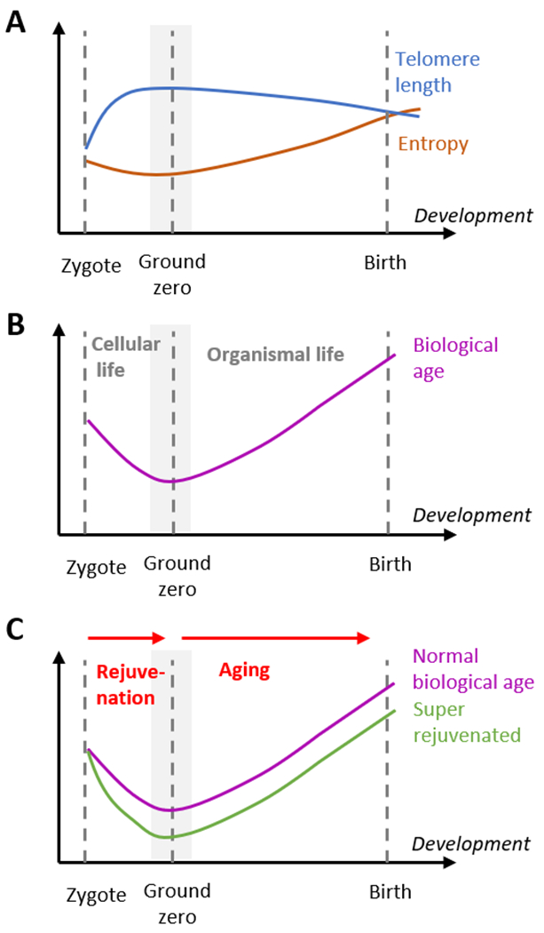

图3：胚胎至出生前生物年龄

基于中心极限定理，本文对BA相同值的样本取均值，近似得到总体均值，以此模拟统计意义上人类在不同BA时的重要CpG位点的甲基化水平，基本思想是根据人类甲基化位点的有限长度的观察记录，建立比较准确地反映时间序列中所包含的动态依存关系的数学模型，借以加深对机体重要甲基化位点的变动机制的理解。

依据Box-Jenkins 模型构建策略，使用一个三步的模型构建策略：第一步，识别一个初步的时间序列模型（模型识别）；第二步，估计模型的参数（模型拟合）；第三步，模型诊断，判断该模型是否合适，如果合适则结束模型构建，如果不合适则返回第一步。常见的时间序列模型根据原来的时间序列是否平稳和回归中包含部分的不同，分为了几个类别：MA（移动平均过程）、AR（自回归过程）、ARMA(自回归移动平均过程)、ARIMA（求和自回归移动平均过程）。

具体来说本文将遵循以下步骤对序列进行建模：

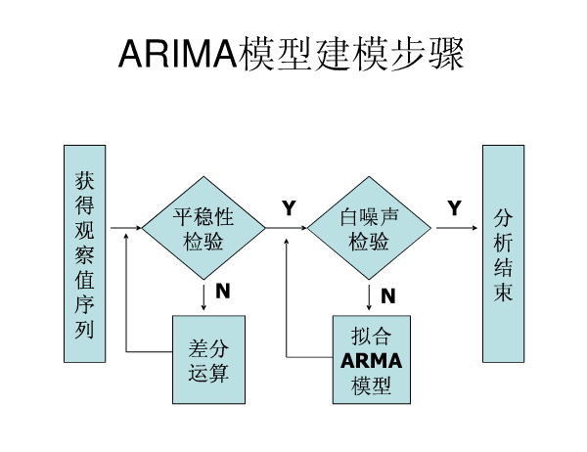

图4：建模流程图

(1)对原序列进行平稳性检验，若原序列为非平稳序列则通过差分消除趋势；

(2) 判断序列是否具有季节（周期）性，若具有季节（周期）性的波动，则通过季节（周期）差分来消除季节（周期）性；

(3) 进行模型识别

(4) 进行模型定阶；

(5) 对模型的参数进行估计；

(6) 对模型的适合性进行检验，即对残差序列进行白噪声检验，判断是否是白噪声序列；

(7) 给出模型的预测结果，并画出趋势预测图。

1. **时间序列图**

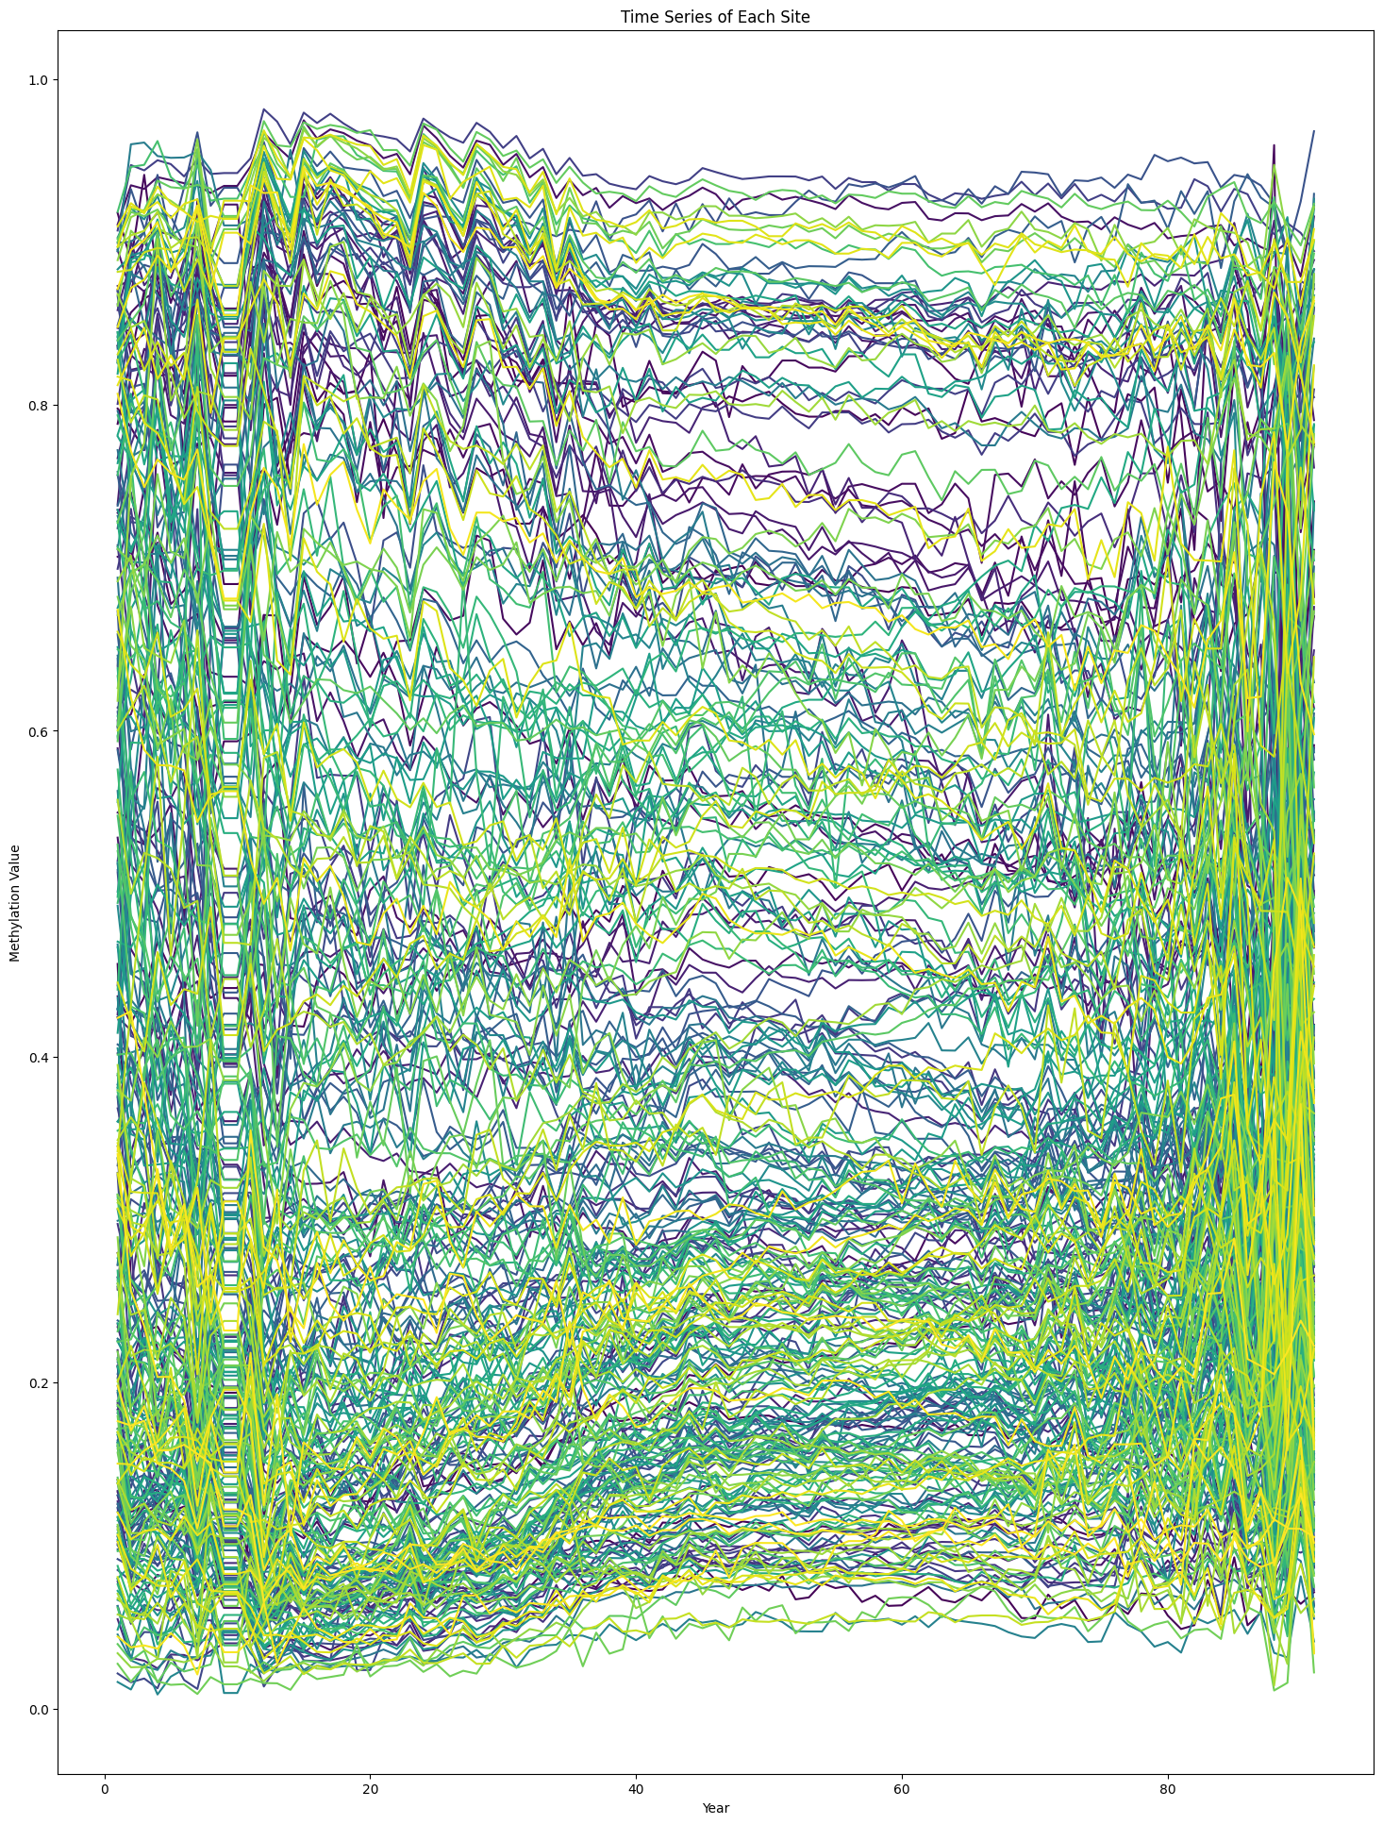

图5：316个CpG位点的时间序列图

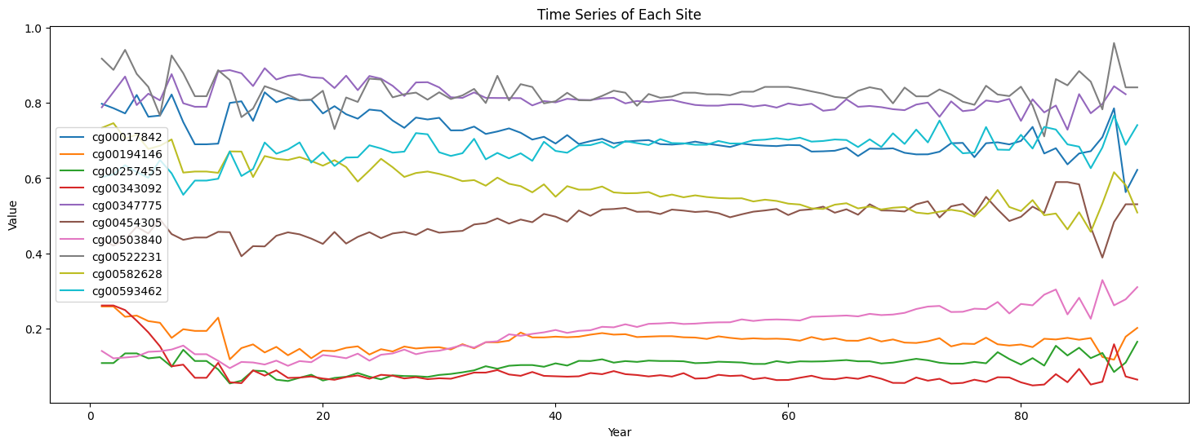

图6：随机选取10个CpG位点的时间序列图

可以看到部分CpG位点有一定的长期趋势，但没有明显周期变动，序列前端和尾端相较于中间序列有较大方差。整体上有一部分的CpG位点有升高的趋势，一部分CpG位点有降低的趋势。

1. **平稳性检验与数据变换**

ADF检验（Augmented Dickey-Fuller test）是最常用检测序列平稳性的检验方法，被检验的时间序列y_t可以写成

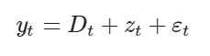

其中D_t是确定性趋势，z_t是随机趋势,ε_t是随机误差。

H_0 为序列存在单位根，如果得到的显著性检验统计量小于三个置信度（10%，5%，1%），则对应有（90%，95，99%）的把握来拒绝原假设。

**4.1第一次ADF检验：**

对316个CpG位点进行只有常数项的ADF检验，完整检验结果见附录T3。在65个位点上显示原始数据已经是平稳的，如图7，不需要再做差分来达到平稳。剩余253个位点是非平稳的，如图8。

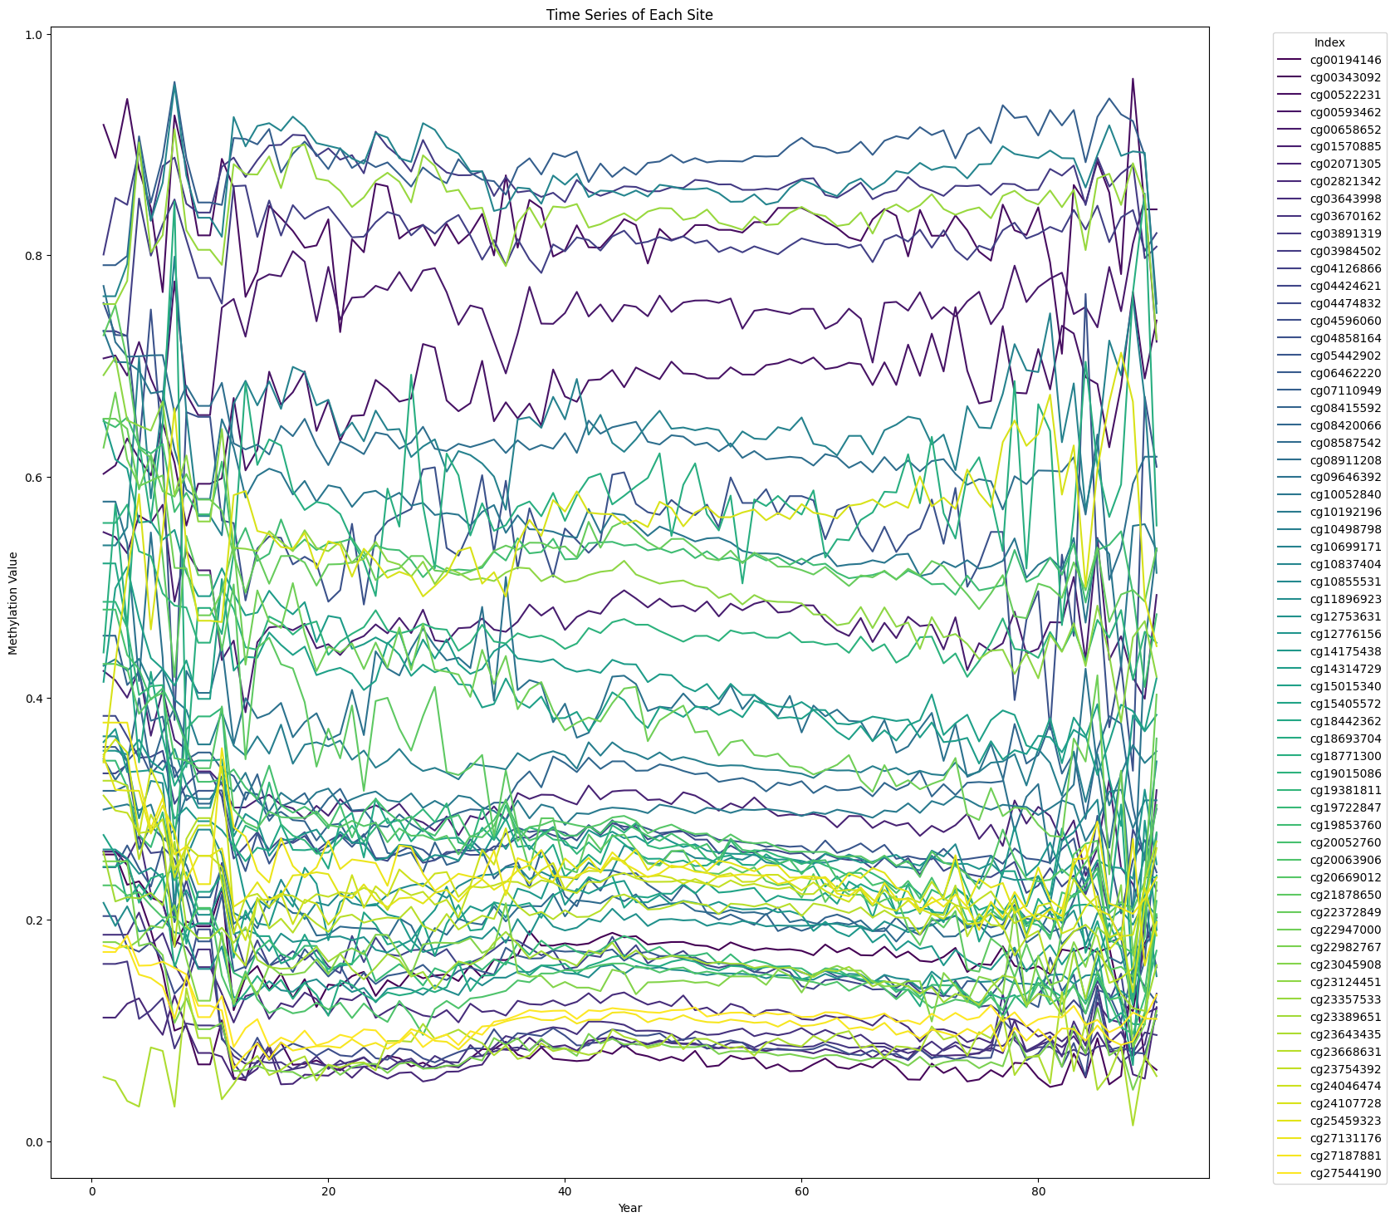

图7：65个未经处理通过平稳性检验的序列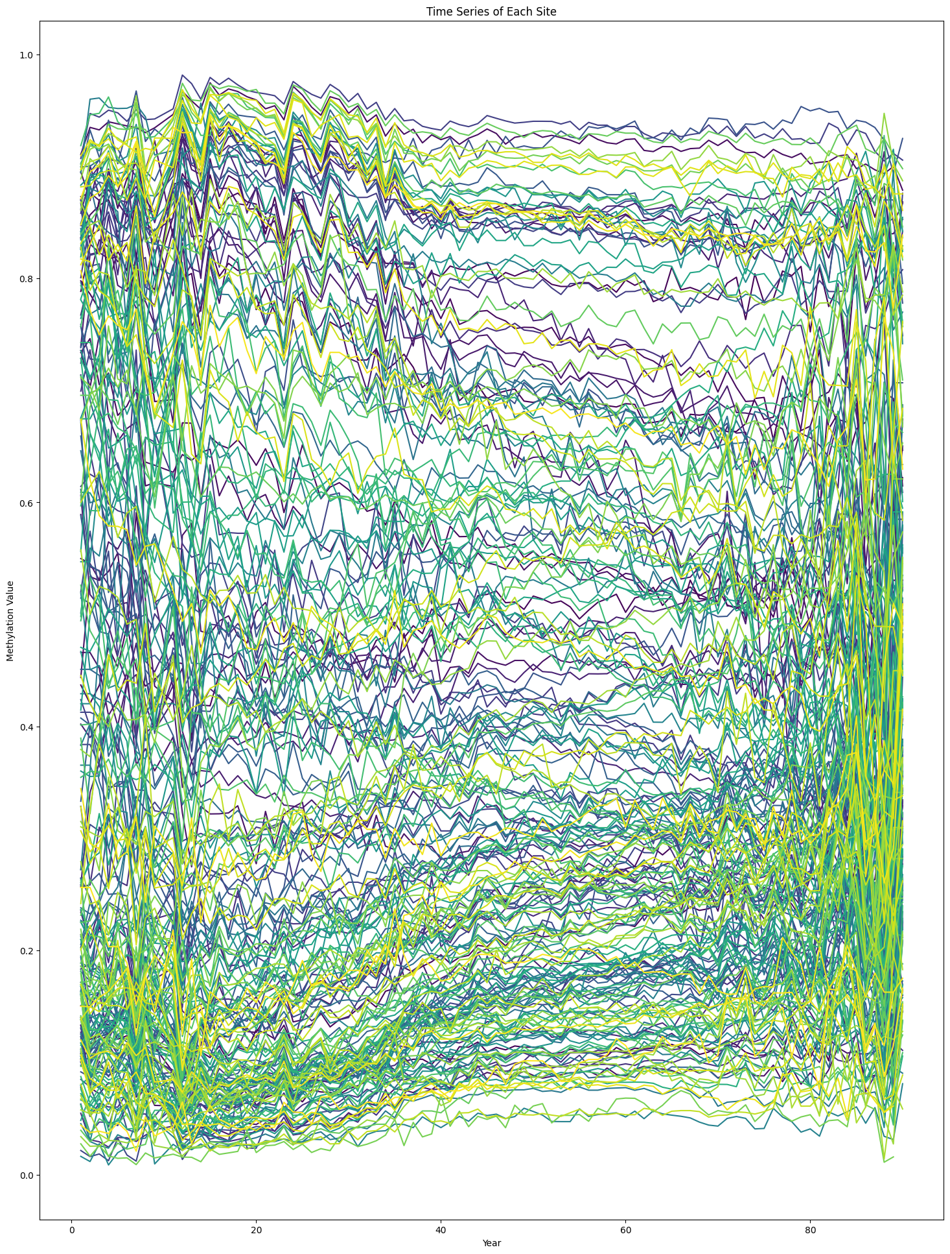

图8：253个未通过平稳性检验的序列

**4.2第二次ADF检验：**

观察到剩余253个位点具有较大的异方差性，因此先对这些位点进行Box-Cox变换。Box-Cox变换是一种通过对数据进行幂函数转换来调整数据分布形态的方法，适用于数据集具有偏斜或非正态分布特征的情况，并且能够使得数据更加符合线性模型的假设。

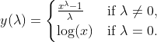

其中，y 是原始数据，λ是 box-cox变换的参数。当 λ = 0时，使用对数变换，否则就使用上述公式进行变换。

变换后的绝大多数位点在尝试性ADF检验后仍然非平稳，因此对这253个位点再进行一阶差分。

此时做第二次ADF检验，完整检验结果见附录T4。在224个位点上显示序列成为了平稳的，如图9。剩余29个位点仍然是非平稳的，如图10，需要再做二阶差分来达到平稳。

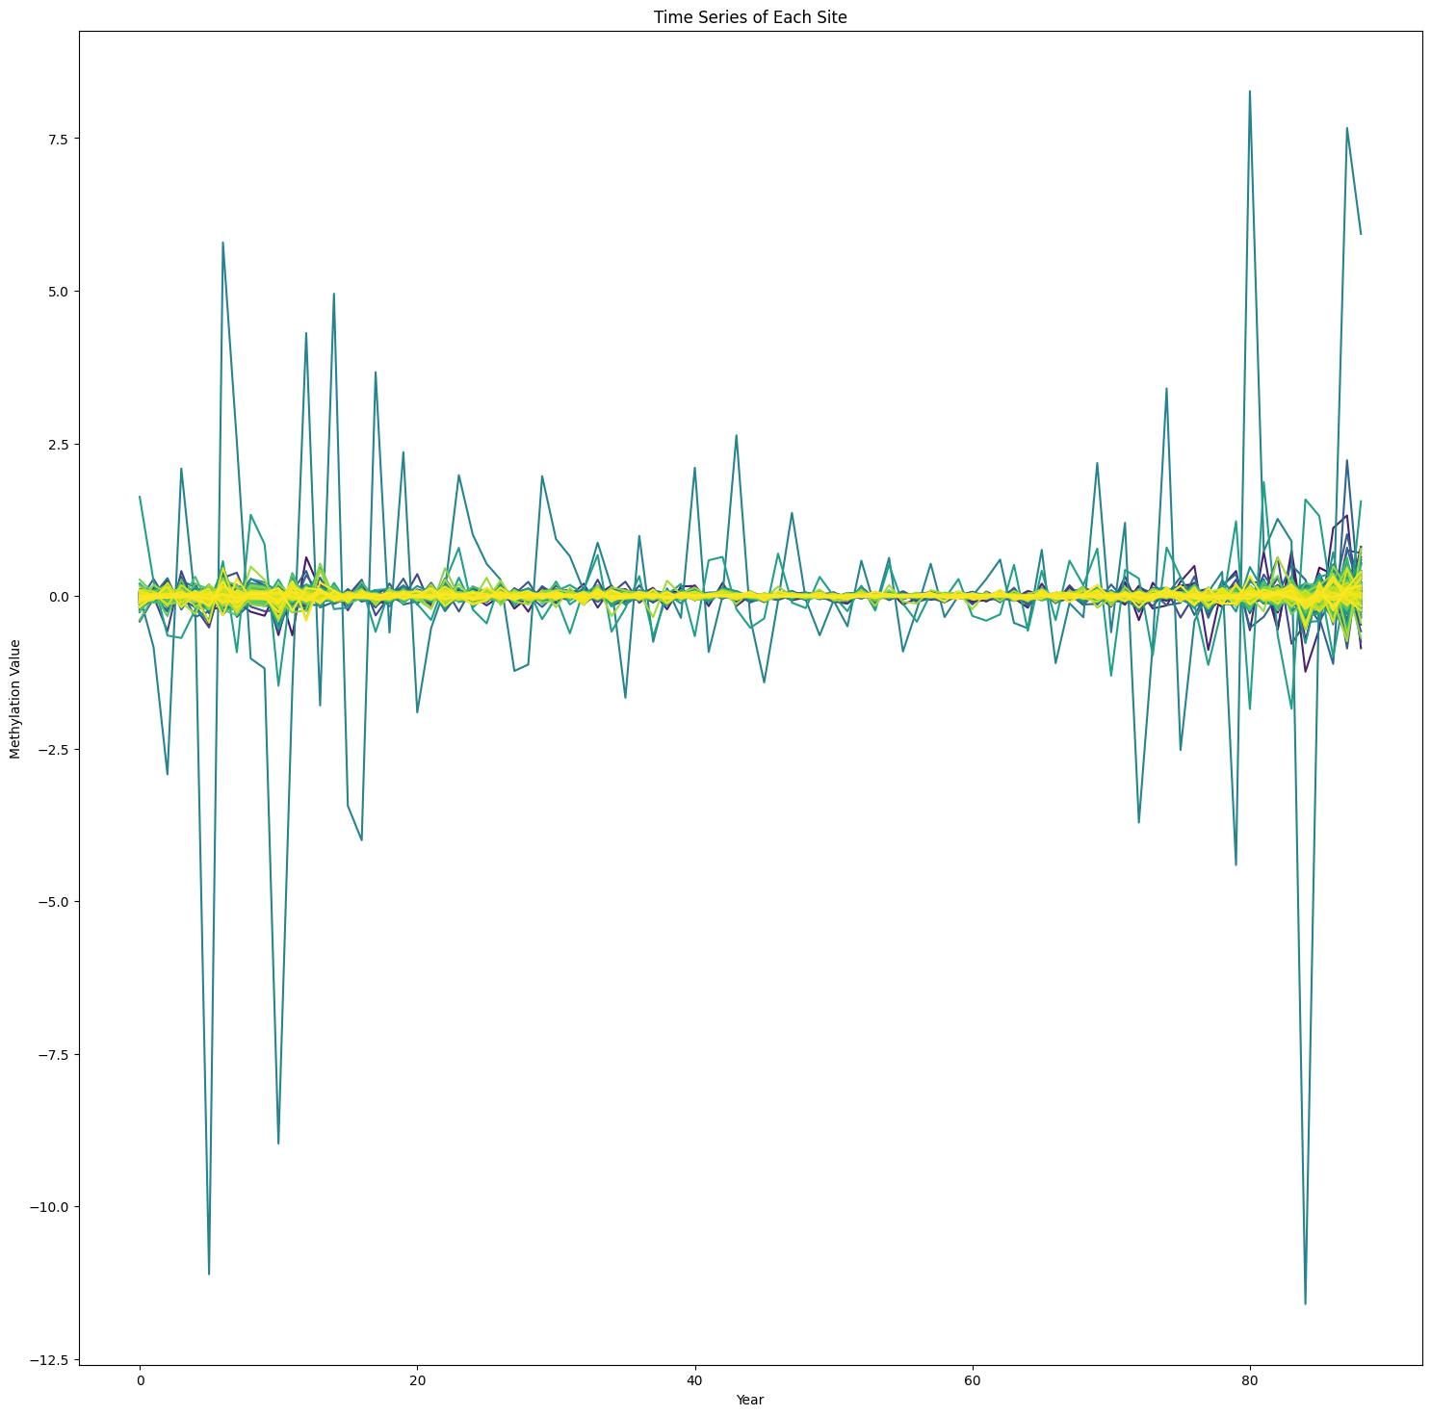

图9：224个一阶差分后通过平稳性检验的序列

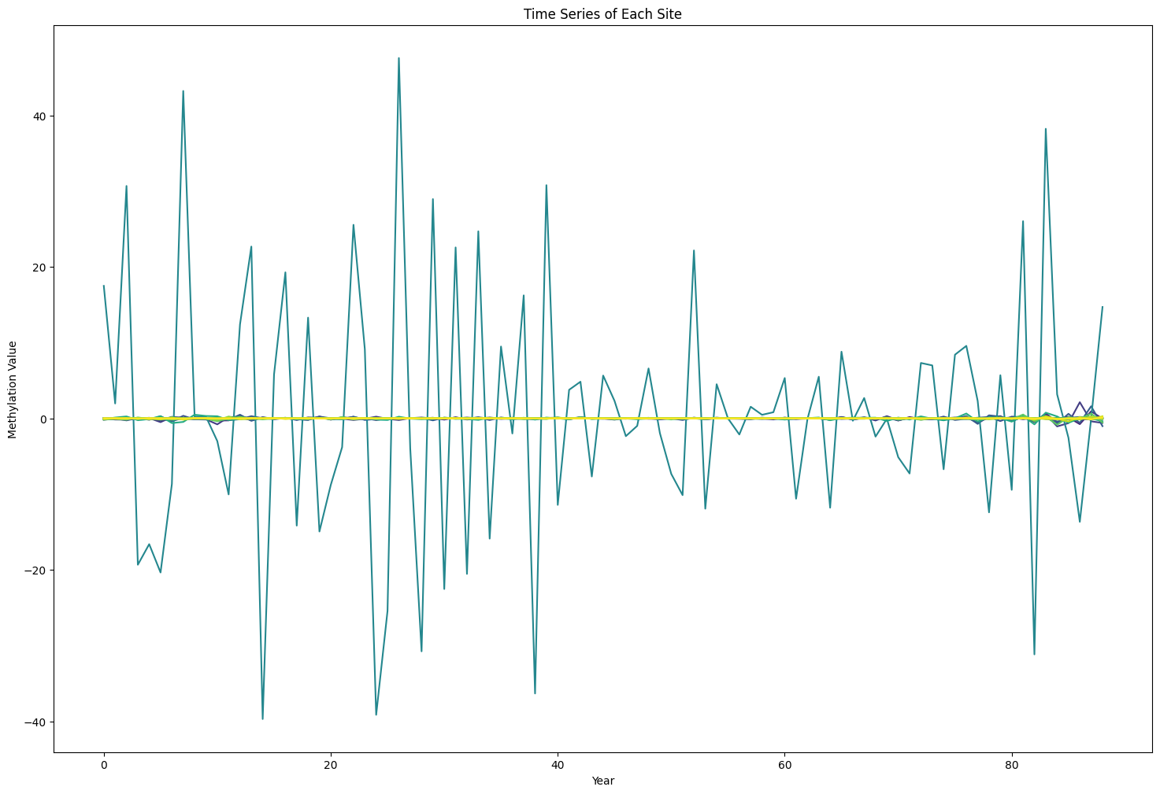

图10：29个一阶差分后未通过平稳性检验的序列

**4.3第三次ADF检验：**

对剩余29个做第三次ADF检验，此时是二阶差分，完整检验结果见附录T5。在28个位点上显示序列成为了平稳的。剩余1个位点cg21184711（位于调控CADPS2的基因片段上，CADPS2是钙依赖性分泌激活剂 2）仍然是非平稳的，考虑到一般d取0,1,更高阶的差分可能会增加数据的随机噪声，导致模型过拟合，缺乏解释意义，因此后文不再对这一阶段的位点进行建模。

1. **确定目标模型阶数**

在ARIMA模型中，变量的未来取值可以表达为过去若干个取值和随机误差的线性函数式：

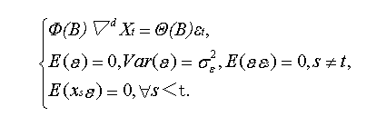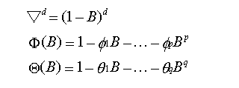

其中B是后移算子，εt为随机误差，d为差分阶数，p和q分别表示自回归阶数和移动平均阶数，Xt为各期的观察值（t=1,2，„，k）。

模型中的差分阶数d主要通过平稳性检验和数据转换过程中差分处理的次数来确定。若经过1次差分就可实现平稳，则d就等于1，若经过2次差分就可实现平稳，则d就等于2，如此类推。

转换成平稳序列后就依据ARMA模型来确定阶数。在ARMA模型的识别过程中，主要用到两个工具：自相关函数(ACF），偏自相关函数(PACF)以及它们各自的相关图。对于一个序列{Xt}来说，它的第i阶自相关系数定义为它的i阶自协方差除以它的方差，通常记ACF(i)。偏自相关函数PACF(i)度量了消除中间滞后项影响后两滞后变量之间的相关关系。

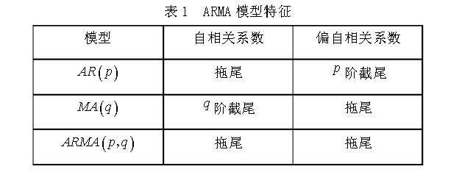

图11：利用自相关和偏自相关系数的特征确定模型阶数

确定p和q的一般规则是：

（1）如果序列的ACF是截尾的，即过了某一滞后项值（设为q）后，ACF变得不显著，接近于零，并且PACF是拖尾的，则可把序列设为MA（q）过程；

（2）如果序列的PACF是截尾的，即过了某一滞后项值（设为p）后，PACF变得不显著，接近于零，并且ACF是拖尾的，则可把序列设为AR（p）过程；

（3）如果序列的ACF和PACF都是拖尾的，则可把该序列设为ARMA（p,q）过程，而关于p和q的值需要不断地从低阶试探，并使信息准则达到最小。

**5.1 对63个平稳序列应用ARMA(p,q)模型：**

对本身已经通过ADF检验的63个位点，考虑使用 ARMA (p, q) 模型进行建模，其中 𝑝 是自回归项的阶数，𝑞 是移动平均项的阶数。剩余253个位点是非平稳的。

为确定𝑝, 𝑞，对这65个位点计算ACF和PACF，画出lag图，通过Barlett近似得到上下界。前5个位点的ACF和PACF如图12，完整的ACF和PACF图见附件1。

以前5个位点为例，分析ACF和PACF图：

1. CpG00194146

ACF: 慢慢衰减。PACF: 在lag=1后快速下降。因此选择 𝑝 = 1, 𝑞 = 0 ，初步识别为AR(1)模型。

1. CpG0343092

ACF: 慢慢衰减。PACF: 在lag=1后快速下降。因此选择 𝑝 = 1, 𝑞 = 0 ，初步识别为AR(1)模型。

1. CpG00522231

ACF: 始终接近0。PACF: 始终接近0。可能是白噪声序列，没有可预测的模式或结构。

1. CpG00593462

ACF: 慢慢衰减。PACF: PACF: 在lag=2后下降到接近0。

因此选择 𝑝 = 2, 𝑞 = 0 ，初步识别为AR(2)模型。

1. CpG00658652

ACF: 慢慢衰减。PACF: 在lag=1后快速下降。

因此选择 𝑝 = 1, 𝑞 = 0 ，初步识别为AR(1)模型。

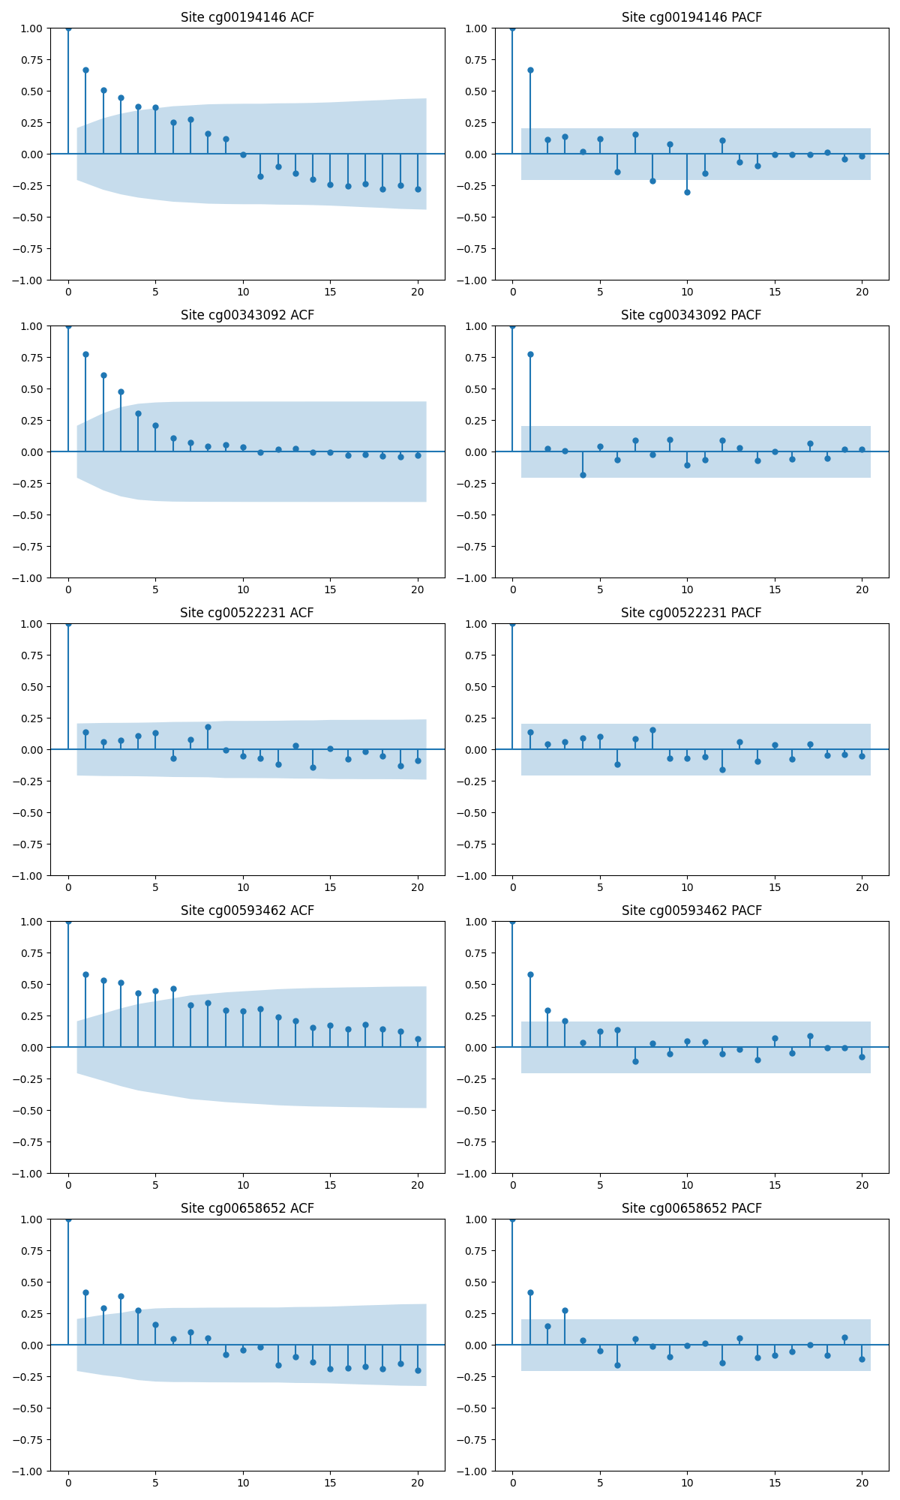。

图12：前5个位点的ACF和PACF

完整的63个位点的定阶结果见后文。

**5.2 对****224个一阶差分后的序列应用ARIMA(p,1,q)模型**

对BoxCox转换后一阶差分通过ADF检验的224个位点，使用 ARIMA (p,1 q) 模型进行建模，其中 𝑝 是自回归项的阶数，𝑞 是移动平均项的阶数。剩余29个位点是非平稳的。

为确定𝑝, 𝑞，对这224个位点计算ACF和PACF，画出lag图，前5个位点的ACF和PACF如图8，完整的ACF和PACF图见附件2。定阶结果见后文。

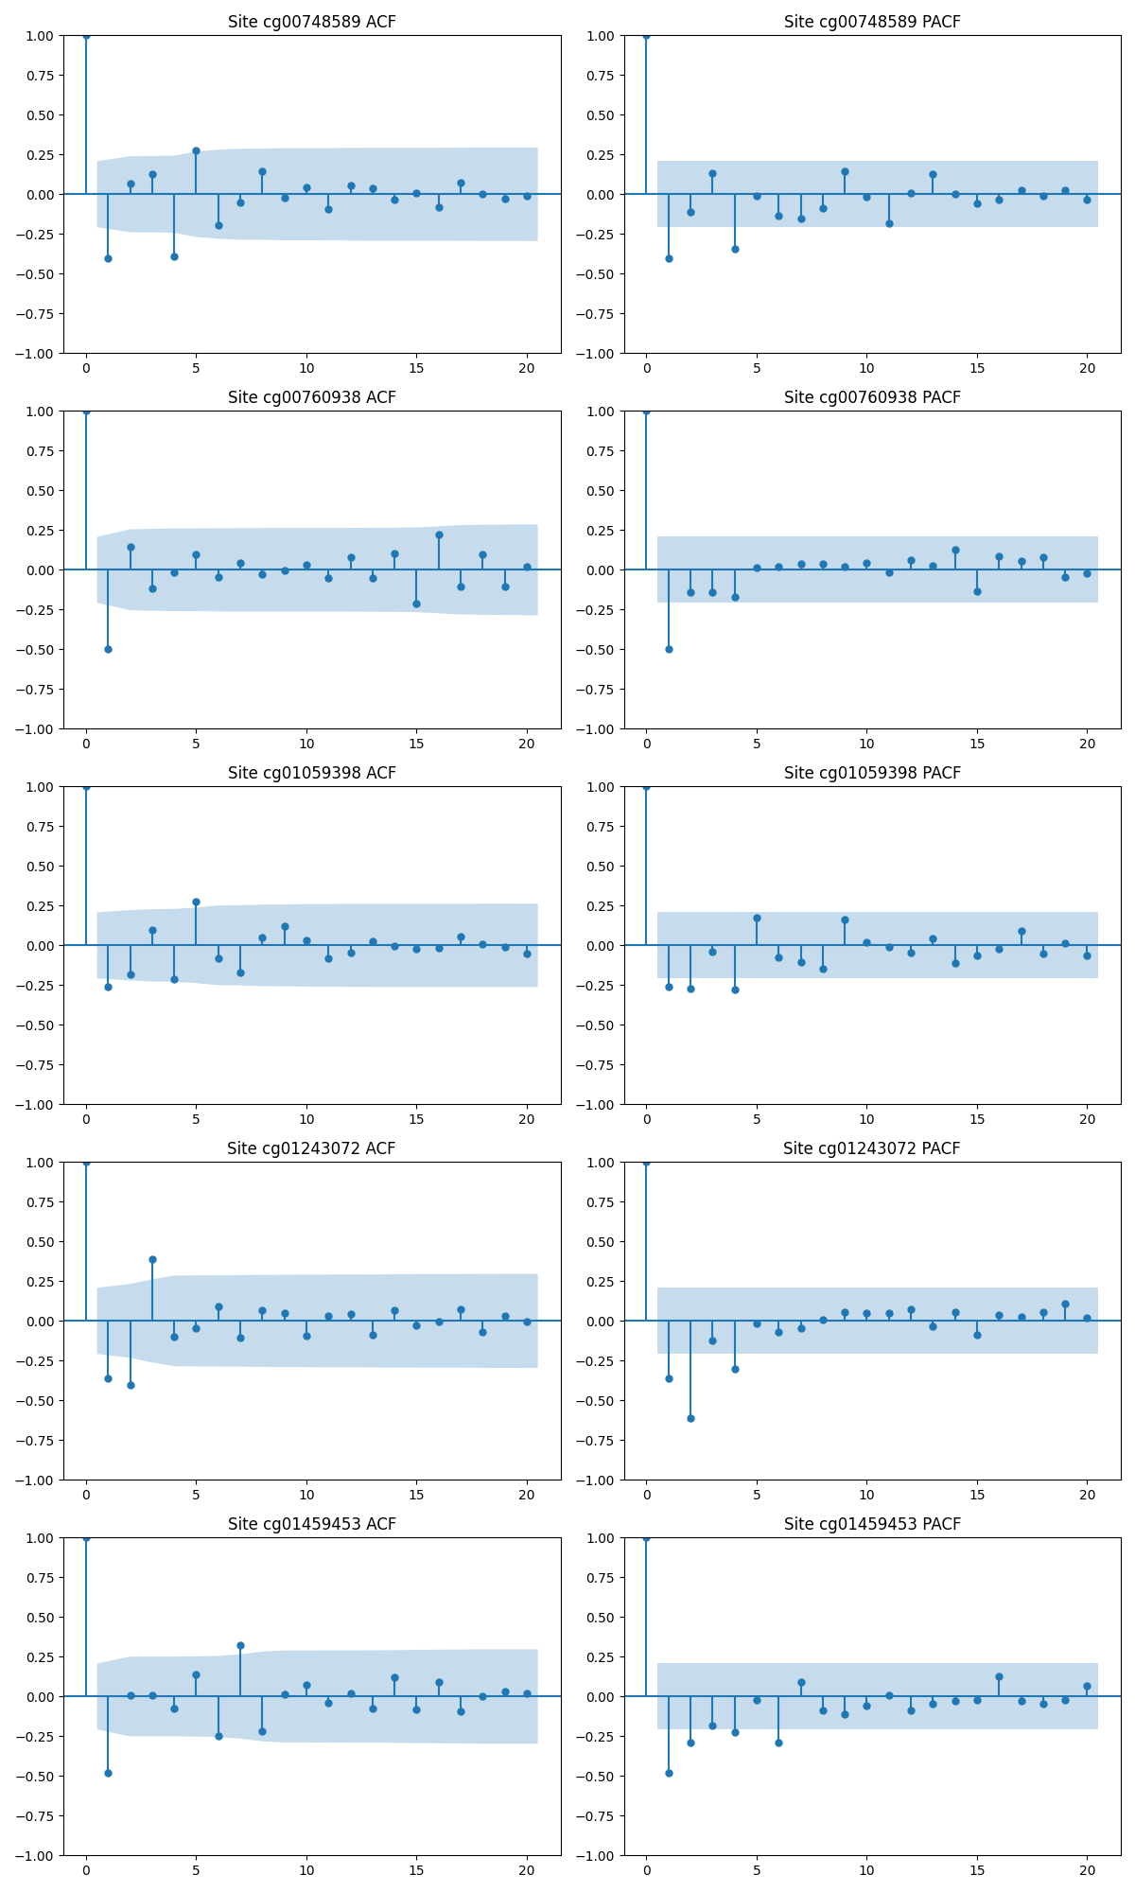

图13：前5个位点的ACF和PACF

1. **估计模型参数**

极大似然估计利用了概率最大的随机事件在一次实验中最可能发生的原理，通过寻找使得一个样本序列联合分布列达到最大值的点来估计其总体的未知参数。 $X$ 均服从正态分布，其概率密度函数为

$$f\left(x\right)=\frac{1}{\sqrt{2π}σ}e^{-\frac{{\left(x-μ\right)}^{2}}{2σ^{2}}}$$

样本序列分别为 $\left(X_{1},X_{2}…X_{n}\right)$，数据的似然函数为:

$$L\left(μ_{X},σ_{X}^{2}\right)={\left(\frac{1}{\sqrt{2π}σ_{X}}\right)}^{n}e^{-\left[\frac{{\left(x_{1}-μ_{X}\right)}^{2}}{2{σ_{X}}^{2}}+\frac{{\left(x_{2}-μ_{X}\right)}^{2}}{2{σ_{X}}^{2}}+…+\frac{{\left(x_{\text{n}}-μ_{X}\right)}^{2}}{2{σ_{X}}^{2}}\right]}$$

取对数后得到对数似然函数，

$$\ln{L}\left(μ_{X},σ_{X}^{2}\right)=-\frac{n}{2}\ln\left(2πσ_{X}^{2}\right)-\frac{1}{2σ_{X}^{2}}\sum_{i=1}^{n}{{\left(x_{i}-μ_{X}\right)}^{2}}$$

对上式 $μ$ 和 $σ^{2}$ 求偏导并令其等于0，得

$$\frac{∂\ln{L}}{∂μ_{X}}=\frac{1}{σ_{X}^{2}}\sum_{i=1}^{n}{\left(x_{i}-μ_{X}\right)}=0,\frac{∂\ln{L}}{∂σ_{X}^{2}}=-\frac{n}{2σ_{X}^{2}}+\frac{1}{2σ_{X}^{4}}\sum_{i=1}^{n}{{\left(x_{i}-μ_{X}\right)}^{2}}=0$$

解似然方程组得到唯一解

$$\hat{μ_{X}}=\overline{X}$$

$$\hat{σ_{X}^{2}}=S_{Xn}^{2}$$

**6.1 估计ARMA(p,q)序列的参数**

对63个位点依据附件1依次确定ARMA模型的阶数p,q，而后使用最大似然估计法，通过优化似然函数来估计模型参数，使得观测到的样本数据在给定参数下的概率（似然）最大。

前20个位点拟合结果如下，完整结果见附录T6。

|  |  |  |  |  |  |  |  |  |
| --- | --- | --- | --- | --- | --- | --- | --- | --- |
| Index | p | q | const | sigma2 | ar.L1 | ma.L1 | ar.L2 | ma.L2 |
| cg00194146 | 1 | 0 | 0.17417 | 0.00033 | 0.77193 |  |  |  |
| cg00343092 | 1 | 0 | 0.10414 | 0.00042 | 0.94349 |  |  |  |
| cg00522231 | 1 | 1 | 0.83357 | 0.0013 | 0.89195 | -0.7649 |  |  |
| cg00593462 | 2 | 0 | 0.67583 | 0.00083 | 0.42622 |  | 0.32642 |  |
| cg00658652 | 1 | 0 | 0.7497 | 0.0008 | 0.43918 |  |  |  |
| cg01570885 | 1 | 0 | 0.47437 | 0.00074 | 0.54886 |  |  |  |
| cg02071305 | 1 | 0 | 0.3107 | 0.00048 | 0.82732 |  |  |  |
| cg02821342 | 1 | 0 | 0.08362 | 0.00017 | 0.69749 |  |  |  |
| cg03643998 | 1 | 0 | 0.15853 | 0.00015 | 0.97912 |  |  |  |
| cg03670162 | 1 | 0 | 0.10818 | 0.00025 | 0.8953 |  |  |  |
| cg03891319 | 1 | 0 | 0.09056 | 0.00014 | 0.83038 |  |  |  |
| cg03984502 | 1 | 1 | 0.86044 | 0.00029 | 0.89612 | -0.5149 |  |  |
| cg04126866 | 1 | 0 | 0.81325 | 0.00044 | 0.46925 |  |  |  |
| cg04424621 | 1 | 0 | 0.1794 | 0.00059 | 0.89161 |  |  |  |
| cg04474832 | 1 | 0 | 0.27577 | 0.0003 | 0.91133 |  |  |  |
| cg04596060 | 1 | 0 | 0.10283 | 0.00033 | 0.86086 |  |  |  |
| cg04858164 | 1 | 1 | 0.56588 | 0.00485 | 0.90783 | -0.692 |  |  |
| cg05442902 | 1 | 0 | 0.27642 | 0.00027 | 0.8281 |  |  |  |
| cg06462220 | 1 | 0 | 0.16505 | 0.00032 | 0.85659 |  |  |  |
| cg07110949 | 1 | 0 | 0.88306 | 0.00067 | 0.64792 |  |  |  |

表2：ARMA拟合得到的结果。

**6.2 估计ARIMA(p,1,q)序列的参数**

对224个位点依据附件2依次确定ARIMA模型的阶数p,q，而后拟合模型参数。

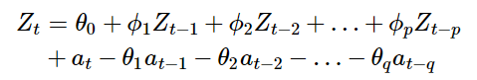

前20个位点部分拟合结果如下。表格中const 代表*θ0*；ar.L1,ar.L2 …… ar.Lp，分别代表*φ1, φ2, ……, φq*；ma.L1,ma.L2 …… ma.Lp，分别代表*θ1,θ2, ……, θq*。

完整结果见附录T9。

|  |  |  |  |  |  |  |  |  |
| --- | --- | --- | --- | --- | --- | --- | --- | --- |
| Index | p | q | const | sigma2 | ar.L1 | ma.L1 | ar.L2 | ma.L2 |
| cg00017842 | 1 | 1 | 0 | 0.003056 | -0.40392 | -0.99985 |  |  |
| cg00347775 | 0 | 0 | 0 | 0.02418 |  |  |  |  |
| cg00454305 | 0 | 0 | 0 | 0.001254 |  |  |  |  |
| cg00503840 | 1 | 1 | 0 | 0.000628 | -0.64583 | -0.99218 |  |  |
| cg00582628 | 0 | 0 | 0 | 0.036612 |  |  |  |  |
| cg00748589 | 1 | 1 | 0 | 0.000576 | -0.45804 | -0.99995 |  |  |
| cg00760938 | 1 | 1 | 0 | 0.006466 | -0.60208 | -0.97959 |  |  |
| cg01059398 | 0 | 0 | 0 | 0.001773 |  |  |  |  |
| cg01243072 | 2 | 3 | 0 | 0.000713 | -0.80398 | -0.81119 | -0.63422 | -0.50828 |
| cg01459453 | 1 | 1 | 0 | 0.001418 | -0.49202 | -0.99986 |  |  |
| cg01511232 | 1 | 1 | 0 | 2.87E-05 | -0.44733 | -0.9993 |  |  |
| cg01527307 | 3 | 1 | 0 | 0.003601 | -0.60958 | -0.99467 | -0.49061 |  |
| cg01528542 | 1 | 1 | 0 | 0.001643 | -0.5584 | -0.99715 |  |  |
| cg01560871 | 1 | 1 | 0 | 0.0003 | -0.49201 | -0.99493 |  |  |
| cg01620164 | 1 | 1 | 0 | 0.00063 | -0.50017 | -0.97968 |  |  |
| cg01740766 | 0 | 0 | 0 | 0.001331 |  |  |  |  |
| cg01820374 | 0 | 0 | 0 | 0.013368 |  |  |  |  |
| cg01844642 | 1 | 1 | 0 | 0.007263 | -0.56189 | -0.99688 |  |  |
| cg01883408 | 1 | 1 | 0 | 0.000442 | -0.62035 | -0.981 |  |  |

表3：一阶ARIMA拟合得到的结果。

1. **模型诊断**

残差时间序列图和残差的ACF图见附件3。正态性通过QQ图判断。自相关性使用Ljung-Box 测试检查。Ljung-Box 测试基于一系列自相关系数来检验总体自相关性是否为零，以确认时间序列模型是否已经充分捕捉了数据中的自相关信息。如果 p-值小于显著性水平（通常设定为0.05），则拒绝原假设，认为数据存在自相关性；如果 p-值大于或等于0.05，则不能拒绝原假设，认为残差中没有自相关，模型较好地捕获了时间序列的结构。

ARMA(p,q)序列中61个LB检验得到的p值大于0.05。残差均值和方差完整结果见附录T8。

1. **预测**

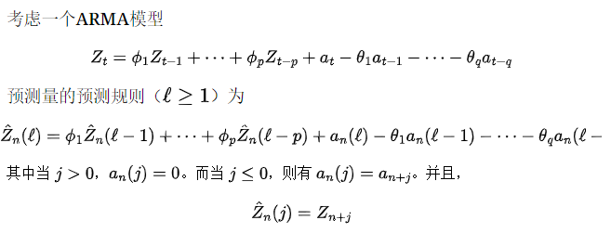

对于给定的时刻 $n$，进行前向5步预测可以表示为：

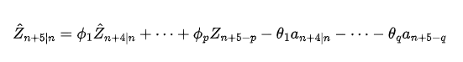

序列完整预测结果见附录T7。前5个位点 ℓ = 1,2,3,4,5的预测结果如图。

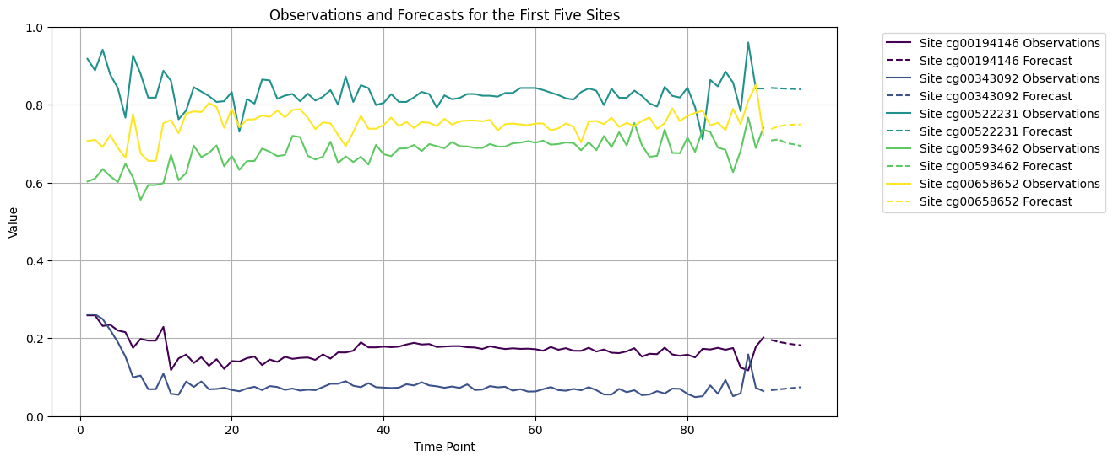

图14：ARMA模型前5个位点预测结果

一阶差分后的ARIMA(p,1,q)序列完整预测结果见附录。前5个位点预测结果如图。

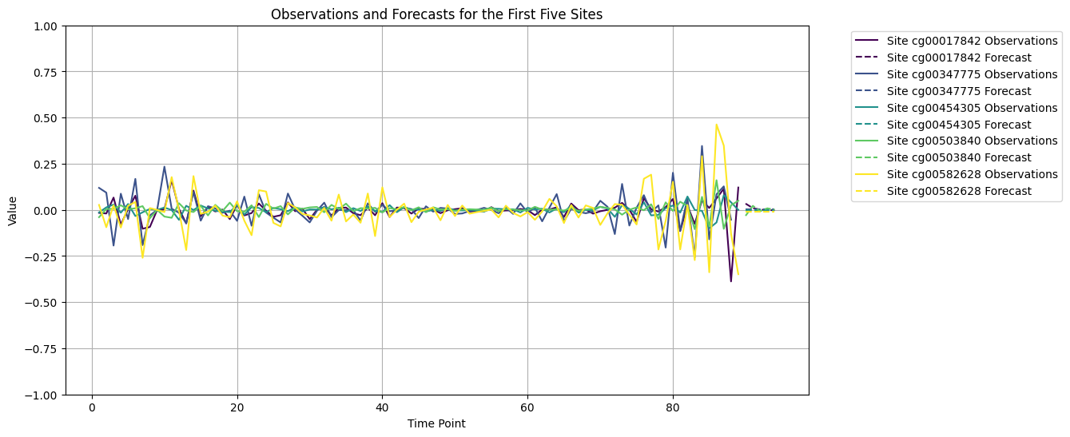

图15：ARIMA一阶差分模型前5个位点预测结果

1. **讨论**

表观基因组学时钟已被用于准确预测细胞、组织和生物体的年龄超过十年[1-3]。最近，新的表观基因组学时钟已针对死亡率、表型、病理和生理读数以及衰老速度进行了训练。模型构建的基本特征是平均在宏观组织样本上的 DNA 甲基化 (DNAm) 水平。然而，纯粹基于时钟的表观遗传老化方法仍然是现象学的，并且缺乏详尽的机制解释。

鉴于 CpG 的很大一部分会随着年龄而发生显著变化，因此可以根据 DNAm 水平和弹性网络回归对时序年龄进行直接预测。表观遗传时钟通常包含随着年龄而发生显著变化的数十万个 CpG 位点中的数百个，因此主要挑战是如何选择包含有关衰老的最具生物学相关信息并能产生该过程的宝贵生物标志物的 CpG。可以为此目的使用更多生物学的信息，例如遗传位点数据。

本文观察到序列期间，每个与年龄相关的 CpG 位点的 DNAm 水平的总体变化很小。甲基化最大的变化约为 30%，大多数 CpG 位点，其变化在整个生命周期中均 <10%。在某些情况下，即使 DNAm 水平发生很小的变化（例如 10%），也可能对细胞产生生物学效应（例如，激活逆转录转座子或促凋亡基因），并对生物体产生长期健康影响。然而，平均而言我们观察到基因组中全局 DNAm 变化，其在整个生命周期中仅轻微改变其正常 DNAm 水平。

此外还观察到的七种主要的 DNAm 变化模式，如图16。1、4 和 7 表示其甲基化水平随BA保持恒定，并且仅在初始 DNAm 水平上有所不同，2 和 3 对应随BA增加的甲基化；5 和 6 对应随BA降低的甲基化，2 和 5 随着熵的增长而趋向于 0.5 的甲基化水平，3 和 6 对应明显的熵减小。

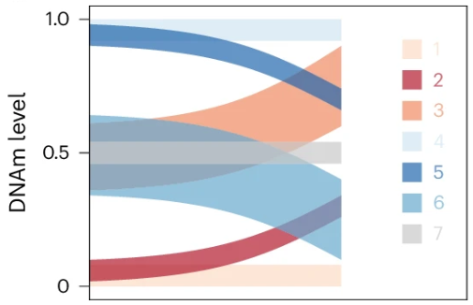

图16：主要的 DNAm 变化模式

序列图整体 DNAm 变化很普遍，但幅度相对较慢且较小，DNAm 水平趋向于中间值，并且随着BA的增长异质性增加，这与早期关于表观遗传漂移的研究一致[5-6]。

尽管如此，不同位点之间的变化程度和速率存在显著差异，这可能反映了不同生物学过程和病理状态的独特表观遗传调控模式。例如，某些CpG位点的甲基化水平可能与特定的衰老相关疾病（如心血管病、糖尿病、癌症和阿尔茨海默病）密切相关。此外还观察到CpG位点甲基化水平的变化遵循一定变化机制（多属于AR，ARMA，ARIMA，极少MA），也有一部分属于白噪声序列。在未来的研究中，可以结合遗传位点信息和环境暴露数据，进一步探索影响DNA甲基化的多因素交互作用。有助于我们更全面地理解衰老过程中的表观遗传机制。

总之，本文通过建立和分析CpG位点的DNA甲基化时间序列，为解析衰老过程中的表观遗传变化提供了一些数据和见解。

参考文献

1. Hannum, G. et al. Genome-wide methylation profiles reveal quantitative views of human aging rates. Mol. Cell 49 , 359–367 (2013).
2. Horvath, S. DNA methylation age of human tissues and cell types. Genome Biol. 14 , R115 (2013).
3. Johansson, Å., Enroth, S. & Gyllensten, U. Continuous aging of the human DNA methylome throughout the human lifespan. PLoS ONE 8 , e67378 (2013).
4. Ying, K., Liu, H., Tarkhov, A.E. et al. Causality-enriched epigenetic age uncouples damage and adaptation. Nat Aging 4, 231–246 (2024).
5. Gladyshev VN. The Ground Zero of Organismal Life and Aging. Trends Mol Med. 2021 Jan;27(1):11-19. doi: 10.1016/j.molmed.2020.08.012. Epub 2020 Sep 23. PMID: 32980264; PMCID: PMC9183202.(10.1016/j.molmed.2020.08.012)
6. Zhou, W. et al. DNA methylation loss in late-replicating domains is linked to mitotic cell division. Nat. Genet. 50 , 591–602 (2018).
7. Slieker, R. C. et al. Age-related accrual of methylomic variability is linked to fundamental ageing mechanisms. Genome Biol. 17 , 191 (2016).
8. Jonathan D.Cryer, Kung-Sik Chan.Time Series Analysis With Applications in R.Springer (2015)
9. 罗珊,王迪.《时间序列分析》课件.MATH4702.2024

代码

import pandas as pd

import numpy as np

import matplotlib.pyplot as plt

import seaborn as sns

from biolearn.data_library import DataLibrary

from biolearn.model_gallery import ModelGallery

import statsmodels.api as sm

from scipy.stats import boxcox

from statsmodels.tsa.arima.model import ARIMA

from statsmodels.tsa.stattools import adfuller

import matplotlib.pyplot as plt

from matplotlib.backends.backend_pdf import PdfPages

from statsmodels.graphics.tsaplots import plot_acf, plot_pacf

from statsmodels.stats.diagnostic import acorr_ljungbox

def save_acf_pacf_to_pdf(*df*, *max_lags*=20, *filename*='ACF_PACF_Plots.pdf'):

    with PdfPages(filename) as pdf:

        for index, series in df.iterrows():

            fig, (ax1, ax2) = plt.subplots(2, 1, *figsize*=(10, 8))

            plot_acf(series, *lags*=max_lags, *ax*=ax1)

            ax1.set_title(f'Autocorrelation Function for Site {index}')

            plot_pacf(series, *lags*=max_lags, *ax*=ax2)

            ax2.set_title(f'Partial Autocorrelation Function for Site {index}')

            pdf.savefig(fig)

            plt.close(fig)

def plot_first_five_sites(*df*):

    fig, axes = plt.subplots(5, 2, *figsize*=(12, 20), *dpi*=100)

    for i, (index, series) in enumerate(df.iloc[:5].iterrows()):

        plot_acf(series, *lags*=20, *ax*=axes[i, 0], *title*=f'Site {index} ACF')

        plot_pacf(series, *lags*=20, *ax*=axes[i, 1], *title*=f'Site {index} PACF')

    plt.tight_layout()

    plt.savefig('First_Five_Sites_ACF_PACF.png')

    plt.close()

def plot_observations_and_forecasts(*forecast_df*, *stationary_df*):

    plt.figure(*figsize*=(12, 6))

    colors = plt.cm.viridis(np.linspace(0, 1, 5))

    for (index, row), color in zip(forecast_df.iloc[:5].iterrows(), colors):

        observations = stationary_df.loc[row['Index']]

        observation_times = range(1, len(observations) + 1)

        forecast_values = [row[f'Forecast_{90 + i}'] for i in range(1, 6)]

        forecast_times = range(len(observations) + 1, len(observations) + 6)

        plt.plot(observation_times, observations, *color*=color, *label*=f'Site {row["Index"]} Observations', *linestyle*='-')

        plt.plot(forecast_times, forecast_values, *color*=color, *label*=f'Site {row["Index"]} Forecast', *linestyle*='--')

    plt.title('Observations and Forecasts for the First Five Sites')

    plt.xlabel('Time Point')

    plt.ylabel('Value')

    plt.ylim(0, 1)

    plt.legend(*bbox_to_anchor*=(1.05, 1),*loc*='upper left')

    plt.grid(True)

    plt.savefig('Observations_Forecasts_First_Five_Sites.png')

    plt.show()

gallery = ModelGallery()

datasets = ["GSE41169", "GSE40279", "GSE51057", "GSE42861", "GSE51032",

            "GSE73103", "GSE69270", "GSE64495", "GSE30870", "GSE52588"]

predictions = []

for i, dataset_name in enumerate(datasets):

    data_source = DataLibrary().get(dataset_name)

    exec(f"data{i+1} = data_source.load()")

    exec(f"horvath_results{i+1} = gallery.get('Horvathv2').predict(eval(f'data{i+1}'))")

    predictions.append(eval(f"horvath_results{i+1}"))

prediction=pd.concat(predictions)

prediction['Predicted'] = prediction['Predicted'].round().astype(int)

prediction.to_csv("E:/111/age_prediction.csv",*index*=True,*header*=True,*sep*="\t")

panel = pd.DataFrame(0, *index*=list(data1.dnam.index), *columns*=range(1, 101))

count = pd.DataFrame(0, *index*=['count'], *columns*=range(1, 101))

for i, pred in enumerate(prediction['Predicted']):

    if pred in panel.columns:

        index_name = prediction.index[i]

        for j, dataset_name in enumerate(datasets):

            data = globals()[f'data{j+1}']

            if index_name in data.dnam.columns:

                panel[pred] = panel[pred].add(data.dnam[index_name])

                count[pred] += 1

    else:

        print("100 is not enough")

count_transposed = count.T

plt.figure(*figsize*=(10, 6))

plt.scatter(count_transposed.index, count_transposed['count'])

plt.title('Count of Predictions')

plt.xlabel('Prediction Index')

plt.ylabel('Count')

plt.grid(True)

plt.show()

zero_count_columns = count.columns[count.iloc[0] == 0]

print("Count columns with zero count:", zero_count_columns)

panel_weighted = panel.copy()

for col in panel.columns:

    if col in zero_count_columns:

        panel_weighted[col] = 0

    else:

        panel_weighted[col] = panel[col] / count[col].iloc[0]

cg_strings = [

     "cg12140144", "cg26933021", "cg20822990", "cg07312601", "cg09993145", "cg23605843",

    "cg25410668", "cg17879376", "cg14962509", "cg24375409", "cg22851420", "cg24107728",

    "cg14614643", "cg00257455", "cg23045908", "cg15201877", "cg18933331", "cg05675373",

    "cg19269039", "cg16008966", "cg14565725", "cg05940231", "cg03984502", "cg25256723",

    "cg16054275", "cg01459453", "cg16599143", "cg02275294", "cg21870884", "cg10501210",

    "cg02901139", "cg11298786", "cg09809672", "cg05940691", "cg12869659", "cg23028740",

    "cg10959651", "cg00522231", "cg01752203", "cg23643435", "cg01243072", "cg07589899",

    "cg10855531", "cg22943590", "cg23398076", "cg12082609", "cg01447660", "cg02085953",

    "cg15149655", "cg22809047", "cg06639320", "cg22454769", "cg00017842", "cg23606718",

    "cg22061831", "cg12757011", "cg01620164", "cg12105450", "cg00760938", "cg10376763",

    "cg23077820", "cg08166272", "cg10523019", "cg23462687", "cg20669012", "cg03183882",

    "cg15910502", "cg12941369", "cg02244028", "cg24888989", "cg00702638", "cg07303143",

    "cg26614073", "cg15988232", "cg16933388", "cg19381811", "cg03019000", "cg01844642",

    "cg04474832", "cg03891319", "cg03607117", "cg22264409", "cg11205552", "cg17321954",

    "cg06796779", "cg18303397", "cg09025210", "cg14423778", "cg15277914", "cg07553761",

    "cg06737494", "cg01059398", "cg26824216", "cg25478614", "cg07110949", "cg23239150",

    "cg21254939", "cg23995914", "cg23836737", "cg05960024", "cg10699857", "cg05024939",

    "cg05106770", "cg06690548", "cg02650266", "cg01511232", "cg25148589", "cg24843443",

    "cg03364683", "cg21815258", "cg12608692", "cg20755989", "cg12238343", "cg02328239",

    "cg21878650", "cg26921969", "cg10837404", "cg01883408", "cg06448705", "cg16983159",

    "cg08234504", "cg11006267", "cg21874213", "cg23500537", "cg26843711", "cg08587542",

    "cg10345936", "cg16281600", "cg03555227", "cg14345676", "cg14314729", "cg23517605",

    "cg01570885", "cg23375552", "cg20052760", "cg16867657", "cg21572722", "cg00194146",

    "cg01527307", "cg22736354", "cg10699171", "cg06493994", "cg04424621", "cg02281167",

    "cg03771840", "cg06685111", "cg06462220", "cg08420066", "cg21467614", "cg12753631",

    "cg18501647", "cg04576021", "cg10192196", "cg18468088", "cg03894990", "cg01740766",

    "cg16255583", "cg04642300", "cg17266282", "cg07095347", "cg00073460", "cg16333846",

    "cg13221458", "cg05468948", "cg00795927", "cg08911208", "cg22372849", "cg16012294",

    "cg22679120", "cg13931228", "cg27009703", "cg11671968", "cg26312920", "cg19663246",

    "cg14396995", "cg18442362", "cg09748749", "cg20692569", "cg23857078",

    "cg21743182", "cg09436502", "cg00503840", "cg04084157", "cg14175438", "cg20665157",

    "cg21184711", "cg02383785", "cg04528819", "cg20426994", "cg08097417", "cg02821342",

    "cg20397034", "cg03473532", "cg08280936", "cg08540945", "cg18769120", "cg26101086",

    "cg19859445", "cg07502389", "cg18267374", "cg00582628", "cg16419235", "cg23710218",

    "cg07583137", "cg12402251", "cg19497517", "cg13586038", "cg19724470", "cg07211259",

    "cg07158339", "cg24046474", "cg14059835", "cg10570177", "cg13649056", "cg13734401",

    "cg26581729", "cg06231995", "cg14411282", "cg12530994", "cg23754392", "cg06908778",

    "cg22796704", "cg01560871", "cg04268405", "cg18738190", "cg04126866", "cg25427880",

    "cg09671951", "cg06888746", "cg24838825", "cg13848598", "cg07906193", "cg12776156",

    "cg05928581", "cg17627559", "cg23091758", "cg04940570", "cg10825530", "cg20654468",

    "cg26552743", "cg21992250", "cg15015340", "cg22843803", "cg02532488", "cg13547237",

    "cg06419846", "cg05496363", "cg20063906", "cg12328429", "cg25969122", "cg18633600",

    "cg08622677", "cg01820374", "cg25719851", "cg13828440", "cg26986871", "cg00748589",

    "cg21747310", "cg00431549", "cg13302154", "cg13909661", "cg19722847", "cg26311454",

    "cg08900043", "cg00753885", "cg18573383", "cg15405572", "cg01528542", "cg08993878",

    "cg22827210", "cg03670162", "cg04596060", "cg21907579", "cg10281002", "cg07172885",

    "cg20404336", "cg18582260", "cg22179082", "cg06648759", "cg23357533", "cg20102280",

    "cg13767001", "cg23389651", "cg09646392", "cg00593462", "cg07115626", "cg06738602",

    "cg03032497", "cg18771300", "cg24058132", "cg13027206", "cg15480367", "cg12177001",

    "cg23709172", "cg14334310", "cg04875128", "cg21296230", "cg02071305", "cg03361973",

    "cg16717122", "cg04858164", "cg25005357", "cg08454546", "cg21801378", "cg15188939",

    "cg20540209", "cg05542681", "cg08949164", "cg09183146", "cg00454305", "cg02871659",

    "cg00991848", "cg02331561", "cg26974444", "cg06112560", "cg10917602", "cg09155044",

    "cg04031656", "cg03746976", "cg18693704", "cg00658652", "cg03991512", "cg22947000",

    "cg07082267", "cg03486383", "cg02228185", "cg23668631", "cg14522800", "cg25135555",

    "cg13029847", "cg06144905", "cg11896923", "cg06874016", "cg25809905", "cg04267101",

    "cg22507023", "cg02867102", "cg13093111", "cg13683374", "cg10644544", "cg03643998",

    "cg11620135", "cg25436157", "cg24217948", "cg17589341", "cg17243289", "cg12459502",

    "cg19283806", "cg10052840", "cg26005082", "cg11766468", "cg10586358", "cg14556683",

    "cg26842024", "cg18335931", "cg17861230", "cg10498798", "cg27212234", "cg17110586",

    "cg21944491", "cg21940708", "cg15811427", "cg06458239", "cg10729426", "cg21911021",

    "cg24834740", "cg19702785", "cg07547549", "cg12303084", "cg27544190", "cg01262913",

    "cg17274064", "cg09428349", "cg10636297", "cg12373771", "cg05442902", "cg16612562",

    "cg19015086", "cg21205978", "cg01949403", "cg08415592", "cg19853760", "cg23124451",

    "cg25459323", "cg27187881", "cg00343092", "cg00347775", "cg27131176", "cg22982767",

    "cg07016730", "cg01892695"

]

core_cpg = pd.DataFrame(cg_strings, *columns*=['CpG'])

Pseudo_TimeSeries_100 = panel_weighted[panel_weighted.index.isin(core_cpg['CpG'])]

Pseudo_TimeSeries_90=Pseudo_TimeSeries_100.iloc[:,:90]

stats = Pseudo_TimeSeries_90.describe()

stats_T=stats.T

stats_T.to_csv("E:/111/Stats_Transformed.csv",*index*=True,*header*=True,*sep*="\t")

Pseudo_TimeSeries_90.to_csv("E:/111/Pseudo_TimeSeries_90.csv",*index*=True,*header*=True,*sep*="\t")

df = Pseudo_TimeSeries_90

total_columns = df.shape[1]

nan_count_per_row = df.isnull().sum(*axis*=1)

nan_percentage_per_row = nan_count_per_row / total_columns

filtered_df = df[nan_percentage_per_row <= 0.05]

df_filtered_filled = filtered_df.fillna(*method*='ffill', *axis*=1)

df_filtered_filled.iloc[:, 9] = np.nan

df_filtered_filled.iloc[:, 9]=df.interpolate(*method*='linear', *axis*=1)

mean_values = df_filtered_filled.mean(*axis*=1)

std_values = df_filtered_filled.std(*axis*=1)

cutoff = std_values * 4

lower = mean_values - cutoff

upper = mean_values + cutoff

outliers = (df_filtered_filled.lt(lower, *axis*=0) | df_filtered_filled.gt(upper, *axis*=0))

df_exclude_outliers =df_filtered_filled.copy()

df_exclude_outliers[outliers] = np.nan

df_exclude_outliers=df_exclude_outliers.fillna(*method*='bfill', *axis*=1)

plt.figure(*figsize*=(18, 24))

num_rows = len(df_filtered_filled)

colors = plt.cm.viridis(np.linspace(0, 1, num_rows))

for (index, row), color in zip(df_filtered_filled.iterrows(), colors):

    plt.plot(df_filtered_filled.columns, row, *label*=index, *color*=color)

plt.title('Time Series of Each Site')

plt.xlabel('Year')

plt.ylabel('Methylation Value')

plt.show()

df_exclude_outliers.to_csv("E:/111/Pseudo_TimeSeries_no_outliers.csv",*index*=True,*header*=True,*sep*="\t")

df_ex_outliiers_demo=df_exclude_outliers.iloc[:10,:]

plt.figure(*figsize*=(18, 6))

for index, row in df_ex_outliiers_demo.iterrows():

    plt.plot(df_ex_outliiers_demo.columns, row, *label*=index)

plt.title('Time Series of Each Site')

plt.xlabel('Year')

plt.ylabel('Value')

plt.legend()

plt.show()

adf_results_1 = []

for index, row in df_exclude_outliers.iterrows():

    result = adfuller(row.dropna(), *autolag*='AIC')

    adf_results_1.append({

        'Row Index': index,

        'ADF Statistic': result[0],

        'p-value': result[1],

        'Critical Value (1%)': result[4]['1%'],

        'Critical Value (5%)': result[4]['5%'],

        'Critical Value (10%)': result[4]['10%'],

        'Stationarity': "Stationary" if result[1] < 0.05 else "Non-stationary"

    })

adf_results_df_1 = pd.DataFrame(adf_results_1)

adf_results_df_1.to_csv("E:/111/ADF_test_1.csv",*index*=True,*header*=True,*sep*="\t")

stationary_df_1 = df_exclude_outliers.loc[adf_results_df_1[adf_results_df_1['Stationarity'] == 'Stationary']['Row Index']]

non_stationary_df_1 = df_exclude_outliers.loc[adf_results_df_1[adf_results_df_1['Stationarity'] == 'Non-stationary']['Row Index']]

stationary_df_1.to_csv("E:/111/ADF_stationary_df_1.csv",*index*=True,*header*=True,*sep*="\t")

non_stationary_df_1.to_csv("E:/111/ADF_nonstationary_df_1.csv",*index*=True,*header*=True,*sep*="\t")

plt.figure(*figsize*=(18, 18))

num_rows = len(stationary_df_1)

colors = plt.cm.viridis(np.linspace(0, 1, num_rows))

for (index, row), color in zip(stationary_df_1.iterrows(), colors):

    plt.plot(stationary_df_1.columns, row, *label*=str(index), *color*=color)

plt.title('Time Series of Each Site')

plt.xlabel('Year')

plt.ylabel('Methylation Value')

plt.legend(*title*='Index', *bbox_to_anchor*=(1.05, 1), *loc*='upper left')

plt.show()

plt.figure(*figsize*=(18, 18))

num_rows = len(non_stationary_df_1)

colors = plt.cm.viridis(np.linspace(0, 1, num_rows))

for (index, row), color in zip(non_stationary_df_1.iterrows(), colors):

    plt.plot(non_stationary_df_1.columns, row, *label*=str(index), *color*=color)

plt.title('Time Series of Each Site')

plt.xlabel('Year')

plt.ylabel('Methylation Value')

plt.show()

save_acf_pacf_to_pdf(stationary_df_1)

print("All ACF and PACF plots have been saved to ACF_PACF_Plots.pdf.")

plot_first_five_sites(stationary_df_1)

print("ACF and PACF plots for the first five sites have been saved to 'First_Five_Sites_ACF_PACF.png'.")

orders = [(1,0), (1,0), (1,1), (2,0), (1,0),

          (1,0),(1,0),(1,0),(1,0),(1,0),

          (1,0),(1,1),(1,0),(1,0),(1,0),

          (1,0),(1,1),(1,0),(1,0),(1,0),

          (1,0),(1,1),(1,0),(1,1),(2,0),

          (1,1),(1,1),(2,0),(2,0),(2,0),

          (2,0),(1,0),(1,0),(1,1),(1,0),

          (1,0),(0,0),(1,0),(0,0),(1,0),

          (1,0),(1,0),(1,0),(1,0),(1,0),

          (1,0),(1,0),(1,0),(1,0),(1,0),

          (0,0),(1,0),(1,1),(1,0),(1,1),

          (1,0),(1,0),(1,1),(1,0),(1,0),

          (1,2),(1,0),(1,0)

          ]

results = []

for index, (p, q) in zip(stationary_df_1.index, orders):

    series = stationary_df_1.loc[index]

    model = ARIMA(series, *order*=(p, 0, q))

    result = model.fit()

    params = {

        'Index': index,

        'p': p,

        'q': q,

        'const': result.params.get('const', 0),

        'sigma2': result.params.get('sigma2', 0)

    }

    for i in range(1, p + 1):

        params[f'ar.L{i}'] = result.params.get(f'ar.L{i}', 0)

    for i in range(1, q + 1):

        params[f'ma.L{i}'] = result.params.get(f'ma.L{i}', 0)

    results.append(params)

results_df_1 = pd.DataFrame(results)

results_df_1.to_csv("E:/111/ARMA_65_result.csv",*index*=True,*header*=True,*sep*="\t")

error_results = []

pdf_pages = PdfPages('Time_Series_Diagnostics.pdf')

for index, (p, q) in zip(stationary_df_1.index, orders):

    series = stationary_df_1.loc[index]

    model = ARIMA(series, *order*=(p, 0, q))

    result = model.fit()

    residuals = result.resid

    fig, ax = plt.subplots(2, 1, *figsize*=(10, 8))

    ax[0].plot(residuals)

    ax[0].set_title(f'Residuals for Series at Index {index}')

    sm.graphics.tsa.plot_acf(residuals, *lags*=20, *ax*=ax[1], *title*=f'ACF for Series at Index {index}')

    pdf_pages.savefig(fig)

    plt.close(fig)

    lb_test = acorr_ljungbox(residuals, *lags*=[20], *return_df*=True)

    lb_pvalue = lb_test['lb_pvalue'].values[0]

    jb_test = sm.stats.jarque_bera(residuals)

    jb_pvalue = jb_test[1]

    error_results.append({

        'Index': index,

        'p': p,

        'q': q,

        'LB p-value': lb_pvalue,

        'Mean of Residuals': residuals.mean(),

        'Std of Residuals': residuals.std()

    })

pdf_pages.close()

error_results_df = pd.DataFrame(error_results)

error_results_df.to_csv("E:/111/63_error_results_df.csv",*index*=True,*header*=True,*sep*="\t")

forecast_results = []

for index, (p, q) in zip(stationary_df_1.index, orders):

    series = stationary_df_1.loc[index]

    model = ARIMA(series, *order*=(p, 0, q))

    fitted_model = model.fit()

    forecast = fitted_model.get_forecast(*steps*=5)

    mean_forecast = forecast.predicted_mean

    conf_int = forecast.conf_int()

    forecast_dict = {

        'Index': index,

    }

    for i, value in enumerate(mean_forecast, *start*=1):

        forecast_dict[f'Forecast_{90 + i}'] = value

        forecast_dict[f'CI_Lower_{90 + i}'] = conf_int.iloc[i - 1, 0]

        forecast_dict[f'CI_Upper_{90 + i}'] = conf_int.iloc[i - 1, 1]

    forecast_results.append(forecast_dict)

forecast_df = pd.DataFrame(forecast_results)

forecast_df.to_csv("E:/111/63_forecast.csv",*index*=True,*header*=True,*sep*="\t")

plot_observations_and_forecasts(forecast_df, stationary_df_1)

data_boxcox_diff1 = pd.DataFrame()

results_2 = []

for index, row in non_stationary_df_1.iterrows():

    data, lambda_ = boxcox(row[row > 0])

    data_diff = np.diff(data, *n*=1)

    temp_df = pd.DataFrame(data_diff.reshape(1, -1))

    data_boxcox_diff1 = pd.concat([data_boxcox_diff1, temp_df], *ignore_index*=True)

    adf_result = adfuller(data_diff)

    results_2.append({

        "index": index,

        "lambda": lambda_,

        "ADF Statistic": adf_result[0],

        "p-value": adf_result[1],

        'Critical Value (1%)': adf_result[4]['1%'],

        'Critical Value (5%)': adf_result[4]['5%'],

        'Critical Value (10%)': adf_result[4]['10%'],

        'Stationarity': "Stationary" if adf_result[1] < 0.05 else "Non-stationary"

    })

results_df_2 = pd.DataFrame(results)

data_boxcox_diff1.index = non_stationary_df_1.index

data_boxcox_diff1.to_csv("E:/111/data_boxcox_diff1.csv",*index*=True,*header*=True,*sep*="\t")

results_df_2.to_csv("E:/111/ADF_test_2.csv",*index*=True,*header*=True,*sep*="\t")

stationary_df_2 =  data_boxcox_diff1.loc[results_df_2[results_df_2['Stationarity'] == 'Stationary']['index']]

non_stationary_df_2 = data_boxcox_diff1.loc[results_df_2[results_df_2['Stationarity'] == 'Non-stationary']['index']]

plt.figure(*figsize*=(18, 18))

num_rows = len(stationary_df_2)

colors = plt.cm.viridis(np.linspace(0, 1, num_rows))

for (index, row), color in zip(stationary_df_2.iterrows(), colors):

    plt.plot(stationary_df_2.columns, row, *label*=str(index), *color*=color)

plt.title('Time Series of Each Site')

plt.xlabel('Year')

plt.ylabel('Methylation Value')

plt.show()

plt.figure(*figsize*=(18, 12))

num_rows = len(non_stationary_df_2)

colors = plt.cm.viridis(np.linspace(0, 1, num_rows))

for (index, row), color in zip(non_stationary_df_2.iterrows(), colors):

    plt.plot(non_stationary_df_2.columns, row, *label*=str(index), *color*=color)

plt.title('Time Series of Each Site')

plt.xlabel('Year')

plt.ylabel('Methylation Value')

plt.show()

save_acf_pacf_to_pdf(stationary_df_2)

print("All ACF and PACF plots have been saved to ACF_PACF_Plots.pdf.")

plot_first_five_sites(stationary_df_2)

print("ACF and PACF plots for the first five sites have been saved to 'First_Five_Sites_ACF_PACF.png'.")

orders = [(1, 1), (0, 0), (0, 0), (1, 1), (0, 0),

          (1,1),(1,1),(0,0),(2,3),(1,1),

          (1,1),(3,1),(1,1),(1,1),(1,1),

          (0,0),(0,0),(1,1),(1,1),(1,1),

          (0,0),(0, 0),(0, 0),(0, 0),(1,1),

          (2,1),(1,1),(1,1),(2,1),(2,2),

          (1,1),(1,1),(1,1),(1,1),(2,1),

          (1,1),(1,1),(1,1),(1,1),(1,1),

          (0,0),(1,1),(2,1),(1,1),(0,0),

          (0,0),(0,0),(2,1),(3,2),(1,1),

          (1,1),(1,1),(1,1),(1,1),(1,1),

          (1,1),(0,0),(0,0),(1,1),(1,1),

          (0,0),(1,1),(1,1),(0,0),(1,1),

          (2,1),(0,0),(2,1),(0,0),(2,2),

          (1,1),(0,0),(1,1),(1,1),(1,1),

          (1,1),(0,0),(1,1),(1,1),(1,1),

          (0,0),(2,1),(0,0),(1,1),(0,0),

          (0,0),(0,0),(0,0),(1,1),(0,0),

          (2,1),(2,1),(0,0),(0,0),(0,0),

          (0,0),(0,0),(1,1),(2,1),(0,0),

          (1,1),(0,0),(1,1),(0,0),(1,1),

          (1,1),(1,1),(2,1),(1,1),(1,1),

          (1,1),(0,0),(0,0),(2,1),(0,0),

          (1,1),(2,1),(1,1),(2,1),(0,0),

          (2,1),(0,0),(0,0),(1,1),(2,1),

          (0,0),(0,0),(0,0),(1,1),(1,1),

          (1,1),(1,1),(1,1),(0,0),(1,1),

          (0,0),(1,1),(1,1),(0,0),(1,1),

          (0,0),(1,1),(1,1),(1,1),(1,1),

          (1,1),(2,1),(1,1),(2,1),(0,0),

          (1,1),(0,0),(1,1),(0,0),(0,0),

          (0,0),(2,1),(2,1),(1,1),(1,1),

          (0,0),(2,1),(2,1),(1,1),(2,3),

          (1,1),(1,1),(0,0),(1,1),(0,0),

          (0,0),(1,1),(1,1),(0,0),(1,1),

          (1,1),(0,0),(2,1),(1,1),(0,0),

          (0,0),(1,1),(0,0),(0,0),(1,1),

          (0,0),(1,1),(1,1),(1,1),(2,1),

          (1,1),(0,0),(1,1),(0,0),(1,1),

          (0,0),(1,1),(0,0),(1,1),(1,1),

          (0,0),(0,0),(0,0),(1,1),(0,0),

          (0,0),(1,1),(1,1),(2,1),(1,1),

          (0,0),(1,1),(1,1),(2,1),(2,1),

          (0,0),(0,0),(1,1),(1,1),(0,0),

          (2,2),(0,0),(2,1)

          ]

results = []

for index, (p, q) in zip(stationary_df_2.index, orders):

    series = stationary_df_2.loc[index]

    model = ARIMA(series, *order*=(p, 1, q))

    result = model.fit()

    params = {

        'Index': index,

        'p': p,

        'q': q,

        'const': result.params.get('const', 0),

        'sigma2': result.params.get('sigma2', 0)

    }

    for i in range(1, p + 1):

        params[f'ar.L{i}'] = result.params.get(f'ar.L{i}', 0)

    for i in range(1, q + 1):

        params[f'ma.L{i}'] = result.params.get(f'ma.L{i}', 0)

    results.append(params)

results_df_2 = pd.DataFrame(results)

forecast_results = []

for index, (p, q) in zip(stationary_df_2.index, orders):

    series = stationary_df_2.loc[index]

    model = ARIMA(series, *order*=(p, 0, q))

    fitted_model = model.fit()

    forecast = fitted_model.get_forecast(*steps*=5)

    mean_forecast = forecast.predicted_mean

    conf_int = forecast.conf_int()

    forecast_dict = {

        'Index': index,

    }

    for i, value in enumerate(mean_forecast, *start*=1):

        forecast_dict[f'Forecast_{90 + i}'] = value

        forecast_dict[f'CI_Lower_{90 + i}'] = conf_int.iloc[i - 1, 0]

        forecast_dict[f'CI_Upper_{90 + i}'] = conf_int.iloc[i - 1, 1]

    forecast_results.append(forecast_dict)

forecast_df = pd.DataFrame(forecast_results)

forecast_df.to_csv("E:/111/224_forecast.csv",*index*=True,*header*=True,*sep*="\t")

plt.show()

plot_observations_and_forecasts(forecast_df, stationary_df_2)

results_df_2.to_csv("E:/111/224_result.csv",*index*=True,*header*=True,*sep*="\t")

附录

附录T1：Horvath Clock的CpG位点

|  |  |
| --- | --- |
| CpGmarker | CoefficientTraining |
| cg12140144 | 0.363181 |
| cg26933021 | -0.0905 |
| cg20822990 | -0.00703 |
| cg07312601 | -0.13509 |
| cg09993145 | -0.04264 |
| cg23605843 | 0.079387 |
| cg25410668 | 0.278005 |
| cg17879376 | -0.20271 |
| cg14962509 | 0.182311 |
| cg24375409 | -0.0238 |
| cg22851420 | 0.097198 |
| cg24107728 | -0.10654 |
| cg14614643 | -0.04339 |
| cg00257455 | -0.1617 |
| cg23045908 | 0.137327 |
| cg15201877 | 0.392098 |
| cg18933331 | -0.23176 |
| cg05675373 | 0.024479 |
| cg19269039 | -0.01756 |
| cg16008966 | -0.20391 |
| cg14565725 | -0.03556 |
| cg05940231 | -0.1067 |
| cg03984502 | 0.222121 |
| cg25256723 | -0.12098 |
| cg16054275 | -0.23397 |
| cg01459453 | 0.041908 |
| cg16599143 | 0.14198 |
| cg02275294 | -0.14287 |
| cg21870884 | -0.01268 |
| cg10501210 | -0.31653 |
| cg02901139 | -0.07311 |
| cg11298786 | -0.19643 |
| cg09809672 | -0.10033 |
| cg05940691 | -0.05999 |
| cg12869659 | -0.04257 |
| cg23028740 | -0.00988 |
| cg10959651 | -0.03821 |
| cg00522231 | 0.018122 |
| cg01752203 | -0.02198 |
| cg23643435 | 0.012875 |
| cg01243072 | -0.00133 |
| cg07589899 | 0.106602 |
| cg10855531 | -0.30056 |
| cg22943590 | -0.08318 |
| cg23398076 | 0.005661 |
| cg12082609 | 0.154152 |
| cg01447660 | -0.11575 |
| cg02085953 | 0.01992 |
| cg15149655 | 0.200279 |
| cg22809047 | 0.118967 |
| cg06639320 | 0.019739 |
| cg22454769 | 0.051866 |
| cg00017842 | 0.15636 |
| cg23606718 | 0.700747 |
| cg22061831 | -0.17746 |
| cg12757011 | 0.155999 |
| cg01620164 | -0.06541 |
| cg12105450 | 0.009945 |
| cg00760938 | 0.0772 |
| cg10376763 | -0.09209 |
| cg23077820 | 0.06101 |
| cg08166272 | 0.105439 |
| cg10523019 | 0.126152 |
| cg23462687 | -0.18373 |
| cg20669012 | 0.126232 |
| cg03183882 | -1.00739 |
| cg15910502 | -0.13377 |
| cg12941369 | 0.024192 |
| cg02244028 | 0.004509 |
| cg24888989 | 1.230382 |
| cg00702638 | 0.725076 |
| cg07303143 | 0.734121 |
| cg26614073 | -0.12423 |
| cg15988232 | -0.05842 |
| cg16933388 | 0.133862 |
| cg19381811 | -0.02832 |
| cg03019000 | -0.08438 |
| cg01844642 | 0.093412 |
| cg04474832 | 0.12053 |
| cg03891319 | -0.25608 |
| cg03607117 | 0.169781 |
| cg22264409 | 0.025066 |
| cg11205552 | 0.039745 |
| cg17321954 | 0.473386 |
| cg06796779 | 0.053573 |
| cg18303397 | 0.021788 |
| cg09025210 | 0.038797 |
| cg14423778 | 0.060485 |
| cg15277914 | -0.03337 |
| cg07553761 | 0.26245 |
| cg06737494 | 0.063912 |
| cg01059398 | -0.00885 |
| cg26824216 | -0.16047 |
| cg25478614 | 0.113493 |
| cg07110949 | 0.002657 |
| cg23239150 | 0.070538 |
| cg21254939 | 0.021572 |
| cg23995914 | 0.140281 |
| cg23836737 | -0.15355 |
| cg05960024 | -0.00102 |
| cg10699857 | -0.27248 |
| cg05024939 | 0.182893 |
| cg05106770 | -0.05997 |
| cg06690548 | 0.094717 |
| cg02650266 | 0.028819 |
| cg01511232 | 0.169551 |
| cg25148589 | 0.078559 |
| cg24843443 | 0.023702 |
| cg03364683 | 0.036555 |
| cg21815258 | 0.326224 |
| cg12608692 | -0.00241 |
| cg20755989 | 0.241204 |
| cg12238343 | 0.061944 |
| cg02328239 | 0.16437 |
| cg21878650 | -0.12802 |
| cg26921969 | 0.395075 |
| cg10837404 | -0.10209 |
| cg01883408 | 0.210085 |
| cg06448705 | 0.113572 |
| cg16983159 | -0.16518 |
| cg08234504 | -0.26153 |
| cg11006267 | 0.300526 |
| cg21874213 | -0.17214 |
| cg23500537 | 0.233706 |
| cg26843711 | 0.110107 |
| cg08587542 | -0.10651 |
| cg10345936 | -0.0129 |
| cg16281600 | 0.047647 |
| cg03555227 | 0.191706 |
| cg14345676 | 0.001316 |
| cg14314729 | -0.06706 |
| cg23517605 | -0.07457 |
| cg01570885 | -0.01748 |
| cg23375552 | -0.14964 |
| cg20052760 | -0.08736 |
| cg16867657 | 0.895063 |
| cg21572722 | 0.258923 |
| cg00194146 | 0.02514 |
| cg01527307 | 0.150123 |
| cg22736354 | 0.12315 |
| cg10699171 | -0.01751 |
| cg06493994 | 0.194146 |
| cg04424621 | 0.038778 |
| cg02281167 | 0.050828 |
| cg03771840 | 0.063284 |
| cg06685111 | -0.11805 |
| cg06462220 | -0.40087 |
| cg08420066 | -0.00879 |
| cg21467614 | -0.0413 |
| cg12753631 | -0.34157 |
| cg18501647 | 0.016363 |
| cg04576021 | 0.190381 |
| cg10192196 | 0.103901 |
| cg18468088 | 0.271258 |
| cg03894990 | 0.001523 |
| cg01740766 | -0.04811 |
| cg16255583 | -0.18026 |
| cg04642300 | 1.63E-04 |
| cg17266282 | -0.04225 |
| cg07095347 | -0.02201 |
| cg00073460 | 0.059376 |
| cg16333846 | 0.226866 |
| cg13221458 | -0.03948 |
| cg05468948 | 0.138578 |
| cg00795927 | -0.06637 |
| cg08911208 | -0.09422 |
| cg22372849 | -0.14012 |
| cg16012294 | 0.139311 |
| cg22679120 | -0.04022 |
| cg13931228 | -0.24855 |
| cg27009703 | -0.17774 |
| cg11671968 | 0.120568 |
| cg26312920 | 0.006823 |
| cg19663246 | -0.03864 |
| cg14396995 | 0.124113 |
| cg18442362 | 0.00651 |
| cg09748749 | -0.2028 |
| cg20692569 | 0.031359 |
| cg23857078 | 0.234566 |
| cg21743182 | 0.002841 |
| cg09436502 | 0.056326 |
| cg00503840 | 0.048661 |
| cg04084157 | 0.358752 |
| cg14175438 | -0.06829 |
| cg20665157 | 0.007167 |
| cg21184711 | 0.095031 |
| cg02383785 | 0.184785 |
| cg04528819 | 0.034465 |
| cg20426994 | -0.10139 |
| cg08097417 | 0.871372 |
| cg02821342 | -0.23832 |
| cg20397034 | -0.24317 |
| cg03473532 | -0.21296 |
| cg08280936 | -0.23613 |
| cg08540945 | -0.16969 |
| cg18769120 | 0.061913 |
| cg26101086 | -0.15728 |
| cg19859445 | 0.187401 |
| cg07502389 | 0.315776 |
| cg18267374 | -0.2119 |
| cg00582628 | 0.020113 |
| cg16419235 | 0.114779 |
| cg23710218 | -0.34917 |
| cg07583137 | 0.045567 |
| cg12402251 | 0.126795 |
| cg19497517 | -0.0434 |
| cg13586038 | 0.123252 |
| cg19724470 | -0.10072 |
| cg07211259 | -0.00538 |
| cg07158339 | -0.03178 |
| cg24046474 | 0.273015 |
| cg14059835 | -0.01607 |
| cg10570177 | -0.09863 |
| cg13649056 | 0.039139 |
| cg13734401 | -0.09566 |
| cg26581729 | 0.020095 |
| cg06231995 | 0.474821 |
| cg14411282 | -0.25729 |
| cg12530994 | -0.22918 |
| cg23754392 | -0.29191 |
| cg06908778 | -0.15769 |
| cg22796704 | -0.02976 |
| cg01560871 | -0.04957 |
| cg04268405 | -0.13107 |
| cg18738190 | -0.10729 |
| cg04126866 | -0.0024 |
| cg25427880 | 0.163756 |
| cg09671951 | 0.100547 |
| cg06888746 | 0.066364 |
| cg24838825 | 0.064358 |
| cg13848598 | 0.193739 |
| cg07906193 | -0.02885 |
| cg12776156 | -0.17899 |
| cg05928581 | -0.04251 |
| cg17627559 | -0.04149 |
| cg23091758 | 0.105288 |
| cg04940570 | 0.289083 |
| cg10825530 | -0.03229 |
| cg20654468 | -0.05372 |
| cg26552743 | 0.143275 |
| cg21992250 | 0.14822 |
| cg15015340 | -0.17707 |
| cg22843803 | 0.056494 |
| cg02532488 | -0.70033 |
| cg13547237 | -0.24482 |
| cg06419846 | 0.173054 |
| cg05496363 | 0.052685 |
| cg20063906 | -0.05977 |
| cg12328429 | 0.084155 |
| cg25969122 | -0.23084 |
| cg18633600 | 0.258224 |
| cg08622677 | 0.228244 |
| cg01820374 | 0.122892 |
| cg25719851 | -0.02293 |
| cg13828440 | 0.00737 |
| cg26986871 | 0.05683 |
| cg00748589 | 0.16672 |
| cg21747310 | -0.14214 |
| cg00431549 | 8.83E-06 |
| cg13302154 | 0.108 |
| cg13909661 | -0.27404 |
| cg19722847 | -0.18193 |
| cg26311454 | 0.122619 |
| cg08900043 | -0.06196 |
| cg00753885 | -0.47831 |
| cg18573383 | 0.181171 |
| cg15405572 | 0.037353 |
| cg01528542 | -0.14237 |
| cg08993878 | -0.06434 |
| cg22827210 | -0.02726 |
| cg03670162 | -0.27255 |
| cg04596060 | -0.66542 |
| cg21907579 | -0.17723 |
| cg10281002 | 0.025872 |
| cg07172885 | 0.117264 |
| cg20404336 | 0.157369 |
| cg18582260 | 0.035026 |
| cg22179082 | 0.002965 |
| cg06648759 | 0.426865 |
| cg23357533 | -0.31533 |
| cg20102280 | -0.06204 |
| cg13767001 | 0.083143 |
| cg23389651 | -0.29355 |
| cg09646392 | -0.03318 |
| cg00593462 | 0.09757 |
| cg07115626 | -0.09476 |
| cg06738602 | -0.0949 |
| cg03032497 | 0.111167 |
| cg18771300 | -0.02005 |
| cg24058132 | -0.11298 |
| cg13027206 | -0.0459 |
| cg15480367 | 0.194531 |
| cg12177001 | -0.07785 |
| cg23709172 | -0.18611 |
| cg14334310 | -0.04688 |
| cg04875128 | 3.58E-04 |
| cg21296230 | -0.0254 |
| cg02071305 | 0.006552 |
| cg03361973 | 0.060348 |
| cg16717122 | 0.145165 |
| cg04858164 | 0.021062 |
| cg25005357 | 0.175415 |
| cg08454546 | -0.09494 |
| cg21801378 | -0.109 |
| cg15188939 | 0.204902 |
| cg20540209 | 0.168254 |
| cg05542681 | 0.13688 |
| cg08949164 | 0.264842 |
| cg09183146 | 0.07315 |
| cg00454305 | 0.104796 |
| cg02871659 | 0.088546 |
| cg00991848 | 0.443893 |
| cg02331561 | -0.25192 |
| cg26974444 | 0.076079 |
| cg06112560 | 0.164151 |
| cg10917602 | -0.01541 |
| cg09155044 | -0.34067 |
| cg04031656 | 0.054786 |
| cg03746976 | -0.05771 |
| cg18693704 | -0.28144 |
| cg00658652 | 0.15261 |
| cg03991512 | -0.07631 |
| cg22947000 | 0.022123 |
| cg07082267 | -0.46918 |
| cg03486383 | 0.163455 |
| cg02228185 | -0.04032 |
| cg23668631 | 0.005437 |
| cg14522800 | 0.130624 |
| cg25135555 | 0.192896 |
| cg13029847 | 0.647782 |
| cg06144905 | 0.159584 |
| cg11896923 | 0.037628 |
| cg06874016 | -0.08773 |
| cg25809905 | -0.09807 |
| cg04267101 | -0.01969 |
| cg22507023 | 0.238759 |
| cg02867102 | -0.11989 |
| cg13093111 | 0.008814 |
| cg13683374 | -0.08264 |
| cg10644544 | -0.66774 |
| cg03643998 | -0.09616 |
| cg11620135 | -0.0179 |
| cg25436157 | -0.10448 |
| cg24217948 | -0.06457 |
| cg17589341 | 0.057342 |
| cg17243289 | 0.043726 |
| cg12459502 | -0.09415 |
| cg19283806 | -0.1172 |
| cg10052840 | -0.07128 |
| cg26005082 | 0.123794 |
| cg11766468 | 0.055277 |
| cg10586358 | -0.04598 |
| cg14556683 | -0.13741 |
| cg26842024 | 0.484249 |
| cg18335931 | -0.25013 |
| cg17861230 | -0.31755 |
| cg10498798 | -0.27093 |
| cg27212234 | 1.019895 |
| cg17110586 | -0.06868 |
| cg21944491 | -0.06198 |
| cg21940708 | 0.226979 |
| cg15811427 | -0.00353 |
| cg06458239 | 0.346805 |
| cg10729426 | 0.234126 |
| cg21911021 | 0.043584 |
| cg24834740 | -0.0719 |
| cg19702785 | 0.127634 |
| cg07547549 | 0.212569 |
| cg12303084 | 0.65172 |
| cg27544190 | -0.57809 |
| cg01262913 | -0.002 |
| cg17274064 | -0.06162 |
| cg09428349 | -0.40912 |
| cg10636297 | 0.18592 |
| cg12373771 | -0.13986 |
| cg05442902 | -0.24031 |
| cg16612562 | 0.001293 |
| cg19015086 | 0.153298 |
| cg21205978 | 0.081658 |
| cg01949403 | 0.059578 |
| cg08415592 | -0.14784 |
| cg19853760 | -0.06145 |
| cg23124451 | -0.03762 |
| cg25459323 | 0.02373 |
| cg27187881 | -0.24456 |
| cg00343092 | -0.08207 |
| cg00347775 | 8.42E-04 |
| cg27131176 | -0.19232 |
| cg22982767 | -0.4122 |
| cg07016730 | -0.02938 |
| cg01892695 | -0.25062 |

附录T2：316个CpG位点描述性统计

|  |  |  |  |  |  |  |  |  |
| --- | --- | --- | --- | --- | --- | --- | --- | --- |
|  | count | mean | std | min | 25% | 50% | 75% | max |
| 1 | 391 | 0.442655 | 0.287683 | 0.016329 | 0.177067 | 0.380373 | 0.725948 | 0.956129 |
| 2 | 391 | 0.429928 | 0.304412 | 0.005472 | 0.149868 | 0.360846 | 0.72965 | 0.993453 |
| 3 | 391 | 0.42921 | 0.301097 | 0.008642 | 0.150927 | 0.359228 | 0.709315 | 0.993551 |
| 4 | 391 | 0.426628 | 0.307746 | 0.0074 | 0.145156 | 0.34327 | 0.715105 | 0.988394 |
| 5 | 391 | 0.421501 | 0.29914 | 0.008479 | 0.145084 | 0.336143 | 0.706365 | 0.989993 |
| 6 | 391 | 0.421855 | 0.298605 | 0.006505 | 0.151221 | 0.343502 | 0.700624 | 0.994271 |
| 7 | 391 | 0.411586 | 0.315039 | 0.002383 | 0.124271 | 0.320877 | 0.697768 | 0.992095 |
| 8 | 391 | 0.405923 | 0.293464 | 0.006053 | 0.147419 | 0.32431 | 0.673099 | 0.993996 |
| 9 | 391 | 0.397407 | 0.294303 | 0.002483 | 0.134218 | 0.304662 | 0.654772 | 0.992337 |
| 10 | 391 | 0 | 0 | 0 | 0 | 0 | 0 | 0 |
| 11 | 355 | 0.395376 | 0.298889 | 0.011274 | 0.125468 | 0.315056 | 0.64907 | 0.975957 |
| 12 | 355 | 0.379599 | 0.323744 | 0.009677 | 0.088401 | 0.266373 | 0.650987 | 0.98139 |
| 13 | 355 | 0.375687 | 0.312605 | 0.008585 | 0.104884 | 0.266549 | 0.63101 | 0.975049 |
| 14 | 354 | 0.376204 | 0.304864 | 0.006643 | 0.108048 | 0.263604 | 0.62781 | 0.959822 |
| 15 | 354 | 0.384522 | 0.32011 | 0.010003 | 0.104867 | 0.269345 | 0.645611 | 0.979295 |
| 16 | 355 | 0.385094 | 0.314631 | 0.00959 | 0.106294 | 0.273474 | 0.642805 | 0.978499 |
| 17 | 354 | 0.384449 | 0.319448 | 0.012072 | 0.1013 | 0.273419 | 0.642777 | 0.97892 |
| 18 | 354 | 0.386829 | 0.315926 | 0.010147 | 0.11087 | 0.278347 | 0.651507 | 0.977135 |
| 19 | 353 | 0.379811 | 0.310109 | 0.009673 | 0.110651 | 0.272365 | 0.628356 | 0.975694 |
| 20 | 354 | 0.378595 | 0.310267 | 0.009841 | 0.11099 | 0.268671 | 0.612032 | 0.979384 |
| 21 | 354 | 0.380791 | 0.305624 | 0.009896 | 0.114327 | 0.276417 | 0.632201 | 0.977076 |
| 22 | 355 | 0.379473 | 0.305855 | 0.010903 | 0.110066 | 0.274567 | 0.628656 | 0.978539 |
| 23 | 354 | 0.378226 | 0.296627 | 0.00927 | 0.12157 | 0.2791 | 0.616678 | 0.979651 |
| 24 | 353 | 0.388109 | 0.311724 | 0.011333 | 0.113601 | 0.288111 | 0.639798 | 0.975652 |
| 25 | 354 | 0.384226 | 0.309059 | 0.011412 | 0.108332 | 0.288659 | 0.622582 | 0.979035 |
| 26 | 353 | 0.38366 | 0.302814 | 0.012421 | 0.114282 | 0.282264 | 0.625192 | 0.978047 |
| 27 | 354 | 0.381473 | 0.298129 | 0.011743 | 0.119529 | 0.278324 | 0.619375 | 0.978766 |
| 28 | 352 | 0.386192 | 0.307468 | 0.011286 | 0.112462 | 0.281437 | 0.615366 | 0.980462 |
| 29 | 355 | 0.385184 | 0.30444 | 0.009984 | 0.120282 | 0.276097 | 0.619848 | 0.980756 |
| 30 | 355 | 0.383229 | 0.297142 | 0.011247 | 0.123542 | 0.285993 | 0.614651 | 0.97687 |
| 31 | 354 | 0.381768 | 0.297978 | 0.009746 | 0.124628 | 0.274936 | 0.602514 | 0.977332 |
| 32 | 354 | 0.381989 | 0.289915 | 0.011571 | 0.132305 | 0.274913 | 0.605812 | 0.978721 |
| 33 | 354 | 0.387728 | 0.293089 | 0.012297 | 0.133579 | 0.290771 | 0.612295 | 0.975413 |
| 34 | 347 | 0.384179 | 0.277557 | 0.013781 | 0.141068 | 0.28844 | 0.603467 | 0.957033 |
| 35 | 354 | 0.390567 | 0.283906 | 0.012128 | 0.142957 | 0.292683 | 0.601254 | 0.978342 |
| 36 | 351 | 0.388672 | 0.278523 | 0.01611 | 0.145439 | 0.282894 | 0.604011 | 0.962835 |
| 37 | 331 | 0.388446 | 0.268782 | 0.041982 | 0.154182 | 0.294818 | 0.59263 | 0.941518 |
| 38 | 348 | 0.38744 | 0.270483 | 0.020915 | 0.152997 | 0.288616 | 0.599368 | 0.9507 |
| 39 | 327 | 0.400023 | 0.272005 | 0.036392 | 0.164663 | 0.311878 | 0.604587 | 0.964981 |
| 40 | 343 | 0.387 | 0.270156 | 0.015285 | 0.157285 | 0.28459 | 0.592757 | 0.958995 |
| 41 | 333 | 0.388254 | 0.271092 | 0.028015 | 0.158304 | 0.288603 | 0.586719 | 0.9476 |
| 42 | 325 | 0.39542 | 0.263668 | 0.052001 | 0.165622 | 0.302369 | 0.603404 | 0.937165 |
| 43 | 335 | 0.392285 | 0.267273 | 0.036748 | 0.165045 | 0.299011 | 0.599943 | 0.962239 |
| 44 | 338 | 0.399621 | 0.264029 | 0.026099 | 0.170308 | 0.306875 | 0.605912 | 0.938097 |
| 45 | 322 | 0.396573 | 0.262139 | 0.03197 | 0.168828 | 0.305918 | 0.604233 | 0.945256 |
| 46 | 333 | 0.399684 | 0.263936 | 0.052238 | 0.174222 | 0.312766 | 0.603691 | 0.942805 |
| 47 | 319 | 0.390346 | 0.257553 | 0.041923 | 0.170613 | 0.301332 | 0.595745 | 0.940475 |
| 48 | 340 | 0.392238 | 0.264754 | 0.023567 | 0.167029 | 0.30415 | 0.59591 | 0.950396 |
| 49 | 325 | 0.397524 | 0.258347 | 0.053495 | 0.177935 | 0.312782 | 0.602067 | 0.939265 |
| 50 | 318 | 0.393263 | 0.252598 | 0.053221 | 0.175446 | 0.306186 | 0.575579 | 0.940149 |
| 51 | 310 | 0.38257 | 0.247143 | 0.03438 | 0.174395 | 0.298936 | 0.560067 | 0.937498 |
| 52 | 324 | 0.399133 | 0.263786 | 0.046189 | 0.175443 | 0.307071 | 0.606479 | 0.955561 |
| 53 | 323 | 0.383987 | 0.254115 | 0.031746 | 0.171582 | 0.298371 | 0.562507 | 0.962927 |
| 54 | 321 | 0.392993 | 0.254581 | 0.019334 | 0.177073 | 0.306694 | 0.579816 | 0.940072 |
| 55 | 323 | 0.388839 | 0.252999 | 0.039591 | 0.174973 | 0.306734 | 0.569438 | 0.932519 |
| 56 | 323 | 0.385909 | 0.255542 | 0.047676 | 0.176728 | 0.299478 | 0.573103 | 0.939174 |
| 57 | 312 | 0.390525 | 0.250406 | 0.053642 | 0.180302 | 0.308357 | 0.573141 | 0.936661 |
| 58 | 352 | 0.393793 | 0.257204 | 0.035443 | 0.174844 | 0.307877 | 0.577355 | 0.935803 |
| 59 | 349 | 0.39861 | 0.256293 | 0.034681 | 0.184617 | 0.316336 | 0.588094 | 0.936996 |
| 60 | 359 | 0.396655 | 0.259066 | 0.038496 | 0.183706 | 0.310513 | 0.582854 | 0.936914 |
| 61 | 338 | 0.381324 | 0.245925 | 0.033935 | 0.18118 | 0.30609 | 0.5561 | 0.940372 |
| 62 | 371 | 0.395377 | 0.255228 | 0.023276 | 0.180899 | 0.3142 | 0.575746 | 0.929075 |
| 63 | 363 | 0.39519 | 0.254304 | 0.046702 | 0.184686 | 0.310827 | 0.570787 | 0.930548 |
| 64 | 365 | 0.396135 | 0.254184 | 0.031594 | 0.184823 | 0.315868 | 0.578675 | 0.930696 |
| 65 | 372 | 0.39923 | 0.257803 | 0.017664 | 0.186249 | 0.313752 | 0.57738 | 0.95561 |
| 66 | 378 | 0.389639 | 0.255718 | 0.028635 | 0.181649 | 0.307653 | 0.569735 | 0.930211 |
| 67 | 363 | 0.404554 | 0.254685 | 0.04186 | 0.19503 | 0.327446 | 0.582714 | 0.93412 |
| 68 | 377 | 0.388137 | 0.257282 | 0.031858 | 0.17969 | 0.307968 | 0.561976 | 0.947479 |
| 69 | 380 | 0.390959 | 0.260972 | 0.023579 | 0.177724 | 0.308513 | 0.57107 | 0.943006 |
| 70 | 376 | 0.391235 | 0.260116 | 0.021454 | 0.175632 | 0.306108 | 0.574004 | 0.947747 |
| 71 | 386 | 0.401351 | 0.26307 | 0.016027 | 0.187266 | 0.32519 | 0.591476 | 0.992807 |
| 72 | 383 | 0.389922 | 0.257333 | 0.020159 | 0.18422 | 0.313429 | 0.562995 | 0.932526 |
| 73 | 388 | 0.39605 | 0.259562 | 0.005546 | 0.185319 | 0.318583 | 0.576115 | 0.993218 |
| 74 | 385 | 0.385565 | 0.261188 | 0.019697 | 0.169266 | 0.304038 | 0.558791 | 0.964716 |
| 75 | 390 | 0.3835 | 0.263758 | 0.002554 | 0.16714 | 0.298106 | 0.556215 | 0.990573 |
| 76 | 386 | 0.39089 | 0.25739 | 0.004673 | 0.184297 | 0.317111 | 0.560116 | 0.959819 |
| 77 | 366 | 0.389936 | 0.252884 | 0.00895 | 0.191632 | 0.306793 | 0.54729 | 0.945228 |
| 78 | 390 | 0.394089 | 0.262669 | 0.012291 | 0.182747 | 0.306643 | 0.562511 | 0.979091 |
| 79 | 389 | 0.383301 | 0.26329 | 0.003978 | 0.172458 | 0.301646 | 0.549458 | 0.988189 |
| 80 | 390 | 0.389399 | 0.264544 | 0.007887 | 0.177577 | 0.307103 | 0.556377 | 0.985642 |
| 81 | 390 | 0.38971 | 0.265949 | 0.009358 | 0.176681 | 0.304515 | 0.569301 | 0.981147 |
| 82 | 390 | 0.389058 | 0.261474 | 0.00152 | 0.177671 | 0.309809 | 0.562171 | 0.994627 |
| 83 | 390 | 0.406978 | 0.259162 | 0.013528 | 0.197858 | 0.337687 | 0.587335 | 0.979705 |
| 84 | 390 | 0.399957 | 0.259111 | 0.000694 | 0.19681 | 0.33041 | 0.585668 | 0.993562 |
| 85 | 390 | 0.415801 | 0.258919 | 0.015284 | 0.199775 | 0.344913 | 0.591017 | 0.973449 |
| 86 | 390 | 0.378952 | 0.267745 | 0.008687 | 0.167185 | 0.296862 | 0.557482 | 0.982293 |
| 87 | 390 | 0.379825 | 0.263307 | 0.017274 | 0.173454 | 0.292886 | 0.535632 | 0.979335 |
| 88 | 390 | 0.371344 | 0.278031 | 0.001082 | 0.15051 | 0.289209 | 0.545921 | 0.995111 |
| 89 | 390 | 0.394224 | 0.272111 | 0.004229 | 0.168681 | 0.316966 | 0.587754 | 0.994868 |
| 90 | 391 | 0.416561 | 0.236039 | 0.024438 | 0.234537 | 0.364622 | 0.572669 | 0.951188 |
| 91 | 390 | 0.38193 | 0.270782 | 0 | 0.165727 | 0.298144 | 0.545337 | 0.994951 |

附录T3：316个CpG位点的ADF检验（第一次检验）

|  |  |  |  |  |  |  |
| --- | --- | --- | --- | --- | --- | --- |
| Row Index | ADF Statistic | p-value | 1% | 5% | 10% | Stationarity |
| cg00017842 | -1.72 | 0.42 | -3.51 | -2.9 | -2.58 | Non-stationary |
| cg00194146 | -3.16 | 0.022 | -3.51 | -2.9 | -2.59 | Stationary |
| cg00257455 | -1.91 | 0.326 | -3.51 | -2.9 | -2.59 | Non-stationary |
| cg00343092 | -7.72 | #### | -3.51 | -2.9 | -2.59 | Stationary |
| cg00347775 | -1.42 | 0.572 | -3.51 | -2.9 | -2.59 | Non-stationary |
| cg00454305 | -1.16 | 0.689 | -3.51 | -2.9 | -2.59 | Non-stationary |
| cg00503840 | 0.18 | 0.971 | -3.51 | -2.9 | -2.59 | Non-stationary |
| cg00522231 | -8.48 | #### | -3.51 | -2.89 | -2.58 | Stationary |
| cg00582628 | -2.71 | 0.072 | -3.51 | -2.9 | -2.59 | Non-stationary |
| cg00593462 | -3.83 | 0.003 | -3.52 | -2.9 | -2.59 | Stationary |
| cg00658652 | -5.87 | #### | -3.51 | -2.89 | -2.58 | Stationary |
| cg00748589 | -0.59 | 0.873 | -3.51 | -2.9 | -2.59 | Non-stationary |
| cg00753885 | 0.083 | 0.965 | -3.51 | -2.9 | -2.59 | Non-stationary |
| cg00760938 | -1.26 | 0.645 | -3.51 | -2.9 | -2.59 | Non-stationary |
| cg00795927 | 0.194 | 0.972 | -3.51 | -2.9 | -2.59 | Non-stationary |
| cg01059398 | -2.01 | 0.282 | -3.51 | -2.9 | -2.58 | Non-stationary |
| cg01243072 | -1.73 | 0.415 | -3.51 | -2.9 | -2.59 | Non-stationary |
| cg01262913 | -0.41 | 0.909 | -3.51 | -2.9 | -2.59 | Non-stationary |
| cg01447660 | -1.44 | 0.562 | -3.52 | -2.9 | -2.59 | Non-stationary |
| cg01459453 | 0.037 | 0.961 | -3.51 | -2.9 | -2.59 | Non-stationary |
| cg01511232 | -2.25 | 0.189 | -3.51 | -2.9 | -2.59 | Non-stationary |
| cg01527307 | -0.92 | 0.782 | -3.51 | -2.9 | -2.59 | Non-stationary |
| cg01528542 | -1.19 | 0.679 | -3.51 | -2.9 | -2.59 | Non-stationary |
| cg01560871 | 0.115 | 0.967 | -3.51 | -2.9 | -2.59 | Non-stationary |
| cg01570885 | -3.96 | 0.002 | -3.51 | -2.9 | -2.59 | Stationary |
| cg01620164 | 2.724 | 0.999 | -3.52 | -2.9 | -2.59 | Non-stationary |
| cg01740766 | -1.72 | 0.419 | -3.51 | -2.9 | -2.59 | Non-stationary |
| cg01820374 | -2 | 0.287 | -3.51 | -2.9 | -2.59 | Non-stationary |
| cg01844642 | 1.694 | 0.998 | -3.51 | -2.9 | -2.59 | Non-stationary |
| cg01883408 | -0.52 | 0.889 | -3.51 | -2.9 | -2.59 | Non-stationary |
| cg01949403 | -2.1 | 0.246 | -3.51 | -2.9 | -2.59 | Non-stationary |
| cg02071305 | -3.94 | 0.002 | -3.51 | -2.9 | -2.59 | Stationary |
| cg02085953 | -1.34 | 0.613 | -3.51 | -2.9 | -2.59 | Non-stationary |
| cg02228185 | 1.222 | 0.996 | -3.51 | -2.9 | -2.59 | Non-stationary |
| cg02244028 | -0.84 | 0.806 | -3.51 | -2.9 | -2.59 | Non-stationary |
| cg02275294 | -1.85 | 0.358 | -3.51 | -2.9 | -2.59 | Non-stationary |
| cg02281167 | -1.05 | 0.733 | -3.51 | -2.9 | -2.59 | Non-stationary |
| cg02328239 | 0.365 | 0.98 | -3.51 | -2.9 | -2.59 | Non-stationary |
| cg02383785 | 0.886 | 0.993 | -3.51 | -2.9 | -2.59 | Non-stationary |
| cg02532488 | -0.32 | 0.923 | -3.52 | -2.9 | -2.59 | Non-stationary |
| cg02650266 | -0.2 | 0.939 | -3.52 | -2.9 | -2.59 | Non-stationary |
| cg02821342 | -3.01 | 0.034 | -3.51 | -2.9 | -2.59 | Stationary |
| cg02871659 | -2.59 | 0.095 | -3.51 | -2.9 | -2.58 | Non-stationary |
| cg03019000 | -0.64 | 0.861 | -3.51 | -2.9 | -2.59 | Non-stationary |
| cg03032497 | 0.596 | 0.988 | -3.51 | -2.9 | -2.59 | Non-stationary |
| cg03183882 | -1.14 | 0.7 | -3.51 | -2.9 | -2.58 | Non-stationary |
| cg03555227 | -0.5 | 0.892 | -3.51 | -2.9 | -2.59 | Non-stationary |
| cg03607117 | 1.205 | 0.996 | -3.52 | -2.9 | -2.59 | Non-stationary |
| cg03643998 | -7.76 | #### | -3.51 | -2.9 | -2.59 | Stationary |
| cg03670162 | -7.82 | #### | -3.51 | -2.9 | -2.59 | Stationary |
| cg03746976 | -2.39 | 0.145 | -3.51 | -2.9 | -2.59 | Non-stationary |
| cg03771840 | -2.36 | 0.153 | -3.51 | -2.9 | -2.59 | Non-stationary |
| cg03891319 | -4.02 | 0.001 | -3.51 | -2.9 | -2.59 | Stationary |
| cg03894990 | -0.24 | 0.933 | -3.51 | -2.9 | -2.59 | Non-stationary |
| cg03984502 | -2.91 | 0.044 | -3.51 | -2.89 | -2.58 | Stationary |
| cg03991512 | -2.76 | 0.064 | -3.52 | -2.9 | -2.59 | Non-stationary |
| cg04031656 | -1.73 | 0.413 | -3.51 | -2.9 | -2.59 | Non-stationary |
| cg04084157 | -0.94 | 0.773 | -3.51 | -2.9 | -2.59 | Non-stationary |
| cg04126866 | -3.9 | 0.002 | -3.51 | -2.9 | -2.59 | Stationary |
| cg04267101 | -2.27 | 0.183 | -3.51 | -2.9 | -2.59 | Non-stationary |
| cg04268405 | -0.32 | 0.922 | -3.51 | -2.9 | -2.59 | Non-stationary |
| cg04424621 | -4.75 | #### | -3.51 | -2.89 | -2.58 | Stationary |
| cg04474832 | -2.93 | 0.042 | -3.51 | -2.9 | -2.59 | Stationary |
| cg04528819 | -1.47 | 0.55 | -3.52 | -2.9 | -2.59 | Non-stationary |
| cg04576021 | -1.13 | 0.702 | -3.51 | -2.9 | -2.59 | Non-stationary |
| cg04596060 | -3.63 | 0.005 | -3.51 | -2.9 | -2.59 | Stationary |
| cg04642300 | -2.53 | 0.108 | -3.52 | -2.9 | -2.59 | Non-stationary |
| cg04858164 | -4.36 | 3E-04 | -3.51 | -2.9 | -2.59 | Stationary |
| cg04875128 | 1.039 | 0.995 | -3.51 | -2.9 | -2.58 | Non-stationary |
| cg04940570 | 0.234 | 0.974 | -3.52 | -2.9 | -2.59 | Non-stationary |
| cg05024939 | -0.43 | 0.904 | -3.52 | -2.9 | -2.59 | Non-stationary |
| cg05106770 | -1.71 | 0.424 | -3.52 | -2.9 | -2.59 | Non-stationary |
| cg05442902 | -3.51 | 0.008 | -3.51 | -2.9 | -2.59 | Stationary |
| cg05468948 | -0.94 | 0.776 | -3.51 | -2.9 | -2.59 | Non-stationary |
| cg05542681 | -1.51 | 0.53 | -3.51 | -2.9 | -2.59 | Non-stationary |
| cg05675373 | -1.83 | 0.366 | -3.52 | -2.9 | -2.59 | Non-stationary |
| cg05928581 | -1.48 | 0.546 | -3.52 | -2.9 | -2.59 | Non-stationary |
| cg05940231 | -1.33 | 0.613 | -3.52 | -2.9 | -2.59 | Non-stationary |
| cg06112560 | -0.75 | 0.835 | -3.51 | -2.9 | -2.59 | Non-stationary |
| cg06144905 | -2.01 | 0.282 | -3.51 | -2.9 | -2.59 | Non-stationary |
| cg06419846 | -2.25 | 0.188 | -3.51 | -2.9 | -2.59 | Non-stationary |
| cg06448705 | 0.842 | 0.992 | -3.51 | -2.9 | -2.59 | Non-stationary |
| cg06462220 | -5.41 | #### | -3.51 | -2.9 | -2.59 | Stationary |
| cg06639320 | -0.53 | 0.886 | -3.51 | -2.9 | -2.59 | Non-stationary |
| cg06648759 | -1.23 | 0.662 | -3.51 | -2.9 | -2.59 | Non-stationary |
| cg06685111 | -2.85 | 0.051 | -3.51 | -2.9 | -2.59 | Non-stationary |
| cg06690548 | -0.7 | 0.848 | -3.51 | -2.9 | -2.59 | Non-stationary |
| cg06737494 | 0.81 | 0.992 | -3.51 | -2.9 | -2.59 | Non-stationary |
| cg06738602 | -1.23 | 0.66 | -3.51 | -2.9 | -2.59 | Non-stationary |
| cg06796779 | -1.37 | 0.596 | -3.51 | -2.9 | -2.59 | Non-stationary |
| cg06874016 | -1.79 | 0.387 | -3.51 | -2.9 | -2.59 | Non-stationary |
| cg06908778 | 0.08 | 0.965 | -3.51 | -2.9 | -2.59 | Non-stationary |
| cg07082267 | -0.89 | 0.792 | -3.51 | -2.9 | -2.59 | Non-stationary |
| cg07095347 | -1.97 | 0.301 | -3.51 | -2.9 | -2.59 | Non-stationary |
| cg07110949 | -4.54 | 2E-04 | -3.51 | -2.89 | -2.58 | Stationary |
| cg07115626 | 0.671 | 0.989 | -3.51 | -2.9 | -2.59 | Non-stationary |
| cg07158339 | -1.5 | 0.534 | -3.51 | -2.9 | -2.59 | Non-stationary |
| cg07172885 | -2.13 | 0.233 | -3.51 | -2.9 | -2.59 | Non-stationary |
| cg07211259 | -2.45 | 0.128 | -3.51 | -2.9 | -2.59 | Non-stationary |
| cg07303143 | -2.25 | 0.189 | -3.51 | -2.9 | -2.59 | Non-stationary |
| cg07312601 | -2.39 | 0.144 | -3.51 | -2.9 | -2.59 | Non-stationary |
| cg07502389 | 0.865 | 0.993 | -3.51 | -2.9 | -2.58 | Non-stationary |
| cg07547549 | -0.41 | 0.908 | -3.51 | -2.9 | -2.59 | Non-stationary |
| cg07553761 | 3.118 | 1 | -3.51 | -2.9 | -2.59 | Non-stationary |
| cg07583137 | -0.32 | 0.922 | -3.51 | -2.9 | -2.59 | Non-stationary |
| cg07906193 | -0.07 | 0.953 | -3.51 | -2.9 | -2.59 | Non-stationary |
| cg08097417 | -1 | 0.755 | -3.51 | -2.9 | -2.59 | Non-stationary |
| cg08166272 | -0.88 | 0.796 | -3.51 | -2.9 | -2.59 | Non-stationary |
| cg08234504 | -1.08 | 0.723 | -3.51 | -2.9 | -2.59 | Non-stationary |
| cg08280936 | 0.265 | 0.976 | -3.51 | -2.9 | -2.58 | Non-stationary |
| cg08415592 | -6.34 | #### | -3.51 | -2.9 | -2.59 | Stationary |
| cg08420066 | -3.46 | 0.009 | -3.51 | -2.9 | -2.59 | Stationary |
| cg08540945 | -1.14 | 0.699 | -3.51 | -2.9 | -2.58 | Non-stationary |
| cg08587542 | -5.84 | #### | -3.51 | -2.9 | -2.58 | Stationary |
| cg08622677 | 1.846 | 0.998 | -3.51 | -2.9 | -2.59 | Non-stationary |
| cg08900043 | -0.02 | 0.957 | -3.51 | -2.9 | -2.59 | Non-stationary |
| cg08911208 | -2.94 | 0.041 | -3.51 | -2.9 | -2.59 | Stationary |
| cg08949164 | -0.75 | 0.833 | -3.51 | -2.9 | -2.59 | Non-stationary |
| cg08993878 | -1.31 | 0.625 | -3.51 | -2.9 | -2.58 | Non-stationary |
| cg09025210 | -1.74 | 0.412 | -3.51 | -2.9 | -2.59 | Non-stationary |
| cg09155044 | 0.325 | 0.978 | -3.52 | -2.9 | -2.59 | Non-stationary |
| cg09183146 | -0.99 | 0.756 | -3.51 | -2.9 | -2.59 | Non-stationary |
| cg09428349 | -1.85 | 0.355 | -3.51 | -2.9 | -2.58 | Non-stationary |
| cg09646392 | -3.74 | 0.004 | -3.51 | -2.9 | -2.59 | Stationary |
| cg09671951 | -1.06 | 0.732 | -3.52 | -2.9 | -2.59 | Non-stationary |
| cg09748749 | -2.21 | 0.204 | -3.51 | -2.9 | -2.59 | Non-stationary |
| cg09809672 | -2.03 | 0.275 | -3.51 | -2.9 | -2.59 | Non-stationary |
| cg09993145 | -2.27 | 0.18 | -3.51 | -2.9 | -2.59 | Non-stationary |
| cg10052840 | -3.65 | 0.005 | -3.51 | -2.9 | -2.59 | Stationary |
| cg10192196 | -2.96 | 0.039 | -3.51 | -2.9 | -2.59 | Stationary |
| cg10345936 | -0.95 | 0.771 | -3.51 | -2.9 | -2.58 | Non-stationary |
| cg10498798 | -5.51 | #### | -3.51 | -2.9 | -2.59 | Stationary |
| cg10501210 | -0.64 | 0.863 | -3.52 | -2.9 | -2.59 | Non-stationary |
| cg10523019 | 0.317 | 0.978 | -3.51 | -2.9 | -2.59 | Non-stationary |
| cg10570177 | -0.79 | 0.823 | -3.51 | -2.9 | -2.59 | Non-stationary |
| cg10586358 | -2.7 | 0.074 | -3.51 | -2.9 | -2.59 | Non-stationary |
| cg10636297 | -1.4 | 0.582 | -3.51 | -2.9 | -2.59 | Non-stationary |
| cg10644544 | -1.26 | 0.648 | -3.51 | -2.9 | -2.59 | Non-stationary |
| cg10699171 | -4.89 | #### | -3.51 | -2.9 | -2.59 | Stationary |
| cg10699857 | -1.61 | 0.478 | -3.51 | -2.9 | -2.59 | Non-stationary |
| cg10825530 | -1.16 | 0.692 | -3.51 | -2.9 | -2.59 | Non-stationary |
| cg10837404 | -4.87 | #### | -3.51 | -2.89 | -2.58 | Stationary |
| cg10855531 | -4.5 | 2E-04 | -3.51 | -2.9 | -2.59 | Stationary |
| cg10917602 | 2.249 | 0.999 | -3.52 | -2.9 | -2.59 | Non-stationary |
| cg10959651 | -2.6 | 0.092 | -3.51 | -2.9 | -2.59 | Non-stationary |
| cg11006267 | -1.36 | 0.601 | -3.52 | -2.9 | -2.59 | Non-stationary |
| cg11205552 | -1.56 | 0.502 | -3.51 | -2.9 | -2.59 | Non-stationary |
| cg11298786 | -1.75 | 0.404 | -3.51 | -2.9 | -2.59 | Non-stationary |
| cg11766468 | 0.027 | 0.961 | -3.51 | -2.9 | -2.59 | Non-stationary |
| cg11896923 | -3.68 | 0.004 | -3.51 | -2.9 | -2.59 | Stationary |
| cg12082609 | -2.44 | 0.13 | -3.52 | -2.9 | -2.59 | Non-stationary |
| cg12140144 | -1.85 | 0.356 | -3.51 | -2.9 | -2.59 | Non-stationary |
| cg12177001 | -0.44 | 0.904 | -3.51 | -2.9 | -2.59 | Non-stationary |
| cg12238343 | 0.525 | 0.986 | -3.51 | -2.9 | -2.59 | Non-stationary |
| cg12303084 | -0.86 | 0.801 | -3.51 | -2.9 | -2.58 | Non-stationary |
| cg12328429 | -0.94 | 0.776 | -3.51 | -2.9 | -2.59 | Non-stationary |
| cg12373771 | 0.092 | 0.966 | -3.51 | -2.9 | -2.59 | Non-stationary |
| cg12402251 | 0.299 | 0.977 | -3.52 | -2.9 | -2.59 | Non-stationary |
| cg12753631 | -4.34 | 4E-04 | -3.51 | -2.89 | -2.58 | Stationary |
| cg12757011 | 1.173 | 0.996 | -3.51 | -2.9 | -2.59 | Non-stationary |
| cg12776156 | -3.52 | 0.007 | -3.51 | -2.9 | -2.58 | Stationary |
| cg12869659 | -2.2 | 0.207 | -3.51 | -2.9 | -2.59 | Non-stationary |
| cg13029847 | -0.76 | 0.83 | -3.51 | -2.9 | -2.59 | Non-stationary |
| cg13547237 | -0.67 | 0.856 | -3.51 | -2.9 | -2.58 | Non-stationary |
| cg13586038 | -2.19 | 0.211 | -3.52 | -2.9 | -2.59 | Non-stationary |
| cg13734401 | 0.239 | 0.974 | -3.52 | -2.9 | -2.59 | Non-stationary |
| cg13848598 | 0.669 | 0.989 | -3.51 | -2.9 | -2.59 | Non-stationary |
| cg14175438 | -3.61 | 0.006 | -3.51 | -2.9 | -2.58 | Stationary |
| cg14314729 | -4.32 | 4E-04 | -3.51 | -2.9 | -2.59 | Stationary |
| cg14334310 | -0.74 | 0.836 | -3.52 | -2.9 | -2.59 | Non-stationary |
| cg14411282 | -2.04 | 0.269 | -3.51 | -2.9 | -2.59 | Non-stationary |
| cg14423778 | -1.22 | 0.663 | -3.51 | -2.9 | -2.59 | Non-stationary |
| cg14522800 | -1.11 | 0.713 | -3.51 | -2.9 | -2.59 | Non-stationary |
| cg14556683 | -2.83 | 0.055 | -3.51 | -2.9 | -2.59 | Non-stationary |
| cg14614643 | -1.66 | 0.451 | -3.51 | -2.9 | -2.59 | Non-stationary |
| cg15015340 | -3.18 | 0.021 | -3.51 | -2.9 | -2.59 | Stationary |
| cg15149655 | 0.859 | 0.993 | -3.51 | -2.9 | -2.59 | Non-stationary |
| cg15188939 | -2.78 | 0.061 | -3.51 | -2.9 | -2.59 | Non-stationary |
| cg15201877 | 0.15 | 0.969 | -3.52 | -2.9 | -2.59 | Non-stationary |
| cg15277914 | 1.393 | 0.997 | -3.52 | -2.9 | -2.59 | Non-stationary |
| cg15405572 | -5.54 | #### | -3.51 | -2.89 | -2.58 | Stationary |
| cg15480367 | 1.694 | 0.998 | -3.51 | -2.9 | -2.59 | Non-stationary |
| cg15811427 | -1.07 | 0.726 | -3.51 | -2.9 | -2.58 | Non-stationary |
| cg15988232 | -1.29 | 0.634 | -3.51 | -2.9 | -2.59 | Non-stationary |
| cg16008966 | -2.67 | 0.08 | -3.52 | -2.9 | -2.59 | Non-stationary |
| cg16281600 | -1.37 | 0.597 | -3.51 | -2.9 | -2.59 | Non-stationary |
| cg16333846 | -1.36 | 0.6 | -3.51 | -2.9 | -2.58 | Non-stationary |
| cg16419235 | 0.095 | 0.966 | -3.51 | -2.9 | -2.59 | Non-stationary |
| cg16599143 | -1.38 | 0.591 | -3.51 | -2.9 | -2.59 | Non-stationary |
| cg16717122 | 0.321 | 0.978 | -3.51 | -2.9 | -2.59 | Non-stationary |
| cg16867657 | -1.76 | 0.4 | -3.51 | -2.9 | -2.59 | Non-stationary |
| cg16933388 | -0.1 | 0.949 | -3.51 | -2.9 | -2.59 | Non-stationary |
| cg16983159 | -2.32 | 0.166 | -3.51 | -2.9 | -2.59 | Non-stationary |
| cg17110586 | -0.2 | 0.938 | -3.51 | -2.9 | -2.59 | Non-stationary |
| cg17243289 | 0.052 | 0.963 | -3.51 | -2.9 | -2.59 | Non-stationary |
| cg17274064 | -2.02 | 0.278 | -3.51 | -2.9 | -2.59 | Non-stationary |
| cg17321954 | 1.187 | 0.996 | -3.51 | -2.9 | -2.59 | Non-stationary |
| cg17589341 | -2.46 | 0.125 | -3.51 | -2.9 | -2.59 | Non-stationary |
| cg17627559 | -2.39 | 0.143 | -3.51 | -2.9 | -2.59 | Non-stationary |
| cg17861230 | 0.977 | 0.994 | -3.51 | -2.9 | -2.59 | Non-stationary |
| cg17879376 | 0.283 | 0.977 | -3.51 | -2.9 | -2.59 | Non-stationary |
| cg18267374 | 1.311 | 0.997 | -3.51 | -2.9 | -2.59 | Non-stationary |
| cg18303397 | 0.167 | 0.97 | -3.51 | -2.9 | -2.59 | Non-stationary |
| cg18442362 | -6.3 | #### | -3.51 | -2.9 | -2.58 | Stationary |
| cg18468088 | -1.42 | 0.572 | -3.51 | -2.9 | -2.59 | Non-stationary |
| cg18501647 | 1.246 | 0.996 | -3.51 | -2.9 | -2.59 | Non-stationary |
| cg18573383 | -0.46 | 0.899 | -3.51 | -2.9 | -2.59 | Non-stationary |
| cg18582260 | -1.82 | 0.368 | -3.51 | -2.9 | -2.59 | Non-stationary |
| cg18633600 | 0.188 | 0.972 | -3.51 | -2.9 | -2.59 | Non-stationary |
| cg18693704 | -4.73 | #### | -3.51 | -2.9 | -2.59 | Stationary |
| cg18738190 | -1.42 | 0.571 | -3.51 | -2.9 | -2.59 | Non-stationary |
| cg18771300 | -8.8 | #### | -3.51 | -2.89 | -2.58 | Stationary |
| cg18933331 | -2.71 | 0.072 | -3.51 | -2.9 | -2.59 | Non-stationary |
| cg19015086 | -6 | #### | -3.51 | -2.9 | -2.59 | Stationary |
| cg19269039 | -2.2 | 0.205 | -3.51 | -2.9 | -2.59 | Non-stationary |
| cg19283806 | -2.11 | 0.24 | -3.51 | -2.9 | -2.59 | Non-stationary |
| cg19381811 | -4.26 | 5E-04 | -3.51 | -2.9 | -2.59 | Stationary |
| cg19497517 | 1.42 | 0.997 | -3.52 | -2.9 | -2.59 | Non-stationary |
| cg19663246 | -1.35 | 0.608 | -3.51 | -2.9 | -2.59 | Non-stationary |
| cg19702785 | 1.776 | 0.998 | -3.51 | -2.89 | -2.58 | Non-stationary |
| cg19722847 | -4.62 | 1E-04 | -3.51 | -2.9 | -2.59 | Stationary |
| cg19853760 | -4.28 | 5E-04 | -3.51 | -2.9 | -2.59 | Stationary |
| cg19859445 | -0.03 | 0.956 | -3.52 | -2.9 | -2.59 | Non-stationary |
| cg20052760 | -3.13 | 0.024 | -3.51 | -2.9 | -2.59 | Stationary |
| cg20063906 | -3.95 | 0.002 | -3.51 | -2.9 | -2.59 | Stationary |
| cg20397034 | -1.83 | 0.367 | -3.51 | -2.9 | -2.59 | Non-stationary |
| cg20426994 | -0.53 | 0.886 | -3.51 | -2.9 | -2.59 | Non-stationary |
| cg20665157 | -1.72 | 0.423 | -3.51 | -2.9 | -2.59 | Non-stationary |
| cg20669012 | -5.1 | #### | -3.51 | -2.9 | -2.59 | Stationary |
| cg20822990 | 0.08 | 0.965 | -3.52 | -2.9 | -2.59 | Non-stationary |
| cg21184711 | -0.9 | 0.789 | -3.51 | -2.9 | -2.59 | Non-stationary |
| cg21205978 | -2.5 | 0.114 | -3.51 | -2.9 | -2.59 | Non-stationary |
| cg21254939 | -1.51 | 0.53 | -3.51 | -2.9 | -2.59 | Non-stationary |
| cg21296230 | 0.256 | 0.975 | -3.51 | -2.9 | -2.59 | Non-stationary |
| cg21467614 | -1.08 | 0.724 | -3.51 | -2.9 | -2.59 | Non-stationary |
| cg21572722 | 0.92 | 0.993 | -3.51 | -2.9 | -2.59 | Non-stationary |
| cg21743182 | -1.73 | 0.415 | -3.51 | -2.9 | -2.58 | Non-stationary |
| cg21747310 | -1.71 | 0.426 | -3.51 | -2.9 | -2.59 | Non-stationary |
| cg21801378 | 0.673 | 0.989 | -3.51 | -2.9 | -2.59 | Non-stationary |
| cg21815258 | -1.11 | 0.71 | -3.51 | -2.9 | -2.59 | Non-stationary |
| cg21870884 | 1.288 | 0.997 | -3.51 | -2.9 | -2.59 | Non-stationary |
| cg21874213 | -1.49 | 0.537 | -3.51 | -2.9 | -2.59 | Non-stationary |
| cg21878650 | -4.59 | 1E-04 | -3.51 | -2.9 | -2.59 | Stationary |
| cg21907579 | 0.085 | 0.965 | -3.51 | -2.9 | -2.59 | Non-stationary |
| cg21911021 | 1.215 | 0.996 | -3.51 | -2.9 | -2.59 | Non-stationary |
| cg21940708 | 0.155 | 0.97 | -3.51 | -2.9 | -2.58 | Non-stationary |
| cg21992250 | -0.75 | 0.834 | -3.52 | -2.9 | -2.59 | Non-stationary |
| cg22061831 | -1.42 | 0.573 | -3.51 | -2.9 | -2.59 | Non-stationary |
| cg22179082 | -1.25 | 0.65 | -3.52 | -2.9 | -2.59 | Non-stationary |
| cg22372849 | -4.49 | 2E-04 | -3.51 | -2.9 | -2.58 | Stationary |
| cg22454769 | -1.39 | 0.588 | -3.51 | -2.9 | -2.59 | Non-stationary |
| cg22507023 | -2.82 | 0.055 | -3.51 | -2.9 | -2.59 | Non-stationary |
| cg22679120 | 0.518 | 0.985 | -3.51 | -2.9 | -2.59 | Non-stationary |
| cg22736354 | -0.28 | 0.928 | -3.51 | -2.9 | -2.59 | Non-stationary |
| cg22809047 | -1.73 | 0.416 | -3.51 | -2.9 | -2.59 | Non-stationary |
| cg22827210 | -1.83 | 0.365 | -3.51 | -2.9 | -2.59 | Non-stationary |
| cg22843803 | -1.86 | 0.353 | -3.51 | -2.9 | -2.59 | Non-stationary |
| cg22851420 | 0.932 | 0.993 | -3.51 | -2.9 | -2.59 | Non-stationary |
| cg22943590 | -0.5 | 0.891 | -3.52 | -2.9 | -2.59 | Non-stationary |
| cg22947000 | -3.59 | 0.006 | -3.51 | -2.9 | -2.59 | Stationary |
| cg22982767 | -2.91 | 0.044 | -3.52 | -2.9 | -2.59 | Stationary |
| cg23028740 | -1.18 | 0.683 | -3.51 | -2.9 | -2.59 | Non-stationary |
| cg23045908 | -3.5 | 0.008 | -3.51 | -2.9 | -2.58 | Stationary |
| cg23077820 | -0.06 | 0.954 | -3.51 | -2.9 | -2.59 | Non-stationary |
| cg23091758 | 2.935 | 1 | -3.52 | -2.9 | -2.59 | Non-stationary |
| cg23124451 | -3.84 | 0.002 | -3.51 | -2.9 | -2.59 | Stationary |
| cg23357533 | -3.27 | 0.016 | -3.51 | -2.9 | -2.59 | Stationary |
| cg23375552 | -0.85 | 0.803 | -3.51 | -2.9 | -2.58 | Non-stationary |
| cg23389651 | -2.92 | 0.043 | -3.51 | -2.9 | -2.59 | Stationary |
| cg23398076 | -1.79 | 0.385 | -3.51 | -2.9 | -2.59 | Non-stationary |
| cg23462687 | -1.3 | 0.628 | -3.51 | -2.9 | -2.59 | Non-stationary |
| cg23500537 | -0.49 | 0.894 | -3.52 | -2.9 | -2.59 | Non-stationary |
| cg23517605 | 0.56 | 0.987 | -3.51 | -2.9 | -2.59 | Non-stationary |
| cg23606718 | -0.64 | 0.862 | -3.52 | -2.9 | -2.59 | Non-stationary |
| cg23643435 | -2.98 | 0.037 | -3.51 | -2.9 | -2.59 | Stationary |
| cg23668631 | -4.56 | 2E-04 | -3.51 | -2.89 | -2.58 | Stationary |
| cg23709172 | -2.03 | 0.274 | -3.51 | -2.9 | -2.59 | Non-stationary |
| cg23710218 | 0.868 | 0.993 | -3.51 | -2.9 | -2.59 | Non-stationary |
| cg23754392 | -4.33 | 4E-04 | -3.51 | -2.9 | -2.59 | Stationary |
| cg23836737 | -2.55 | 0.103 | -3.51 | -2.9 | -2.59 | Non-stationary |
| cg23857078 | -0.24 | 0.934 | -3.51 | -2.9 | -2.58 | Non-stationary |
| cg23995914 | 0.253 | 0.975 | -3.51 | -2.9 | -2.59 | Non-stationary |
| cg24046474 | -2.99 | 0.036 | -3.51 | -2.9 | -2.59 | Stationary |
| cg24058132 | -1.02 | 0.747 | -3.51 | -2.89 | -2.58 | Non-stationary |
| cg24107728 | -3.17 | 0.022 | -3.51 | -2.9 | -2.59 | Stationary |
| cg24217948 | -0.07 | 0.952 | -3.51 | -2.9 | -2.59 | Non-stationary |
| cg24375409 | -1.29 | 0.631 | -3.51 | -2.9 | -2.59 | Non-stationary |
| cg24834740 | -0.82 | 0.814 | -3.51 | -2.9 | -2.59 | Non-stationary |
| cg24838825 | -2.7 | 0.075 | -3.51 | -2.9 | -2.59 | Non-stationary |
| cg25135555 | -1.48 | 0.544 | -3.51 | -2.9 | -2.59 | Non-stationary |
| cg25148589 | -0.56 | 0.879 | -3.51 | -2.9 | -2.58 | Non-stationary |
| cg25256723 | 0.508 | 0.985 | -3.52 | -2.9 | -2.59 | Non-stationary |
| cg25410668 | 1.069 | 0.995 | -3.52 | -2.9 | -2.59 | Non-stationary |
| cg25427880 | -0.92 | 0.783 | -3.51 | -2.9 | -2.59 | Non-stationary |
| cg25436157 | -2.81 | 0.057 | -3.51 | -2.9 | -2.59 | Non-stationary |
| cg25459323 | -3.48 | 0.009 | -3.51 | -2.9 | -2.59 | Stationary |
| cg25478614 | -1.38 | 0.59 | -3.51 | -2.9 | -2.59 | Non-stationary |
| cg25719851 | -0.82 | 0.812 | -3.51 | -2.9 | -2.59 | Non-stationary |
| cg25809905 | -0.45 | 0.901 | -3.51 | -2.9 | -2.59 | Non-stationary |
| cg26005082 | 0.229 | 0.974 | -3.51 | -2.9 | -2.59 | Non-stationary |
| cg26101086 | -0.71 | 0.843 | -3.51 | -2.9 | -2.59 | Non-stationary |
| cg26311454 | -0.77 | 0.828 | -3.51 | -2.9 | -2.59 | Non-stationary |
| cg26312920 | -0.6 | 0.87 | -3.51 | -2.9 | -2.59 | Non-stationary |
| cg26552743 | -0.63 | 0.864 | -3.51 | -2.9 | -2.58 | Non-stationary |
| cg26581729 | -2.78 | 0.061 | -3.51 | -2.9 | -2.59 | Non-stationary |
| cg26824216 | -2.1 | 0.243 | -3.51 | -2.9 | -2.59 | Non-stationary |
| cg26842024 | -0.38 | 0.913 | -3.51 | -2.9 | -2.59 | Non-stationary |
| cg26843711 | -1.13 | 0.701 | -3.51 | -2.9 | -2.59 | Non-stationary |
| cg26921969 | 1.06 | 0.995 | -3.51 | -2.9 | -2.59 | Non-stationary |
| cg26933021 | -2.05 | 0.267 | -3.51 | -2.9 | -2.59 | Non-stationary |
| cg26974444 | -0.64 | 0.861 | -3.51 | -2.9 | -2.59 | Non-stationary |
| cg26986871 | -2.56 | 0.101 | -3.51 | -2.9 | -2.59 | Non-stationary |
| cg27009703 | -0.62 | 0.867 | -3.52 | -2.9 | -2.59 | Non-stationary |
| cg27131176 | -3.89 | 0.002 | -3.51 | -2.9 | -2.59 | Stationary |
| cg27187881 | -4.23 | 6E-04 | -3.51 | -2.89 | -2.58 | Stationary |
| cg27544190 | -4.59 | 1E-04 | -3.51 | -2.9 | -2.59 | Stationary |

附录T4：253个经过BoxCox和一阶差分转换的原先非平稳的CpG位点的ADF检验（第二次检验）

|  |  |  |  |  |  |  |  |
| --- | --- | --- | --- | --- | --- | --- | --- |
| Row index | lambda | ADF Statistic | p-value | Critical Value (1%) | Critical Value (5%) | Critical Value (10%) | Stationarity |
| cg00017842 | -0.36391 | -7.31681 | 1.22E-10 | -3.50974 | -2.89619 | -2.58526 | Stationary |
| cg00257455 | 1.203771 | -2.25766 | 0.185986 | -3.51487 | -2.89841 | -2.58644 | Non-stationary |
| cg00347775 | -3.73391 | -9.42423 | 5.40E-16 | -3.50974 | -2.89619 | -2.58526 | Stationary |
| cg00454305 | 1.205116 | -5.15063 | 1.11E-05 | -3.51274 | -2.89749 | -2.58595 | Stationary |
| cg00503840 | 0.654884 | -3.92994 | 0.001825 | -3.51071 | -2.89662 | -2.58548 | Stationary |
| cg00582628 | -1.5714 | -6.39474 | 2.06E-08 | -3.51487 | -2.89841 | -2.58644 | Stationary |
| cg00748589 | 0.861985 | -7.12253 | 3.69E-10 | -3.50974 | -2.89619 | -2.58526 | Stationary |
| cg00753885 | 0.71296 | -3.86702 | 0.002291 | -3.51598 | -2.89889 | -2.58669 | Stationary |
| cg00760938 | -9.67595 | -16.6066 | 1.75E-29 | -3.50694 | -2.89499 | -2.58461 | Stationary |
| cg00795927 | -4.84821 | -2.46073 | 0.125324 | -3.51948 | -2.90039 | -2.5875 | Non-stationary |
| cg01059398 | 1.465501 | -9.88914 | 3.60E-17 | -3.50785 | -2.89538 | -2.58482 | Stationary |
| cg01243072 | 1.114813 | -4.83101 | 4.74E-05 | -3.51274 | -2.89749 | -2.58595 | Stationary |
| cg01262913 | 1.124093 | -2.38838 | 0.145042 | -3.51274 | -2.89749 | -2.58595 | Non-stationary |
| cg01447660 | -0.3893 | -2.32336 | 0.164545 | -3.51598 | -2.89889 | -2.58669 | Non-stationary |
| cg01459453 | 1.304607 | -3.6056 | 0.005655 | -3.51274 | -2.89749 | -2.58595 | Stationary |
| cg01527307 | -8.06888 | -9.70068 | 1.07E-16 | -3.50878 | -2.89578 | -2.58504 | Stationary |
| cg01528542 | 0.434789 | -8.38561 | 2.44E-13 | -3.50878 | -2.89578 | -2.58504 | Stationary |
| cg01560871 | 2.071044 | -7.27606 | 1.54E-10 | -3.50974 | -2.89619 | -2.58526 | Stationary |
| cg01570885 | -1.63617 | -3.93517 | 0.001791 | -3.51711 | -2.89938 | -2.58695 | Stationary |
| cg01620164 | 2.03222 | -3.46297 | 0.008991 | -3.51379 | -2.89794 | -2.58619 | Stationary |
| cg01740766 | 0.972194 | -6.56699 | 8.11E-09 | -3.51171 | -2.89705 | -2.58571 | Stationary |
| cg01820374 | -0.35145 | -5.69499 | 7.91E-07 | -3.51071 | -2.89662 | -2.58548 | Stationary |
| cg01844642 | -0.8817 | -7.27148 | 1.58E-10 | -3.50878 | -2.89578 | -2.58504 | Stationary |
| cg01883408 | 1.361985 | -5.65299 | 9.76E-07 | -3.51071 | -2.89662 | -2.58548 | Stationary |
| cg01949403 | -4.37084 | -10.6516 | 4.64E-19 | -3.50785 | -2.89538 | -2.58482 | Stationary |
| cg02085953 | -1.82305 | -2.86867 | 0.049114 | -3.51598 | -2.89889 | -2.58669 | Stationary |
| cg02228185 | 3.281411 | -8.56198 | 8.65E-14 | -3.50878 | -2.89578 | -2.58504 | Stationary |
| cg02244028 | -0.64595 | -7.34659 | 1.03E-10 | -3.50974 | -2.89619 | -2.58526 | Stationary |
| cg02275294 | 0.561675 | -3.73152 | 0.003691 | -3.51171 | -2.89705 | -2.58571 | Stationary |
| cg02281167 | 0.196051 | -10.4384 | 1.54E-18 | -3.50974 | -2.89619 | -2.58526 | Stationary |
| cg02328239 | 0.096279 | -4.05541 | 0.001147 | -3.51379 | -2.89794 | -2.58619 | Stationary |
| cg02383785 | 0.603603 | -7.71048 | 1.27E-11 | -3.50974 | -2.89619 | -2.58526 | Stationary |
| cg02532488 | 0.871151 | -2.99923 | 0.034966 | -3.51598 | -2.89889 | -2.58669 | Stationary |
| cg02650266 | 0.096337 | -12.182 | 1.34E-22 | -3.50785 | -2.89538 | -2.58482 | Stationary |
| cg02871659 | 0.437752 | -10.9376 | 9.47E-20 | -3.50785 | -2.89538 | -2.58482 | Stationary |
| cg03019000 | 3.583256 | -5.45673 | 2.57E-06 | -3.51071 | -2.89662 | -2.58548 | Stationary |
| cg03032497 | 0.411641 | -7.18883 | 2.53E-10 | -3.50974 | -2.89619 | -2.58526 | Stationary |
| cg03183882 | 2.171296 | -8.91507 | 1.08E-14 | -3.50785 | -2.89538 | -2.58482 | Stationary |
| cg03555227 | 1.106596 | -8.53004 | 1.04E-13 | -3.50878 | -2.89578 | -2.58504 | Stationary |
| cg03607117 | 0.154478 | -6.81772 | 2.04E-09 | -3.50878 | -2.89578 | -2.58504 | Stationary |
| cg03746976 | -0.31592 | -7.40623 | 7.33E-11 | -3.51171 | -2.89705 | -2.58571 | Stationary |
| cg03771840 | 1.262451 | -4.84973 | 4.36E-05 | -3.51274 | -2.89749 | -2.58595 | Stationary |
| cg03894990 | 0.587422 | -9.81079 | 5.66E-17 | -3.50785 | -2.89538 | -2.58482 | Stationary |
| cg03984502 | 5.902028 | -8.97331 | 7.65E-15 | -3.50785 | -2.89538 | -2.58482 | Stationary |
| cg03991512 | 0.845737 | -7.45717 | 5.47E-11 | -3.50974 | -2.89619 | -2.58526 | Stationary |
| cg04031656 | -7.49697 | -9.91 | 3.19E-17 | -3.50878 | -2.89578 | -2.58504 | Stationary |
| cg04084157 | 0.282933 | -2.69745 | 0.074481 | -3.51379 | -2.89794 | -2.58619 | Non-stationary |
| cg04267101 | 0.371309 | -3.28929 | 0.015364 | -3.51487 | -2.89841 | -2.58644 | Stationary |
| cg04268405 | -6.66045 | -5.32441 | 4.87E-06 | -3.50974 | -2.89619 | -2.58526 | Stationary |
| cg04474832 | -1.08025 | -2.50424 | 0.114447 | -3.51379 | -2.89794 | -2.58619 | Non-stationary |
| cg04528819 | 0.613141 | -8.1626 | 9.06E-13 | -3.50974 | -2.89619 | -2.58526 | Stationary |
| cg04576021 | -0.96698 | -4.9871 | 2.35E-05 | -3.51071 | -2.89662 | -2.58548 | Stationary |
| cg04642300 | -0.20517 | -6.15897 | 7.25E-08 | -3.51071 | -2.89662 | -2.58548 | Stationary |
| cg04858164 | 1.072058 | -8.32965 | 3.40E-13 | -3.51171 | -2.89705 | -2.58571 | Stationary |
| cg04875128 | 0.397357 | -3.51668 | 0.007569 | -3.51828 | -2.89988 | -2.58722 | Stationary |
| cg04940570 | 0.447387 | -3.44895 | 0.009399 | -3.51379 | -2.89794 | -2.58619 | Stationary |
| cg05024939 | 0.571284 | -7.132 | 3.50E-10 | -3.50974 | -2.89619 | -2.58526 | Stationary |
| cg05106770 | 0.456066 | -10.5685 | 7.41E-19 | -3.50974 | -2.89619 | -2.58526 | Stationary |
| cg05468948 | 2.044483 | -6.61654 | 6.19E-09 | -3.51171 | -2.89705 | -2.58571 | Stationary |
| cg05542681 | 0.542301 | -3.80826 | 0.002824 | -3.51379 | -2.89794 | -2.58619 | Stationary |
| cg05675373 | 1.08102 | -2.14379 | 0.227276 | -3.51828 | -2.89988 | -2.58722 | Non-stationary |
| cg05928581 | -3.05076 | -2.66839 | 0.079669 | -3.51487 | -2.89841 | -2.58644 | Non-stationary |
| cg05940231 | 1.414883 | -8.34943 | 3.02E-13 | -3.50974 | -2.89619 | -2.58526 | Stationary |
| cg06112560 | -5.80393 | -9.78292 | 6.66E-17 | -3.50785 | -2.89538 | -2.58482 | Stationary |
| cg06144905 | 0.690429 | -2.9331 | 0.041632 | -3.51487 | -2.89841 | -2.58644 | Stationary |
| cg06419846 | 3.279887 | -8.66138 | 4.81E-14 | -3.50878 | -2.89578 | -2.58504 | Stationary |
| cg06448705 | 0.257847 | -6.96744 | 8.84E-10 | -3.51071 | -2.89662 | -2.58548 | Stationary |
| cg06639320 | 0.727189 | -5.38481 | 3.65E-06 | -3.50974 | -2.89619 | -2.58526 | Stationary |
| cg06648759 | 0.896546 | -5.03664 | 1.88E-05 | -3.51274 | -2.89749 | -2.58595 | Stationary |
| cg06685111 | -0.94555 | -5.49551 | 2.13E-06 | -3.51274 | -2.89749 | -2.58595 | Stationary |
| cg06690548 | 2.549749 | -9.75454 | 7.85E-17 | -3.50785 | -2.89538 | -2.58482 | Stationary |
| cg06737494 | -0.21606 | -11.0632 | 4.75E-20 | -3.50785 | -2.89538 | -2.58482 | Stationary |
| cg06738602 | -0.02277 | -6.15281 | 7.49E-08 | -3.51071 | -2.89662 | -2.58548 | Stationary |
| cg06796779 | 1.676113 | -5.57555 | 1.43E-06 | -3.51171 | -2.89705 | -2.58571 | Stationary |
| cg06874016 | -0.8374 | -2.64625 | 0.083811 | -3.51487 | -2.89841 | -2.58644 | Non-stationary |
| cg06908778 | 1.121374 | -8.66694 | 4.66E-14 | -3.50974 | -2.89619 | -2.58526 | Stationary |
| cg07082267 | -0.7074 | -6.21147 | 5.49E-08 | -3.51171 | -2.89705 | -2.58571 | Stationary |
| cg07095347 | 0.214914 | -4.95665 | 2.70E-05 | -3.51828 | -2.89988 | -2.58722 | Stationary |
| cg07115626 | -0.02147 | -4.46793 | 0.000225 | -3.51171 | -2.89705 | -2.58571 | Stationary |
| cg07158339 | 1.175946 | -4.4595 | 0.000233 | -3.51274 | -2.89749 | -2.58595 | Stationary |
| cg07172885 | 1.064631 | -3.30106 | 0.014831 | -3.51274 | -2.89749 | -2.58595 | Stationary |
| cg07211259 | -0.4243 | -3.74882 | 0.003477 | -3.51598 | -2.89889 | -2.58669 | Stationary |
| cg07303143 | 0.5354 | -14.3678 | 9.61E-27 | -3.50785 | -2.89538 | -2.58482 | Stationary |
| cg07312601 | 0.064905 | -5.99717 | 1.69E-07 | -3.51171 | -2.89705 | -2.58571 | Stationary |
| cg07502389 | 0.425575 | -8.97543 | 7.55E-15 | -3.50785 | -2.89538 | -2.58482 | Stationary |
| cg07547549 | 0.997944 | -4.96424 | 2.61E-05 | -3.51171 | -2.89705 | -2.58571 | Stationary |
| cg07553761 | 0.231629 | -5.7979 | 4.70E-07 | -3.51171 | -2.89705 | -2.58571 | Stationary |
| cg07583137 | 1.137648 | -3.04184 | 0.031167 | -3.51487 | -2.89841 | -2.58644 | Stationary |
| cg07906193 | 2.146775 | -6.42578 | 1.75E-08 | -3.51274 | -2.89749 | -2.58595 | Stationary |
| cg08097417 | 0.590057 | -2.61205 | 0.090532 | -3.51274 | -2.89749 | -2.58595 | Non-stationary |
| cg08166272 | 0.740083 | -7.73101 | 1.13E-11 | -3.50785 | -2.89538 | -2.58482 | Stationary |
| cg08234504 | -0.21166 | -9.18161 | 2.24E-15 | -3.50974 | -2.89619 | -2.58526 | Stationary |
| cg08280936 | -0.05963 | -4.01714 | 0.001323 | -3.51379 | -2.89794 | -2.58619 | Stationary |
| cg08540945 | 1.32832 | -7.89709 | 4.28E-12 | -3.50878 | -2.89578 | -2.58504 | Stationary |
| cg08622677 | 0.121345 | -9.73914 | 8.59E-17 | -3.50878 | -2.89578 | -2.58504 | Stationary |
| cg08900043 | 0.939393 | -8.66019 | 4.85E-14 | -3.50974 | -2.89619 | -2.58526 | Stationary |
| cg08949164 | 0.480276 | -2.76606 | 0.063288 | -3.51379 | -2.89794 | -2.58619 | Non-stationary |
| cg08993878 | 1.101009 | -12.8818 | 4.64E-24 | -3.50785 | -2.89538 | -2.58482 | Stationary |
| cg09025210 | -0.09289 | -5.68783 | 8.20E-07 | -3.50974 | -2.89619 | -2.58526 | Stationary |
| cg09155044 | 1.269934 | -4.38579 | 0.000315 | -3.51828 | -2.89988 | -2.58722 | Stationary |
| cg09183146 | 2.047716 | -6.0335 | 1.40E-07 | -3.51171 | -2.89705 | -2.58571 | Stationary |
| cg09428349 | 1.340649 | -3.32827 | 0.013661 | -3.51948 | -2.90039 | -2.5875 | Stationary |
| cg09671951 | 0.666532 | -4.30929 | 0.000428 | -3.51598 | -2.89889 | -2.58669 | Stationary |
| cg09748749 | 0.710787 | -4.0381 | 0.001224 | -3.51274 | -2.89749 | -2.58595 | Stationary |
| cg09809672 | 0.249821 | -4.72936 | 7.41E-05 | -3.51487 | -2.89841 | -2.58644 | Stationary |
| cg09993145 | 1.196637 | -7.06421 | 5.13E-10 | -3.51071 | -2.89662 | -2.58548 | Stationary |
| cg10345936 | -3.69597 | -11.6862 | 1.69E-21 | -3.50785 | -2.89538 | -2.58482 | Stationary |
| cg10501210 | 1.409317 | -1.55458 | 0.506359 | -3.51711 | -2.89938 | -2.58695 | Non-stationary |
| cg10523019 | 0.21739 | -12.9316 | 3.69E-24 | -3.50785 | -2.89538 | -2.58482 | Stationary |
| cg10570177 | 1.144427 | -7.85804 | 5.38E-12 | -3.50974 | -2.89619 | -2.58526 | Stationary |
| cg10586358 | 0.281151 | -7.469 | 5.11E-11 | -3.50878 | -2.89578 | -2.58504 | Stationary |
| cg10636297 | 0.717039 | -4.38748 | 0.000312 | -3.51274 | -2.89749 | -2.58595 | Stationary |
| cg10644544 | 0.759214 | -7.24223 | 1.87E-10 | -3.50974 | -2.89619 | -2.58526 | Stationary |
| cg10699857 | 2.580516 | -2.77666 | 0.061685 | -3.51828 | -2.89988 | -2.58722 | Non-stationary |
| cg10825530 | -6.27043 | -2.18251 | 0.212656 | -3.51828 | -2.89988 | -2.58722 | Non-stationary |
| cg10855531 | -2.49713 | -9.14746 | 2.74E-15 | -3.50974 | -2.89619 | -2.58526 | Stationary |
| cg10917602 | 2.63418 | -4.74463 | 6.93E-05 | -3.51828 | -2.89988 | -2.58722 | Stationary |
| cg11006267 | 0.55549 | -7.21877 | 2.14E-10 | -3.51274 | -2.89749 | -2.58595 | Stationary |
| cg11205552 | -0.34987 | -5.5341 | 1.76E-06 | -3.51274 | -2.89749 | -2.58595 | Stationary |
| cg11298786 | 0.63807 | -3.44469 | 0.009526 | -3.51948 | -2.90039 | -2.5875 | Stationary |
| cg11766468 | 9.457041 | -3.86858 | 0.002279 | -3.51379 | -2.89794 | -2.58619 | Stationary |
| cg12082609 | 1.230201 | -4.12396 | 0.000884 | -3.51274 | -2.89749 | -2.58595 | Stationary |
| cg12140144 | 1.379894 | -3.00136 | 0.034768 | -3.51711 | -2.89938 | -2.58695 | Stationary |
| cg12177001 | -3.63433 | -9.62749 | 1.65E-16 | -3.50785 | -2.89538 | -2.58482 | Stationary |
| cg12238343 | 0.515246 | -3.07767 | 0.02825 | -3.51274 | -2.89749 | -2.58595 | Stationary |
| cg12303084 | 3.452902 | -6.09653 | 1.01E-07 | -3.50974 | -2.89619 | -2.58526 | Stationary |
| cg12328429 | -8.7817 | -18.0623 | 2.62E-30 | -3.50694 | -2.89499 | -2.58461 | Stationary |
| cg12373771 | 0.476798 | -6.51263 | 1.09E-08 | -3.50974 | -2.89619 | -2.58526 | Stationary |
| cg12402251 | 0.745937 | -3.59876 | 0.005785 | -3.51598 | -2.89889 | -2.58669 | Stationary |
| cg12757011 | -0.33494 | -6.08725 | 1.06E-07 | -3.50974 | -2.89619 | -2.58526 | Stationary |
| cg12869659 | 0.080453 | -6.6133 | 6.30E-09 | -3.51274 | -2.89749 | -2.58595 | Stationary |
| cg13029847 | 0.66633 | -2.75788 | 0.064546 | -3.51274 | -2.89749 | -2.58595 | Non-stationary |
| cg13547237 | 1.122778 | -9.17605 | 2.32E-15 | -3.50878 | -2.89578 | -2.58504 | Stationary |
| cg13586038 | -6.5102 | -3.16804 | 0.021911 | -3.51598 | -2.89889 | -2.58669 | Stationary |
| cg13734401 | 1.117182 | -3.56787 | 0.006406 | -3.51598 | -2.89889 | -2.58669 | Stationary |
| cg13848598 | 0.382496 | -5.55857 | 1.56E-06 | -3.51171 | -2.89705 | -2.58571 | Stationary |
| cg14334310 | 0.254976 | -2.69146 | 0.075527 | -3.51598 | -2.89889 | -2.58669 | Non-stationary |
| cg14411282 | -2.58752 | -7.07115 | 4.93E-10 | -3.51171 | -2.89705 | -2.58571 | Stationary |
| cg14423778 | 1.570959 | -6.09102 | 1.04E-07 | -3.51071 | -2.89662 | -2.58548 | Stationary |
| cg14522800 | 2.528736 | -7.60594 | 2.32E-11 | -3.51171 | -2.89705 | -2.58571 | Stationary |
| cg14556683 | 1.140795 | -8.09428 | 1.35E-12 | -3.50974 | -2.89619 | -2.58526 | Stationary |
| cg14614643 | 0.847599 | -9.72918 | 9.10E-17 | -3.50785 | -2.89538 | -2.58482 | Stationary |
| cg15015340 | -2.74055 | -3.63039 | 0.005206 | -3.51487 | -2.89841 | -2.58644 | Stationary |
| cg15149655 | 0.223336 | -6.07118 | 1.15E-07 | -3.51171 | -2.89705 | -2.58571 | Stationary |
| cg15188939 | 10.81324 | -2.44945 | 0.128263 | -3.51711 | -2.89938 | -2.58695 | Non-stationary |
| cg15201877 | 0.347814 | -7.08972 | 4.44E-10 | -3.50974 | -2.89619 | -2.58526 | Stationary |
| cg15277914 | 2.118361 | -8.80254 | 2.09E-14 | -3.50974 | -2.89619 | -2.58526 | Stationary |
| cg15480367 | -0.42027 | -4.10694 | 0.000943 | -3.51071 | -2.89662 | -2.58548 | Stationary |
| cg15811427 | -1.59695 | -9.69492 | 1.11E-16 | -3.50785 | -2.89538 | -2.58482 | Stationary |
| cg15988232 | 1.986086 | -6.82017 | 2.01E-09 | -3.51171 | -2.89705 | -2.58571 | Stationary |
| cg16008966 | -1.51472 | -6.98245 | 8.13E-10 | -3.51171 | -2.89705 | -2.58571 | Stationary |
| cg16281600 | -4.05843 | -2.66437 | 0.080409 | -3.51948 | -2.90039 | -2.5875 | Non-stationary |
| cg16333846 | -5.58042 | -15.4255 | 3.00E-28 | -3.50694 | -2.89499 | -2.58461 | Stationary |
| cg16419235 | 0.4053 | -3.07454 | 0.028496 | -3.51487 | -2.89841 | -2.58644 | Stationary |
| cg16599143 | -0.46652 | -6.67979 | 4.37E-09 | -3.51274 | -2.89749 | -2.58595 | Stationary |
| cg16717122 | 0.622948 | -6.63292 | 5.66E-09 | -3.50974 | -2.89619 | -2.58526 | Stationary |
| cg16867657 | 1.051882 | -5.51478 | 1.94E-06 | -3.51379 | -2.89794 | -2.58619 | Stationary |
| cg16933388 | 0.651301 | -3.19777 | 0.020114 | -3.51948 | -2.90039 | -2.5875 | Stationary |
| cg16983159 | 1.965283 | -2.49128 | 0.117611 | -3.51379 | -2.89794 | -2.58619 | Non-stationary |
| cg17110586 | 0.33036 | -15.5631 | 2.03E-28 | -3.50694 | -2.89499 | -2.58461 | Stationary |
| cg17243289 | 1.054697 | -2.33129 | 0.162076 | -3.51598 | -2.89889 | -2.58669 | Non-stationary |
| cg17321954 | 0.296204 | -3.20713 | 0.019576 | -3.51071 | -2.89662 | -2.58548 | Stationary |
| cg17589341 | -0.34907 | -5.07616 | 1.57E-05 | -3.51274 | -2.89749 | -2.58595 | Stationary |
| cg17627559 | 1.236129 | -8.18637 | 7.88E-13 | -3.50974 | -2.89619 | -2.58526 | Stationary |
| cg17861230 | 0.379787 | -7.64117 | 1.89E-11 | -3.50974 | -2.89619 | -2.58526 | Stationary |
| cg17879376 | 2.424437 | -5.55007 | 1.63E-06 | -3.51274 | -2.89749 | -2.58595 | Stationary |
| cg18267374 | 0.450011 | -7.47279 | 5.00E-11 | -3.50878 | -2.89578 | -2.58504 | Stationary |
| cg18303397 | 1.366494 | -5.80139 | 4.62E-07 | -3.50974 | -2.89619 | -2.58526 | Stationary |
| cg18468088 | 0.539754 | -6.58023 | 7.55E-09 | -3.51274 | -2.89749 | -2.58595 | Stationary |
| cg18501647 | -0.21059 | -6.52848 | 1.00E-08 | -3.51171 | -2.89705 | -2.58571 | Stationary |
| cg18573383 | 0.491208 | -3.17073 | 0.021743 | -3.51274 | -2.89749 | -2.58595 | Stationary |
| cg18633600 | 0.569502 | -8.64366 | 5.34E-14 | -3.50974 | -2.89619 | -2.58526 | Stationary |
| cg18738190 | 0.340789 | -6.1529 | 7.49E-08 | -3.51379 | -2.89794 | -2.58619 | Stationary |
| cg18933331 | -0.01731 | -6.69311 | 4.06E-09 | -3.51274 | -2.89749 | -2.58595 | Stationary |
| cg19269039 | 0.137459 | -5.56283 | 1.53E-06 | -3.51071 | -2.89662 | -2.58548 | Stationary |
| cg19283806 | 0.478059 | -7.53286 | 3.54E-11 | -3.50974 | -2.89619 | -2.58526 | Stationary |
| cg19497517 | 0.870345 | -5.41829 | 3.10E-06 | -3.51274 | -2.89749 | -2.58595 | Stationary |
| cg19663246 | 0.940486 | -11.8197 | 8.47E-22 | -3.50785 | -2.89538 | -2.58482 | Stationary |
| cg19702785 | -0.08379 | -13.7632 | 1.00E-25 | -3.50694 | -2.89499 | -2.58461 | Stationary |
| cg19859445 | 2.029855 | -2.65294 | 0.082541 | -3.51711 | -2.89938 | -2.58695 | Non-stationary |
| cg20397034 | 2.197845 | -6.22167 | 5.21E-08 | -3.50974 | -2.89619 | -2.58526 | Stationary |
| cg20426994 | 0.415918 | -14.431 | 7.63E-27 | -3.50785 | -2.89538 | -2.58482 | Stationary |
| cg20665157 | 3.060098 | -3.79061 | 0.003005 | -3.51379 | -2.89794 | -2.58619 | Stationary |
| cg20822990 | -0.9094 | -2.85934 | 0.050284 | -3.51948 | -2.90039 | -2.5875 | Non-stationary |
| cg21184711 | 1.993305 | -1.38874 | 0.587662 | -3.51487 | -2.89841 | -2.58644 | Non-stationary |
| cg21205978 | 0.207307 | -8.8459 | 1.62E-14 | -3.50878 | -2.89578 | -2.58504 | Stationary |
| cg21254939 | 1.751727 | -7.19859 | 2.40E-10 | -3.51171 | -2.89705 | -2.58571 | Stationary |
| cg21296230 | 0.499853 | -8.34758 | 3.06E-13 | -3.50878 | -2.89578 | -2.58504 | Stationary |
| cg21467614 | 0.225626 | -4.08226 | 0.001036 | -3.51379 | -2.89794 | -2.58619 | Stationary |
| cg21572722 | 0.384916 | -4.3743 | 0.00033 | -3.51487 | -2.89841 | -2.58644 | Stationary |
| cg21743182 | -10.0298 | -13.0247 | 2.41E-24 | -3.50785 | -2.89538 | -2.58482 | Stationary |
| cg21747310 | -1.17109 | -8.9176 | 1.06E-14 | -3.50878 | -2.89578 | -2.58504 | Stationary |
| cg21801378 | 0.399862 | -7.73183 | 1.12E-11 | -3.51171 | -2.89705 | -2.58571 | Stationary |
| cg21815258 | -14.8626 | -5.01766 | 2.05E-05 | -3.50974 | -2.89619 | -2.58526 | Stationary |
| cg21870884 | 0.876718 | -7.0016 | 7.30E-10 | -3.50878 | -2.89578 | -2.58504 | Stationary |
| cg21874213 | -1.65338 | -9.81473 | 5.54E-17 | -3.50878 | -2.89578 | -2.58504 | Stationary |
| cg21907579 | 0.433608 | -2.75213 | 0.065443 | -3.51948 | -2.90039 | -2.5875 | Non-stationary |
| cg21911021 | 0.666193 | -3.48407 | 0.008406 | -3.51274 | -2.89749 | -2.58595 | Stationary |
| cg21940708 | 2.267933 | -17.9592 | 2.82E-30 | -3.50694 | -2.89499 | -2.58461 | Stationary |
| cg21992250 | 0.632436 | -3.7991 | 0.002916 | -3.51948 | -2.90039 | -2.5875 | Stationary |
| cg22061831 | 0.706866 | -5.62051 | 1.15E-06 | -3.51171 | -2.89705 | -2.58571 | Stationary |
| cg22179082 | 0.794024 | -3.07921 | 0.028131 | -3.51487 | -2.89841 | -2.58644 | Stationary |
| cg22454769 | 0.973353 | -6.68933 | 4.15E-09 | -3.51171 | -2.89705 | -2.58571 | Stationary |
| cg22507023 | 3.133078 | -6.58117 | 7.51E-09 | -3.51379 | -2.89794 | -2.58619 | Stationary |
| cg22679120 | 4.770883 | -6.77393 | 2.60E-09 | -3.50974 | -2.89619 | -2.58526 | Stationary |
| cg22736354 | 0.700225 | -3.21732 | 0.019004 | -3.51071 | -2.89662 | -2.58548 | Stationary |
| cg22809047 | -3.80839 | -9.03696 | 5.26E-15 | -3.50878 | -2.89578 | -2.58504 | Stationary |
| cg22827210 | 1.248539 | -6.92732 | 1.11E-09 | -3.51071 | -2.89662 | -2.58548 | Stationary |
| cg22843803 | 0.436148 | -4.96735 | 2.57E-05 | -3.51379 | -2.89794 | -2.58619 | Stationary |
| cg22851420 | 0.399755 | -11.6597 | 1.95E-21 | -3.50785 | -2.89538 | -2.58482 | Stationary |
| cg22943590 | 1.228129 | -3.58006 | 0.006154 | -3.51711 | -2.89938 | -2.58695 | Stationary |
| cg23028740 | -11.6389 | -3.77445 | 0.00318 | -3.51379 | -2.89794 | -2.58619 | Stationary |
| cg23077820 | 1.326064 | -7.72817 | 1.14E-11 | -3.51071 | -2.89662 | -2.58548 | Stationary |
| cg23091758 | 0.139424 | -4.07498 | 0.001065 | -3.51487 | -2.89841 | -2.58644 | Stationary |
| cg23375552 | 2.360187 | -16.5755 | 1.85E-29 | -3.50694 | -2.89499 | -2.58461 | Stationary |
| cg23398076 | 1.353972 | -7.62631 | 2.06E-11 | -3.51171 | -2.89705 | -2.58571 | Stationary |
| cg23462687 | -9.94651 | -4.79654 | 5.52E-05 | -3.51071 | -2.89662 | -2.58548 | Stationary |
| cg23500537 | -0.66378 | -6.79405 | 2.33E-09 | -3.51071 | -2.89662 | -2.58548 | Stationary |
| cg23517605 | 0.208834 | -5.55131 | 1.62E-06 | -3.51071 | -2.89662 | -2.58548 | Stationary |
| cg23606718 | 0.431012 | -6.36473 | 2.43E-08 | -3.51071 | -2.89662 | -2.58548 | Stationary |
| cg23643435 | 1.424937 | -7.7377 | 1.08E-11 | -3.50974 | -2.89619 | -2.58526 | Stationary |
| cg23709172 | 1.194908 | -2.49268 | 0.117266 | -3.51598 | -2.89889 | -2.58669 | Non-stationary |
| cg23710218 | 0.543514 | -3.52527 | 0.007361 | -3.51171 | -2.89705 | -2.58571 | Stationary |
| cg23836737 | 0.618796 | -4.477 | 0.000216 | -3.51379 | -2.89794 | -2.58619 | Stationary |
| cg23857078 | -0.69495 | -9.5768 | 2.21E-16 | -3.50785 | -2.89538 | -2.58482 | Stationary |
| cg23995914 | 0.50941 | -6.41544 | 1.85E-08 | -3.51379 | -2.89794 | -2.58619 | Stationary |
| cg24058132 | 0.929014 | -15.2032 | 5.79E-28 | -3.50694 | -2.89499 | -2.58461 | Stationary |
| cg24217948 | 2.06759 | -5.08721 | 1.49E-05 | -3.51171 | -2.89705 | -2.58571 | Stationary |
| cg24375409 | 0.819564 | -5.68777 | 8.20E-07 | -3.51828 | -2.89988 | -2.58722 | Stationary |
| cg24834740 | 0.889324 | -7.26585 | 1.64E-10 | -3.50878 | -2.89578 | -2.58504 | Stationary |
| cg24838825 | 0.658948 | -2.46264 | 0.124831 | -3.51379 | -2.89794 | -2.58619 | Non-stationary |
| cg25135555 | -6.53836 | -7.96734 | 2.84E-12 | -3.50785 | -2.89538 | -2.58482 | Stationary |
| cg25148589 | 0.662204 | -8.76732 | 2.58E-14 | -3.50785 | -2.89538 | -2.58482 | Stationary |
| cg25256723 | 1.163408 | -4.41444 | 0.00028 | -3.51828 | -2.89988 | -2.58722 | Stationary |
| cg25410668 | -0.51392 | -6.83978 | 1.80E-09 | -3.51071 | -2.89662 | -2.58548 | Stationary |
| cg25427880 | 0.704515 | -6.34872 | 2.64E-08 | -3.50974 | -2.89619 | -2.58526 | Stationary |
| cg25478614 | 0.109706 | -2.25564 | 0.186674 | -3.51379 | -2.89794 | -2.58619 | Non-stationary |
| cg25719851 | -0.09934 | -8.23282 | 6.00E-13 | -3.50974 | -2.89619 | -2.58526 | Stationary |
| cg25809905 | 1.504901 | -5.23141 | 7.58E-06 | -3.51379 | -2.89794 | -2.58619 | Stationary |
| cg26005082 | 0.423605 | -3.29366 | 0.015164 | -3.51379 | -2.89794 | -2.58619 | Stationary |
| cg26101086 | -9.53753 | -3.97986 | 0.00152 | -3.51071 | -2.89662 | -2.58548 | Stationary |
| cg26311454 | -9.61817 | -8.20351 | 7.13E-13 | -3.50878 | -2.89578 | -2.58504 | Stationary |
| cg26312920 | 1.040418 | -2.95381 | 0.039439 | -3.51379 | -2.89794 | -2.58619 | Stationary |
| cg26552743 | -7.37772 | -14.2439 | 1.52E-26 | -3.50785 | -2.89538 | -2.58482 | Stationary |
| cg26581729 | 0.257612 | -7.75886 | 9.57E-12 | -3.51071 | -2.89662 | -2.58548 | Stationary |
| cg26824216 | 0.95009 | -2.75186 | 0.065487 | -3.51487 | -2.89841 | -2.58644 | Non-stationary |
| cg26842024 | 0.201508 | -6.87461 | 1.49E-09 | -3.50878 | -2.89578 | -2.58504 | Stationary |
| cg26843711 | -0.11554 | -8.51935 | 1.11E-13 | -3.51171 | -2.89705 | -2.58571 | Stationary |
| cg26921969 | 0.434255 | -9.57399 | 2.25E-16 | -3.50785 | -2.89538 | -2.58482 | Stationary |
| cg26933021 | -1.10743 | -10.2565 | 4.35E-18 | -3.50878 | -2.89578 | -2.58504 | Stationary |
| cg26974444 | -2.34222 | -2.82542 | 0.054733 | -3.51948 | -2.90039 | -2.5875 | Non-stationary |
| cg26986871 | 0.973316 | -6.98788 | 7.88E-10 | -3.51071 | -2.89662 | -2.58548 | Stationary |
| cg27009703 | 0.394298 | -5.07585 | 1.57E-05 | -3.51598 | -2.89889 | -2.58669 | Stationary |

附录T5：29个经过BoxCox和二阶差分转换的原先非平稳的CpG位点的ADF检验（第三次检验）

|  |  |  |  |  |  |  |  |
| --- | --- | --- | --- | --- | --- | --- | --- |
| index | lambda | ADF Statistic | p-value | Critical Value (1%) | Critical Value (5%) | Critical Value (10%) | Stationarity |
| cg00257455 | 0.242551 | -8.07414 | 1.52E-12 | -3.59664 | -2.9333 | -2.60499 | Stationary |
| cg00795927 | 0.184671 | -6.89653 | 1.31E-09 | -3.62092 | -2.94354 | -2.6104 | Stationary |
| cg01262913 | -0.0412 | -5.04063 | 1.84E-05 | -3.6104 | -2.93911 | -2.60806 | Stationary |
| cg01447660 | 0.18489 | -8.32611 | 3.47E-13 | -3.60556 | -2.93707 | -2.60699 | Stationary |
| cg04084157 | 0.167859 | -6.72838 | 3.34E-09 | -3.59664 | -2.9333 | -2.60499 | Stationary |
| cg04474832 | 0.202037 | -6.40195 | 1.99E-08 | -3.62092 | -2.94354 | -2.6104 | Stationary |
| cg05675373 | 0.09442 | -5.7164 | 7.10E-07 | -3.58857 | -2.92989 | -2.60318 | Stationary |
| cg05928581 | 0.330168 | -6.98216 | 8.14E-10 | -3.63922 | -2.95123 | -2.61445 | Stationary |
| cg06874016 | 0.082308 | -5.97497 | 1.90E-07 | -3.66992 | -2.96407 | -2.62117 | Stationary |
| cg08097417 | 0.175624 | -3.63646 | 0.005101 | -3.57785 | -2.92534 | -2.60077 | Stationary |
| cg08949164 | 0.218943 | -6.08908 | 1.05E-07 | -3.5925 | -2.93155 | -2.60407 | Stationary |
| cg10501210 | 0.153524 | -8.42594 | 1.93E-13 | -3.61551 | -2.94126 | -2.6092 | Stationary |
| cg10699857 | 0.172004 | -3.13686 | 0.023943 | -3.62665 | -2.94595 | -2.61167 | Stationary |
| cg10825530 | 0.288915 | -8.88276 | 1.30E-14 | -3.60098 | -2.93513 | -2.60596 | Stationary |
| cg13029847 | 0.114103 | -13.1545 | 1.35E-24 | -3.56849 | -2.92136 | -2.59866 | Stationary |
| cg14334310 | 0.216829 | -8.91096 | 1.10E-14 | -3.61551 | -2.94126 | -2.6092 | Stationary |
| cg15188939 | 0.265068 | -6.36189 | 2.46E-08 | -3.60098 | -2.93513 | -2.60596 | Stationary |
| cg16281600 | 0.171505 | -6.26143 | 4.21E-08 | -3.61551 | -2.94126 | -2.6092 | Stationary |
| cg16983159 | 0.101044 | -5.95116 | 2.15E-07 | -3.60556 | -2.93707 | -2.60699 | Stationary |
| cg17243289 | 0.256531 | -5.65296 | 9.77E-07 | -3.58483 | -2.9283 | -2.60234 | Stationary |
| cg19859445 | 0.251243 | -8.39986 | 2.25E-13 | -3.63922 | -2.95123 | -2.61445 | Stationary |
| cg20822990 | 0.089048 | -5.28654 | 5.84E-06 | -3.65352 | -2.95722 | -2.61759 | Stationary |
| cg21184711 | 0.119471 | -2.20949 | 0.20282 | -3.63274 | -2.94851 | -2.61302 | Non-stationary |
| cg21907579 | 0.09616 | -6.04114 | 1.35E-07 | -3.60556 | -2.93707 | -2.60699 | Stationary |
| cg23709172 | 0.191589 | -8.18096 | 8.13E-13 | -3.60556 | -2.93707 | -2.60699 | Stationary |
| cg24838825 | 0.13353 | -5.27279 | 6.23E-06 | -3.62665 | -2.94595 | -2.61167 | Stationary |
| cg25478614 | 0.207286 | -8.45245 | 1.65E-13 | -3.58126 | -2.92678 | -2.60154 | Stationary |
| cg26824216 | 0.110438 | -6.91704 | 1.17E-09 | -3.61551 | -2.94126 | -2.6092 | Stationary |
| cg26974444 | 0.181088 | -6.68684 | 4.21E-09 | -3.63274 | -2.94851 | -2.61302 | Stationary |

附录T6：ARMA参数估计

|  |  |  |  |  |  |  |  |  |
| --- | --- | --- | --- | --- | --- | --- | --- | --- |
| Index | p | q | const | sigma2 | ar.L1 | ma.L1 | ar.L2 | ma.L2 |
| cg00194146 | 1 | 0 | 0.17417 | 0.00033 | 0.77193 |  |  |  |
| cg00343092 | 1 | 0 | 0.10414 | 0.00042 | 0.94349 |  |  |  |
| cg00522231 | 1 | 1 | 0.83357 | 0.0013 | 0.89195 | -0.7649 |  |  |
| cg00593462 | 2 | 0 | 0.67583 | 0.00083 | 0.42622 |  | 0.32642 |  |
| cg00658652 | 1 | 0 | 0.7497 | 0.0008 | 0.43918 |  |  |  |
| cg01570885 | 1 | 0 | 0.47437 | 0.00074 | 0.54886 |  |  |  |
| cg02071305 | 1 | 0 | 0.3107 | 0.00048 | 0.82732 |  |  |  |
| cg02821342 | 1 | 0 | 0.08362 | 0.00017 | 0.69749 |  |  |  |
| cg03643998 | 1 | 0 | 0.15853 | 0.00015 | 0.97912 |  |  |  |
| cg03670162 | 1 | 0 | 0.10818 | 0.00025 | 0.8953 |  |  |  |
| cg03891319 | 1 | 0 | 0.09056 | 0.00014 | 0.83038 |  |  |  |
| cg03984502 | 1 | 1 | 0.86044 | 0.00029 | 0.89612 | -0.5149 |  |  |
| cg04126866 | 1 | 0 | 0.81325 | 0.00044 | 0.46925 |  |  |  |
| cg04424621 | 1 | 0 | 0.1794 | 0.00059 | 0.89161 |  |  |  |
| cg04474832 | 1 | 0 | 0.27577 | 0.0003 | 0.91133 |  |  |  |
| cg04596060 | 1 | 0 | 0.10283 | 0.00033 | 0.86086 |  |  |  |
| cg04858164 | 1 | 1 | 0.56588 | 0.00485 | 0.90783 | -0.692 |  |  |
| cg05442902 | 1 | 0 | 0.27642 | 0.00027 | 0.8281 |  |  |  |
| cg06462220 | 1 | 0 | 0.16505 | 0.00032 | 0.85659 |  |  |  |
| cg07110949 | 1 | 0 | 0.88306 | 0.00067 | 0.64792 |  |  |  |
| cg08415592 | 1 | 0 | 0.29898 | 0.00047 | 0.97131 |  |  |  |
| cg08420066 | 1 | 1 | 0.3228 | 0.00043 | 0.78524 | -0.3279 |  |  |
| cg08587542 | 1 | 0 | 0.21706 | 0.00021 | 0.9291 |  |  |  |
| cg08911208 | 1 | 1 | 0.65404 | 0.00043 | 0.98444 | -0.5344 |  |  |
| cg09646392 | 2 | 0 | 0.3997 | 0.00305 | 0.43921 |  | 0.2001 |  |
| cg10052840 | 1 | 1 | 0.60487 | 0.00052 | 0.99091 | -0.5318 |  |  |
| cg10192196 | 1 | 1 | 0.30206 | ###### | 0.04154 | 0.32062 |  |  |
| cg10498798 | 2 | 0 | 0.36926 | 0.00016 | 0.35899 |  | 0.60493 |  |
| cg10699171 | 2 | 0 | 0.64233 | 0.00182 | 0.40786 |  | -0.0866 |  |
| cg10837404 | 2 | 0 | 0.86668 | 0.00078 | 0.60204 |  | 0.06226 |  |
| cg10855531 | 2 | 0 | 0.25705 | 0.00052 | 0.85603 |  | -0.0808 |  |
| cg11896923 | 1 | 0 | 0.15248 | 0.00021 | 0.65276 |  |  |  |
| cg12753631 | 1 | 0 | 0.20186 | 0.00012 | 0.84637 |  |  |  |
| cg12776156 | 1 | 1 | 0.2946 | 0.00022 | 0.988 | -0.5831 |  |  |
| cg14175438 | 1 | 0 | 0.22259 | 0.00072 | 0.86673 |  |  |  |
| cg14314729 | 1 | 0 | 0.47714 | 0.00041 | 0.982 |  |  |  |
| cg15015340 | 0 | 0 | 0.40066 | 0.00113 |  |  |  |  |
| cg15405572 | 1 | 0 | 0.2106 | 0.00074 | 0.52082 |  |  |  |
| cg18442362 | 0 | 0 | 0.26483 | 0.00371 |  |  |  |  |
| cg18693704 | 1 | 0 | 0.15917 | 0.00038 | 0.80273 |  |  |  |
| cg18771300 | 1 | 0 | 0.5802 | 0.00504 | 0.08265 |  |  |  |
| cg19015086 | 1 | 0 | 0.46486 | 0.00029 | 0.81417 |  |  |  |
| cg19381811 | 1 | 0 | 0.29277 | 0.00098 | 0.90985 |  |  |  |
| cg19722847 | 1 | 0 | 0.21288 | 0.00025 | 0.97856 |  |  |  |
| cg19853760 | 1 | 0 | 0.53686 | 0.00047 | 0.85152 |  |  |  |
| cg20052760 | 1 | 0 | 0.31598 | 0.00036 | 0.98297 |  |  |  |
| cg20063906 | 1 | 0 | 0.15497 | 0.00027 | 0.88052 |  |  |  |
| cg20669012 | 1 | 0 | 0.30433 | 0.00039 | 0.93887 |  |  |  |
| cg21878650 | 1 | 0 | 0.39726 | 0.00229 | 0.964 |  |  |  |
| cg22372849 | 1 | 0 | 0.53975 | 0.00034 | 0.89716 |  |  |  |
| cg22947000 | 0 | 0 | 0.39716 | 0.0081 |  |  |  |  |
| cg22982767 | 1 | 0 | 0.12158 | 0.0003 | 0.95991 |  |  |  |
| cg23045908 | 1 | 1 | 0.1584 | 0.00059 | 0.8783 | -0.7245 |  |  |
| cg23124451 | 1 | 0 | 0.52007 | 0.00072 | 0.93854 |  |  |  |
| cg23357533 | 1 | 1 | 0.84063 | 0.00078 | -0.2213 | 0.71217 |  |  |
| cg23389651 | 1 | 0 | 0.16683 | 0.00029 | 0.82975 |  |  |  |
| cg23643435 | 1 | 0 | 0.0802 | 0.00039 | 0.13154 |  |  |  |
| cg23668631 | 1 | 1 | 0.21665 | 0.0006 | 0.77921 | -0.04 |  |  |
| cg23754392 | 1 | 0 | 0.23244 | 0.00028 | 0.77756 |  |  |  |
| cg24046474 | 1 | 0 | 0.23585 | 0.00062 | 0.78087 |  |  |  |
| cg24107728 | 1 | 2 | 0.54612 | 0.00181 | 0.96991 | -0.3493 |  | -0.4315 |
| cg25459323 | 1 | 0 | 0.24089 | 0.00049 | 0.66649 |  |  |  |
| cg27131176 | 1 | 0 | 0.25057 | 0.00058 | 0.79057 |  |  |  |

附录T7：ARMA预测

|  |  |  |  |  |  |  |  |  |  |  |  |  |  |  |  |
| --- | --- | --- | --- | --- | --- | --- | --- | --- | --- | --- | --- | --- | --- | --- | --- |
| Index | Forecast_91 | CI_Lower_91 | CI_Upper_91 | Forecast_92 | CI_Lower_92 | CI_Upper_92 | Forecast_93 | CI_Lower_93 | CI_Upper_93 | Forecast_94 | CI_Lower_94 | CI_Upper_94 | Forecast_95 | CI_Lower_95 | CI_Upper_95 |
| cg00194146 | 0.195501 | 0.160158 | 0.230844 | 0.190637 | 0.145989 | 0.235286 | 0.186883 | 0.137517 | 0.236249 | 0.183984 | 0.13201 | 0.235958 | 0.181747 | 0.12828 | 0.235215 |
| cg00343092 | 0.066547 | 0.026185 | 0.106908 | 0.068671 | 0.01318 | 0.124161 | 0.070675 | 0.004568 | 0.136781 | 0.072565 | -0.00173 | 0.146857 | 0.074349 | -0.00653 | 0.155233 |
| cg00522231 | 0.842841 | 0.772152 | 0.91353 | 0.841839 | 0.770582 | 0.913095 | 0.840945 | 0.76924 | 0.91265 | 0.840148 | 0.768087 | 0.912208 | 0.839437 | 0.767095 | 0.911778 |
| cg00593462 | 0.707798 | 0.651467 | 0.764129 | 0.710732 | 0.649498 | 0.771966 | 0.701142 | 0.633549 | 0.768734 | 0.698012 | 0.627513 | 0.768512 | 0.693548 | 0.620816 | 0.766279 |
| cg00658652 | 0.737461 | 0.68196 | 0.792962 | 0.744327 | 0.683709 | 0.804945 | 0.747343 | 0.685787 | 0.808898 | 0.748667 | 0.686932 | 0.810402 | 0.749248 | 0.687479 | 0.811018 |
| cg01570885 | 0.484666 | 0.431342 | 0.537989 | 0.480022 | 0.419195 | 0.540849 | 0.477473 | 0.414561 | 0.540385 | 0.476074 | 0.412547 | 0.539601 | 0.475306 | 0.411595 | 0.539018 |
| cg02071305 | 0.315802 | 0.272782 | 0.358821 | 0.314921 | 0.259088 | 0.370755 | 0.314193 | 0.251071 | 0.377315 | 0.31359 | 0.24593 | 0.381249 | 0.313091 | 0.242494 | 0.383689 |
| cg02821342 | 0.1096 | 0.084024 | 0.135176 | 0.101741 | 0.070558 | 0.132924 | 0.09626 | 0.062686 | 0.129833 | 0.092436 | 0.057759 | 0.127114 | 0.08977 | 0.054568 | 0.124971 |
| cg03643998 | 0.120655 | 0.096377 | 0.144933 | 0.121446 | 0.087468 | 0.155423 | 0.12222 | 0.081035 | 0.163405 | 0.122978 | 0.075909 | 0.170047 | 0.12372 | 0.07163 | 0.17581 |
| cg03670162 | 0.13044 | 0.099158 | 0.161723 | 0.12811 | 0.086121 | 0.170098 | 0.126023 | 0.077117 | 0.174928 | 0.124154 | 0.070342 | 0.177966 | 0.122481 | 0.065038 | 0.179925 |
| cg03891319 | 0.094831 | 0.071384 | 0.118278 | 0.094106 | 0.063629 | 0.124583 | 0.093504 | 0.059005 | 0.128004 | 0.093004 | 0.055985 | 0.130024 | 0.092589 | 0.053928 | 0.131251 |
| cg03984502 | 0.831244 | 0.79775 | 0.864739 | 0.834277 | 0.798432 | 0.870123 | 0.836995 | 0.799368 | 0.874623 | 0.839431 | 0.800431 | 0.878431 | 0.841614 | 0.801546 | 0.881682 |
| cg04126866 | 0.816388 | 0.775189 | 0.857588 | 0.814725 | 0.769215 | 0.860235 | 0.813944 | 0.767539 | 0.86035 | 0.813578 | 0.766978 | 0.860178 | 0.813406 | 0.766763 | 0.860049 |
| cg04424621 | 0.159287 | 0.111795 | 0.206778 | 0.161467 | 0.097839 | 0.225094 | 0.16341 | 0.089425 | 0.237396 | 0.165143 | 0.08386 | 0.246426 | 0.166688 | 0.080041 | 0.253336 |
| cg04474832 | 0.230324 | 0.196402 | 0.264246 | 0.234354 | 0.188458 | 0.28025 | 0.238026 | 0.184173 | 0.291879 | 0.241373 | 0.181713 | 0.301033 | 0.244423 | 0.180339 | 0.308508 |
| cg04596060 | 0.112282 | 0.076743 | 0.147822 | 0.110967 | 0.064073 | 0.157861 | 0.109835 | 0.056051 | 0.163619 | 0.10886 | 0.050492 | 0.167228 | 0.108021 | 0.046476 | 0.169565 |
| cg04858164 | 0.54584 | 0.409301 | 0.682379 | 0.547687 | 0.408003 | 0.687371 | 0.549365 | 0.407141 | 0.691588 | 0.550887 | 0.406604 | 0.69517 | 0.55227 | 0.406311 | 0.698228 |
| cg05442902 | 0.248476 | 0.216462 | 0.280489 | 0.25328 | 0.211715 | 0.294846 | 0.257259 | 0.210252 | 0.304265 | 0.260554 | 0.210154 | 0.310953 | 0.263282 | 0.210682 | 0.315882 |
| cg06462220 | 0.131023 | 0.096212 | 0.165834 | 0.135903 | 0.090067 | 0.181738 | 0.140082 | 0.08761 | 0.192555 | 0.143663 | 0.086812 | 0.200514 | 0.14673 | 0.086869 | 0.206591 |
| cg07110949 | 0.80083 | 0.750275 | 0.851386 | 0.829781 | 0.769542 | 0.89002 | 0.848539 | 0.78467 | 0.912407 | 0.860692 | 0.79536 | 0.926024 | 0.868566 | 0.80263 | 0.934503 |
| cg08415592 | 0.277902 | 0.235241 | 0.320562 | 0.278507 | 0.219035 | 0.337979 | 0.279094 | 0.207283 | 0.350905 | 0.279665 | 0.197902 | 0.361427 | 0.280219 | 0.19007 | 0.370368 |
| cg08420066 | 0.302218 | 0.261378 | 0.343058 | 0.306638 | 0.261729 | 0.351547 | 0.310108 | 0.262865 | 0.357352 | 0.312833 | 0.264206 | 0.36146 | 0.314973 | 0.265512 | 0.364434 |
| cg08587542 | 0.192422 | 0.164056 | 0.220788 | 0.194169 | 0.15545 | 0.232888 | 0.195792 | 0.14998 | 0.241604 | 0.1973 | 0.14615 | 0.24845 | 0.198701 | 0.143356 | 0.254046 |
| cg08911208 | 0.606066 | 0.56557 | 0.646562 | 0.606812 | 0.562403 | 0.651221 | 0.607547 | 0.55965 | 0.655444 | 0.60827 | 0.55722 | 0.659321 | 0.608982 | 0.555052 | 0.662913 |
| cg09646392 | 0.46851 | 0.360302 | 0.576717 | 0.45703 | 0.338845 | 0.575215 | 0.438651 | 0.313048 | 0.564255 | 0.428282 | 0.299554 | 0.557009 | 0.420049 | 0.289637 | 0.550461 |
| cg10052840 | 0.535488 | 0.490607 | 0.58037 | 0.536119 | 0.486733 | 0.585505 | 0.536744 | 0.483303 | 0.590185 | 0.537363 | 0.48022 | 0.594506 | 0.537977 | 0.477418 | 0.598535 |
| cg10192196 | 0.302586 | 0.285072 | 0.320099 | 0.302084 | 0.283457 | 0.32071 | 0.302063 | 0.283434 | 0.320691 | 0.302062 | 0.283434 | 0.32069 | 0.302062 | 0.283434 | 0.32069 |
| cg10498798 | 0.346185 | 0.321625 | 0.370745 | 0.35053 | 0.324435 | 0.376624 | 0.348577 | 0.316864 | 0.38029 | 0.350505 | 0.316666 | 0.384343 | 0.350015 | 0.312944 | 0.387086 |
| cg10699171 | 0.58723 | 0.503626 | 0.670835 | 0.631046 | 0.540755 | 0.721338 | 0.642496 | 0.551958 | 0.733033 | 0.643372 | 0.552834 | 0.733909 | 0.642738 | 0.552198 | 0.733278 |
| cg10837404 | 0.796728 | 0.741922 | 0.851534 | 0.817166 | 0.753194 | 0.881138 | 0.832516 | 0.76444 | 0.900591 | 0.84303 | 0.773083 | 0.912976 | 0.850315 | 0.77949 | 0.92114 |
| cg10855531 | 0.330373 | 0.285615 | 0.375132 | 0.312883 | 0.253964 | 0.371801 | 0.298918 | 0.23317 | 0.364667 | 0.288378 | 0.219084 | 0.357673 | 0.280485 | 0.209282 | 0.351687 |
| cg11896923 | 0.150101 | 0.121462 | 0.17874 | 0.150927 | 0.116726 | 0.185127 | 0.151465 | 0.115153 | 0.187778 | 0.151817 | 0.114641 | 0.188993 | 0.152047 | 0.114509 | 0.189585 |
| cg12753631 | 0.202939 | 0.181323 | 0.224554 | 0.202772 | 0.174454 | 0.231091 | 0.202632 | 0.170356 | 0.234907 | 0.202512 | 0.167678 | 0.237347 | 0.202412 | 0.165854 | 0.238969 |
| cg12776156 | 0.264828 | 0.235674 | 0.293981 | 0.265185 | 0.233732 | 0.296637 | 0.265538 | 0.231992 | 0.299083 | 0.265886 | 0.230417 | 0.301356 | 0.266231 | 0.228979 | 0.303483 |
| cg14175438 | 0.195256 | 0.142813 | 0.247698 | 0.198898 | 0.129499 | 0.268297 | 0.202054 | 0.122253 | 0.281856 | 0.204791 | 0.117991 | 0.29159 | 0.207162 | 0.115455 | 0.298869 |
| cg14314729 | 0.386551 | 0.346976 | 0.426126 | 0.388182 | 0.332716 | 0.443647 | 0.389783 | 0.322456 | 0.457109 | 0.391355 | 0.314301 | 0.468409 | 0.392899 | 0.307508 | 0.47829 |
| cg15015340 | 0.400658 | 0.334843 | 0.466473 | 0.400658 | 0.334843 | 0.466473 | 0.400658 | 0.334843 | 0.466473 | 0.400658 | 0.334843 | 0.466473 | 0.400658 | 0.334843 | 0.466473 |
| cg15405572 | 0.22493 | 0.171648 | 0.278211 | 0.218064 | 0.157989 | 0.278139 | 0.214488 | 0.152699 | 0.276277 | 0.212626 | 0.15038 | 0.274871 | 0.211656 | 0.149287 | 0.274025 |
| cg18442362 | 0.264826 | 0.145382 | 0.384271 | 0.264826 | 0.145382 | 0.384271 | 0.264826 | 0.145382 | 0.384271 | 0.264826 | 0.145382 | 0.384271 | 0.264826 | 0.145382 | 0.384271 |
| cg18693704 | 0.190964 | 0.152699 | 0.22923 | 0.184693 | 0.135623 | 0.233763 | 0.179659 | 0.124742 | 0.234575 | 0.175617 | 0.117242 | 0.233992 | 0.172373 | 0.111875 | 0.232872 |
| cg18771300 | 0.578183 | 0.438994 | 0.717373 | 0.58003 | 0.440366 | 0.719694 | 0.580183 | 0.440516 | 0.71985 | 0.580195 | 0.440528 | 0.719863 | 0.580196 | 0.440529 | 0.719864 |
| cg19015086 | 0.45271 | 0.419509 | 0.485911 | 0.454967 | 0.412153 | 0.497781 | 0.456805 | 0.408666 | 0.504944 | 0.458301 | 0.406935 | 0.509666 | 0.459519 | 0.406122 | 0.512916 |
| cg19381811 | 0.280014 | 0.21859 | 0.341438 | 0.281164 | 0.198121 | 0.364208 | 0.282211 | 0.184837 | 0.379585 | 0.283163 | 0.175358 | 0.390969 | 0.28403 | 0.168298 | 0.399761 |
| cg19722847 | 0.172797 | 0.141959 | 0.203634 | 0.173656 | 0.130511 | 0.216802 | 0.174497 | 0.122214 | 0.22678 | 0.17532 | 0.115584 | 0.235057 | 0.176126 | 0.110035 | 0.242217 |
| cg19853760 | 0.484769 | 0.442086 | 0.527451 | 0.492503 | 0.436443 | 0.548563 | 0.499088 | 0.435053 | 0.563124 | 0.504696 | 0.43545 | 0.573943 | 0.509471 | 0.436679 | 0.582263 |
| cg20052760 | 0.218515 | 0.181537 | 0.255492 | 0.220174 | 0.168323 | 0.272025 | 0.221805 | 0.158837 | 0.284774 | 0.223409 | 0.151308 | 0.29551 | 0.224985 | 0.145046 | 0.304925 |
| cg20063906 | 0.198922 | 0.166464 | 0.231379 | 0.193671 | 0.150424 | 0.236917 | 0.189047 | 0.139012 | 0.239082 | 0.184976 | 0.130254 | 0.239697 | 0.181391 | 0.123295 | 0.239487 |
| cg20669012 | 0.30362 | 0.265024 | 0.342216 | 0.303664 | 0.250722 | 0.356605 | 0.303704 | 0.240774 | 0.366635 | 0.303743 | 0.23317 | 0.374316 | 0.303779 | 0.227098 | 0.38046 |
| cg21878650 | 0.36476 | 0.27097 | 0.458549 | 0.36593 | 0.235657 | 0.496202 | 0.367058 | 0.210318 | 0.523797 | 0.368145 | 0.190307 | 0.545984 | 0.369193 | 0.17378 | 0.564607 |
| cg22372849 | 0.535461 | 0.499241 | 0.571681 | 0.535902 | 0.487241 | 0.584562 | 0.536297 | 0.479572 | 0.593023 | 0.536652 | 0.474187 | 0.599117 | 0.53697 | 0.470243 | 0.603698 |
| cg22947000 | 0.397164 | 0.220754 | 0.573573 | 0.397164 | 0.220754 | 0.573573 | 0.397164 | 0.220754 | 0.573573 | 0.397164 | 0.220754 | 0.573573 | 0.397164 | 0.220754 | 0.573573 |
| cg22982767 | 0.117581 | 0.083692 | 0.15147 | 0.117741 | 0.070767 | 0.164716 | 0.117896 | 0.061489 | 0.174302 | 0.118043 | 0.054168 | 0.181919 | 0.118185 | 0.048129 | 0.188242 |
| cg23045908 | 0.164426 | 0.116804 | 0.212047 | 0.163692 | 0.115511 | 0.211873 | 0.163048 | 0.11444 | 0.211657 | 0.162483 | 0.113547 | 0.211418 | 0.161986 | 0.112799 | 0.211173 |
| cg23124451 | 0.425363 | 0.372936 | 0.47779 | 0.431184 | 0.359284 | 0.503085 | 0.436648 | 0.351194 | 0.522102 | 0.441776 | 0.345958 | 0.537593 | 0.446588 | 0.342494 | 0.550682 |
| cg23357533 | 0.787006 | 0.732188 | 0.841824 | 0.8525 | 0.791434 | 0.913565 | 0.838005 | 0.77665 | 0.899361 | 0.841213 | 0.779843 | 0.902583 | 0.840503 | 0.779133 | 0.901873 |
| cg23389651 | 0.160217 | 0.126785 | 0.193649 | 0.161343 | 0.117901 | 0.204785 | 0.162277 | 0.113114 | 0.21144 | 0.163052 | 0.11031 | 0.215795 | 0.163695 | 0.108623 | 0.218767 |
| cg23643435 | 0.077363 | 0.038658 | 0.116067 | 0.079827 | 0.040789 | 0.118865 | 0.080151 | 0.041107 | 0.119195 | 0.080194 | 0.04115 | 0.119237 | 0.080199 | 0.041156 | 0.119243 |
| cg23668631 | 0.25702 | 0.209203 | 0.304837 | 0.248107 | 0.188643 | 0.30757 | 0.241161 | 0.175629 | 0.306694 | 0.235749 | 0.166792 | 0.304707 | 0.231532 | 0.160576 | 0.302488 |
| cg23754392 | 0.257459 | 0.224386 | 0.290533 | 0.251894 | 0.209999 | 0.293789 | 0.247566 | 0.201144 | 0.293989 | 0.244202 | 0.195245 | 0.293159 | 0.241585 | 0.191158 | 0.292013 |
| cg24046474 | 0.19652 | 0.14768 | 0.24536 | 0.205137 | 0.143171 | 0.267104 | 0.211867 | 0.143115 | 0.280618 | 0.217121 | 0.144543 | 0.289699 | 0.221224 | 0.146409 | 0.29604 |
| cg24107728 | 0.534949 | 0.451588 | 0.61831 | 0.571812 | 0.473701 | 0.669924 | 0.571039 | 0.471904 | 0.670175 | 0.570289 | 0.4702 | 0.670379 | 0.569562 | 0.468583 | 0.670541 |
| cg25459323 | 0.212178 | 0.168797 | 0.255559 | 0.221755 | 0.169622 | 0.273888 | 0.228138 | 0.172557 | 0.283718 | 0.232392 | 0.175347 | 0.289436 | 0.235227 | 0.177544 | 0.29291 |
| cg27131176 | 0.240678 | 0.193646 | 0.28771 | 0.242749 | 0.182795 | 0.302704 | 0.244387 | 0.177614 | 0.311159 | 0.245681 | 0.17498 | 0.316382 | 0.246704 | 0.173655 | 0.319753 |

附录T8：ARMA残差检验

|  |  |  |  |  |  |
| --- | --- | --- | --- | --- | --- |
| Index | p | q | LB p-value | Mean of Residuals | Std of Residuals |
| cg00343092 | 1 | 0 | 0.693412 | -0.00165 | 0.025953 |
| cg00522231 | 1 | 1 | 0.732941 | -0.00164 | 0.036364 |
| cg00593462 | 2 | 0 | 0.876913 | 0.001023 | 0.029375 |
| cg00658652 | 1 | 0 | 0.552148 | 0.000213 | 0.02855 |
| cg01570885 | 1 | 0 | 0.062186 | -0.00046 | 0.02771 |
| cg02071305 | 1 | 0 | 0.50251 | -0.00104 | 0.024204 |
| cg02821342 | 1 | 0 | 0.957681 | -0.00022 | 0.013286 |
| cg03643998 | 1 | 0 | 0.746635 | -0.00112 | 0.016362 |
| cg03670162 | 1 | 0 | 0.75599 | -0.00078 | 0.017664 |
| cg03891319 | 1 | 0 | 0.801751 | -0.00064 | 0.01348 |
| cg03984502 | 1 | 1 | 0.939394 | 0.000828 | 0.017692 |
| cg04126866 | 1 | 0 | 0.351233 | 0.00043 | 0.021528 |
| cg04424621 | 1 | 0 | 0.392044 | -0.00151 | 0.02828 |
| cg04474832 | 1 | 0 | 0.283073 | -0.00109 | 0.020274 |
| cg04596060 | 1 | 0 | 0.146726 | -0.00096 | 0.020385 |
| cg04858164 | 1 | 1 | 0.852868 | -0.00473 | 0.070613 |
| cg05442902 | 1 | 0 | 0.305386 | -0.00073 | 0.017834 |
| cg06462220 | 1 | 0 | 0.005494 | -0.00078 | 0.019342 |
| cg07110949 | 1 | 0 | 0.979107 | 0.000665 | 0.026695 |
| cg08415592 | 1 | 0 | 0.941159 | -0.0017 | 0.027183 |
| cg08420066 | 1 | 1 | 0.97578 | -0.00026 | 0.021006 |
| cg08587542 | 1 | 0 | 0.357405 | -0.00102 | 0.017502 |
| cg08911208 | 1 | 1 | 0.89521 | -0.00318 | 0.023707 |
| cg09646392 | 2 | 0 | 0.956161 | -0.00187 | 0.05656 |
| cg10052840 | 1 | 1 | 0.762195 | -0.00391 | 0.026133 |
| cg10192196 | 1 | 1 | 0.896145 | 9.59E-06 | 0.008991 |
| cg10498798 | 2 | 0 | 0.127846 | -0.00145 | 0.013899 |
| cg10699171 | 2 | 0 | 0.871112 | 0.000238 | 0.043113 |
| cg10837404 | 2 | 0 | 0.958827 | 0.000886 | 0.02899 |
| cg10855531 | 2 | 0 | 0.947066 | -0.00076 | 0.024701 |
| cg11896923 | 1 | 0 | 0.455429 | -0.00045 | 0.015318 |
| cg12753631 | 1 | 0 | 0.223367 | -0.00058 | 0.012374 |
| cg12776156 | 1 | 1 | 0.94258 | -0.00226 | 0.015864 |
| cg14175438 | 1 | 0 | 0.619117 | -0.00133 | 0.029708 |
| cg14314729 | 1 | 0 | 0.596576 | -0.0019 | 0.027162 |
| cg15015340 | 0 | 0 | 1.98E-74 | 5.37E-06 | 0.033773 |
| cg15405572 | 1 | 0 | 0.785677 | -0.00038 | 0.02758 |
| cg18442362 | 0 | 0 | 7.56E-40 | 4.95E-06 | 0.061288 |
| cg18693704 | 1 | 0 | 0.223359 | -0.00079 | 0.021018 |
| cg18771300 | 1 | 0 | 0.974854 | 0.000132 | 0.071429 |
| cg19015086 | 1 | 0 | 0.002293 | -0.00084 | 0.018826 |
| cg19381811 | 1 | 0 | 0.102622 | -0.00196 | 0.036609 |
| cg19722847 | 1 | 0 | 0.314203 | -0.00142 | 0.020782 |
| cg19853760 | 1 | 0 | 0.003105 | -0.00107 | 0.024145 |
| cg20052760 | 1 | 0 | 0.933428 | -0.00179 | 0.025469 |
| cg20063906 | 1 | 0 | 0.939234 | -0.00074 | 0.018086 |
| cg20669012 | 1 | 0 | 0.593993 | -0.00132 | 0.02343 |
| cg21878650 | 1 | 0 | 0.550745 | -0.00354 | 0.058676 |
| cg22372849 | 1 | 0 | 0.89164 | -0.00112 | 0.021417 |
| cg22947000 | 0 | 0 | 1.47E-97 | 5.03E-06 | 0.090506 |
| cg22982767 | 1 | 0 | 0.678555 | -0.0014 | 0.021868 |
| cg23045908 | 1 | 1 | 0.977339 | -0.00056 | 0.024448 |
| cg23124451 | 1 | 0 | 0.06412 | -0.00179 | 0.031811 |
| cg23357533 | 1 | 1 | 0.744741 | 0.000136 | 0.028538 |
| cg23389651 | 1 | 0 | 0.072344 | -0.00087 | 0.019027 |
| cg23643435 | 1 | 0 | 0.243112 | 3.14E-05 | 0.019863 |
| cg23668631 | 1 | 1 | 0.91938 | -0.001 | 0.026047 |
| cg23754392 | 1 | 0 | 0.973887 | -0.00069 | 0.018184 |
| cg24046474 | 1 | 0 | 0.621295 | -0.00098 | 0.026734 |
| cg24107728 | 1 | 2 | 0.98132 | 0.004455 | 0.045177 |
| cg25459323 | 1 | 0 | 0.310087 | -0.00078 | 0.023477 |
| cg27131176 | 1 | 0 | 0.173326 | -0.00112 | 0.026365 |

附录T9：ARIMA参数估计

|  |  |  |  |  |  |  |  |  |
| --- | --- | --- | --- | --- | --- | --- | --- | --- |
| Index | p | q | const | sigma2 | ar.L1 | ma.L1 | ar.L2 | ma.L2 |
| cg00017842 | 1 | 1 | 0 | 0.003056 | -0.40392 | -0.99985 |  |  |
| cg00347775 | 0 | 0 | 0 | 0.02418 |  |  |  |  |
| cg00454305 | 0 | 0 | 0 | 0.001254 |  |  |  |  |
| cg00503840 | 1 | 1 | 0 | 0.000628 | -0.64583 | -0.99218 |  |  |
| cg00582628 | 0 | 0 | 0 | 0.036612 |  |  |  |  |
| cg00748589 | 1 | 1 | 0 | 0.000576 | -0.45804 | -0.99995 |  |  |
| cg00760938 | 1 | 1 | 0 | 0.006466 | -0.60208 | -0.97959 |  |  |
| cg01059398 | 0 | 0 | 0 | 0.001773 |  |  |  |  |
| cg01243072 | 2 | 3 | 0 | 0.000713 | -0.80398 | -0.81119 | -0.63422 | -0.50828 |
| cg01459453 | 1 | 1 | 0 | 0.001418 | -0.49202 | -0.99986 |  |  |
| cg01511232 | 1 | 1 | 0 | 2.87E-05 | -0.44733 | -0.9993 |  |  |
| cg01527307 | 3 | 1 | 0 | 0.003601 | -0.60958 | -0.99467 | -0.49061 |  |
| cg01528542 | 1 | 1 | 0 | 0.001643 | -0.5584 | -0.99715 |  |  |
| cg01560871 | 1 | 1 | 0 | 0.0003 | -0.49201 | -0.99493 |  |  |
| cg01620164 | 1 | 1 | 0 | 0.00063 | -0.50017 | -0.97968 |  |  |
| cg01740766 | 0 | 0 | 0 | 0.001331 |  |  |  |  |
| cg01820374 | 0 | 0 | 0 | 0.013368 |  |  |  |  |
| cg01844642 | 1 | 1 | 0 | 0.007263 | -0.56189 | -0.99688 |  |  |
| cg01883408 | 1 | 1 | 0 | 0.000442 | -0.62035 | -0.981 |  |  |
| cg01949403 | 1 | 1 | 0 | 0.000839 | -0.35341 | -0.99675 |  |  |
| cg02085953 | 0 | 0 | 0 | 0.280786 |  |  |  |  |
| cg02228185 | 0 | 0 | 0 | 0.000759 |  |  |  |  |
| cg02244028 | 0 | 0 | 0 | 0.002059 |  |  |  |  |
| cg02275294 | 0 | 0 | 0 | 0.003878 |  |  |  |  |
| cg02281167 | 1 | 1 | 0 | 0.00671 | -0.28477 | -0.99998 |  |  |
| cg02328239 | 2 | 1 | 0 | 0.004975 | -0.75319 | -0.98036 | -0.44944 |  |
| cg02383785 | 1 | 1 | 0 | 0.001709 | -0.38576 | -0.97848 |  |  |
| cg02532488 | 1 | 1 | 0 | 7.79E-05 | -0.56797 | -0.87405 |  |  |
| cg02650266 | 2 | 1 | 0 | 0.013583 | -0.81583 | -0.99229 | -0.51043 |  |
| cg02871659 | 2 | 2 | 0 | 0.002345 | -0.15599 | -1.21628 | -0.32722 | 0.21644 |
| cg03019000 | 1 | 1 | 0 | 0.000211 | -0.39359 | -0.97344 |  |  |
| cg03032497 | 1 | 1 | 0 | 0.004116 | -0.38712 | -0.99816 |  |  |
| cg03183882 | 1 | 1 | 0 | 2.23E-07 | -0.44145 | -0.84712 |  |  |
| cg03555227 | 1 | 1 | 0 | 0.000523 | -0.68805 | -0.99991 |  |  |
| cg03607117 | 2 | 1 | 0 | 0.011218 | -0.44802 | -0.94004 | -0.3522 |  |
| cg03746976 | 1 | 1 | 0 | 0.006441 | -0.55226 | -0.99812 |  |  |
| cg03771840 | 1 | 1 | 0 | 0.001292 | -0.2806 | -0.99991 |  |  |
| cg03894990 | 1 | 1 | 0 | 0.001651 | -0.34486 | -0.99995 |  |  |
| cg03991512 | 1 | 1 | 0 | 0.002736 | -0.74538 | -0.99994 |  |  |
| cg04031656 | 1 | 1 | 0 | 0.016817 | -0.46226 | -0.99998 |  |  |
| cg04267101 | 0 | 0 | 0 | 0.003628 |  |  |  |  |
| cg04268405 | 1 | 1 | 0 | 0.0002 | -0.40495 | -0.92742 |  |  |
| cg04528819 | 2 | 1 | 0 | 0.002033 | -0.76182 | -0.9912 | -0.41733 |  |
| cg04576021 | 1 | 1 | 0 | 0.000773 | -0.74523 | -0.98752 |  |  |
| cg04642300 | 0 | 0 | 0 | 0.119666 |  |  |  |  |
| cg04875128 | 0 | 0 | 0 | 0.023696 |  |  |  |  |
| cg04940570 | 0 | 0 | 0 | 0.010111 |  |  |  |  |
| cg05024939 | 2 | 1 | 0 | 0.00199 | -0.40636 | -0.99994 | -0.50306 |  |
| cg05106770 | 3 | 2 | 0 | 0.003579 | -0.33519 | -1.40273 | -0.76211 | 0.425083 |
| cg05468948 | 1 | 1 | 0 | 4.22E-05 | -0.53771 | -0.80383 |  |  |
| cg05542681 | 1 | 1 | 0 | 0.007943 | -0.79581 | -0.99846 |  |  |
| cg05940231 | 1 | 1 | 0 | 7.74E-05 | -0.82934 | -0.83438 |  |  |
| cg06112560 | 1 | 1 | 0 | 0.002573 | -0.46668 | -0.99513 |  |  |
| cg06419846 | 1 | 1 | 0 | 0.000109 | -0.48167 | -0.97847 |  |  |
| cg06448705 | 1 | 1 | 0 | 0.003924 | -0.61445 | -0.9964 |  |  |
| cg06639320 | 1 | 1 | 0 | 0.00074 | -0.44927 | -0.99085 |  |  |
| cg06648759 | 0 | 0 | 0 | 0.002336 |  |  |  |  |
| cg06685111 | 0 | 0 | 0 | 0.037412 |  |  |  |  |
| cg06690548 | 1 | 1 | 0 | 0.000254 | -0.52423 | -0.99717 |  |  |
| cg06737494 | 1 | 1 | 0 | 0.019498 | -0.74587 | -0.99998 |  |  |
| cg06738602 | 0 | 0 | 0 | 0.07825 |  |  |  |  |
| cg06796779 | 1 | 1 | 0 | 0.000152 | -0.59594 | -0.99197 |  |  |
| cg06908778 | 1 | 1 | 0 | 0.00039 | -0.49087 | -0.9999 |  |  |
| cg07095347 | 0 | 0 | 0 | 0.021208 |  |  |  |  |
| cg07115626 | 1 | 1 | 0 | 0.015853 | -0.40594 | -0.9984 |  |  |
| cg07158339 | 2 | 1 | 0 | 0.000952 | -0.76922 | -0.99307 | -0.41534 |  |
| cg07172885 | 0 | 0 | 0 | 0.001332 |  |  |  |  |
| cg07211259 | 2 | 1 | 0 | 0.064877 | -0.60905 | -0.97081 | -0.73178 |  |
| cg07303143 | 0 | 0 | 0 | 0.004017 |  |  |  |  |
| cg07312601 | 2 | 2 | 0 | 0.001225 | 0.043198 | -1.63809 | -0.5532 | 0.645059 |
| cg07502389 | 1 | 1 | 0 | 0.001332 | -0.51891 | -0.95115 |  |  |
| cg07547549 | 0 | 0 | 0 | 0.001552 |  |  |  |  |
| cg07553761 | 1 | 1 | 0 | 0.002852 | -0.47721 | -0.99997 |  |  |
| cg07583137 | 1 | 1 | 0 | 0.00085 | -0.75176 | -0.99976 |  |  |
| cg07906193 | 1 | 1 | 0 | 0.000645 | -0.73527 | -0.9998 |  |  |
| cg08166272 | 1 | 1 | 0 | 0.001547 | -0.46716 | -0.99993 |  |  |
| cg08234504 | 0 | 0 | 0 | 0.011087 |  |  |  |  |
| cg08280936 | 1 | 1 | 0 | 0.011397 | -0.52184 | -0.99492 |  |  |
| cg08540945 | 1 | 1 | 0 | 0.000139 | -0.70702 | -0.9874 |  |  |
| cg08622677 | 1 | 1 | 0 | 0.005144 | -0.76016 | -0.98766 |  |  |
| cg08900043 | 0 | 0 | 0 | 0.000387 |  |  |  |  |
| cg08993878 | 2 | 1 | 0 | 0.002452 | -0.73982 | -0.99952 | -0.63063 |  |
| cg09025210 | 0 | 0 | 0 | 0.00371 |  |  |  |  |
| cg09155044 | 1 | 1 | 0 | 0.000561 | -0.53616 | -0.9994 |  |  |
| cg09183146 | 0 | 0 | 0 | 0.000124 |  |  |  |  |
| cg09428349 | 0 | 0 | 0 | 3.57E-05 |  |  |  |  |
| cg09671951 | 0 | 0 | 0 | 0.002746 |  |  |  |  |
| cg09748749 | 0 | 0 | 0 | 0.003399 |  |  |  |  |
| cg09809672 | 1 | 1 | 0 | 0.003042 | -0.56046 | -0.99998 |  |  |
| cg09993145 | 0 | 0 | 0 | 0.006661 |  |  |  |  |
| cg10345936 | 2 | 1 | 0 | 0.00213 | -0.64882 | -0.99665 | -0.39909 |  |
| cg10523019 | 2 | 1 | 0 | 0.005977 | -0.78142 | -0.9846 | -0.55937 |  |
| cg10570177 | 0 | 0 | 0 | 0.000464 |  |  |  |  |
| cg10586358 | 0 | 0 | 0 | 0.01423 |  |  |  |  |
| cg10636297 | 0 | 0 | 0 | 0.002683 |  |  |  |  |
| cg10644544 | 0 | 0 | 0 | 0.000612 |  |  |  |  |
| cg10699857 | 0 | 0 | 0 | 2.28E-06 |  |  |  |  |
| cg10917602 | 1 | 1 | 0 | 0.000218 | -0.4909 | -0.93613 |  |  |
| cg10959651 | 2 | 1 | 0 | 0.000806 | -0.83427 | -0.99985 | -0.37138 |  |
| cg11006267 | 0 | 0 | 0 | 0.016681 |  |  |  |  |
| cg11205552 | 1 | 1 | 0 | 0.009215 | -0.68269 | -0.99852 |  |  |
| cg11298786 | 0 | 0 | 0 | 0.028327 |  |  |  |  |
| cg11766468 | 1 | 1 | 0 | 3.20E-05 | -0.57381 | -0.99984 |  |  |
| cg12082609 | 0 | 0 | 0 | 0.001827 |  |  |  |  |
| cg12140144 | 1 | 1 | 0 | 8.27E-05 | -0.32344 | -0.99976 |  |  |
| cg12177001 | 1 | 1 | 0 | 0.000722 | -0.42017 | -0.99983 |  |  |
| cg12238343 | 1 | 1 | 0 | 0.001649 | -0.51388 | -0.99239 |  |  |
| cg12303084 | 2 | 1 | 0 | 7.97E-08 | -0.5431 | -0.68213 | -0.44163 |  |
| cg12328429 | 1 | 1 | 0 | 0.003458 | -0.66372 | -0.99995 |  |  |
| cg12373771 | 1 | 1 | 0 | 0.001837 | -0.52066 | -0.96035 |  |  |
| cg12402251 | 1 | 1 | 0 | 0.000596 | -0.34073 | -0.98537 |  |  |
| cg12757011 | 0 | 0 | 0 | 0.022601 |  |  |  |  |
| cg12869659 | 0 | 0 | 0 | 0.055141 |  |  |  |  |
| cg13547237 | 2 | 1 | 0 | 0.000252 | -0.87401 | -0.93982 | -0.44261 |  |
| cg13586038 | 0 | 0 | 0 | 0.005242 |  |  |  |  |
| cg13734401 | 1 | 1 | 0 | 0.001149 | -0.38662 | -0.99988 |  |  |
| cg13848598 | 2 | 1 | 0 | 0.00136 | -0.96418 | -0.99186 | -0.68209 |  |
| cg14411282 | 1 | 1 | 0 | 0.027815 | -0.57106 | -0.99946 |  |  |
| cg14423778 | 2 | 1 | 0 | 0.00019 | -0.64622 | -0.98175 | -0.36935 |  |
| cg14522800 | 0 | 0 | 0 | 1.04E-05 |  |  |  |  |
| cg14556683 | 2 | 1 | 0 | 0.000249 | -0.68469 | -0.97754 | -0.48196 |  |
| cg14614643 | 0 | 0 | 0 | 0.00631 |  |  |  |  |
| cg15149655 | 0 | 0 | 0 | 0.071468 |  |  |  |  |
| cg15201877 | 1 | 1 | 0 | 0.004486 | -0.45583 | -0.99996 |  |  |
| cg15277914 | 2 | 1 | 0 | 0.000233 | -0.68633 | -0.9802 | -0.43803 |  |
| cg15811427 | 0 | 0 | 0 | 0.002644 |  |  |  |  |
| cg15988232 | 0 | 0 | 0 | 0.000495 |  |  |  |  |
| cg16008966 | 0 | 0 | 0 | 0.021896 |  |  |  |  |
| cg16333846 | 1 | 1 | 0 | 0.002267 | -0.46572 | -0.965 |  |  |
| cg16419235 | 1 | 1 | 0 | 0.001727 | -0.43789 | -0.99984 |  |  |
| cg16599143 | 1 | 1 | 0 | 0.004461 | -0.46354 | -0.99996 |  |  |
| cg16717122 | 1 | 1 | 0 | 0.001008 | -0.41739 | -0.9904 |  |  |
| cg16867657 | 1 | 1 | 0 | 0.000313 | -0.46305 | -0.98914 |  |  |
| cg16933388 | 0 | 0 | 0 | 0.001871 |  |  |  |  |
| cg17110586 | 1 | 1 | 0 | 0.003091 | -0.72127 | -0.99981 |  |  |
| cg17274064 | 0 | 0 | 0 | 0.09149 |  |  |  |  |
| cg17321954 | 1 | 1 | 0 | 0.002771 | -0.45458 | -0.97275 |  |  |
| cg17589341 | 1 | 1 | 0 | 0.008031 | -0.44932 | -0.99842 |  |  |
| cg17627559 | 0 | 0 | 0 | 0.000228 |  |  |  |  |
| cg17861230 | 1 | 1 | 0 | 0.005609 | -0.3931 | -0.99997 |  |  |
| cg17879376 | 0 | 0 | 0 | 0.000295 |  |  |  |  |
| cg18267374 | 1 | 1 | 0 | 0.001863 | -0.50364 | -0.96331 |  |  |
| cg18303397 | 1 | 1 | 0 | 0.000596 | -0.57863 | -0.99196 |  |  |
| cg18468088 | 1 | 1 | 0 | 0.005017 | -0.77091 | -0.99791 |  |  |
| cg18501647 | 1 | 1 | 0 | 0.002267 | -0.55508 | -0.98978 |  |  |
| cg18573383 | 1 | 1 | 0 | 0.001076 | -0.4744 | -0.9811 |  |  |
| cg18582260 | 2 | 1 | 0 | 0.000237 | -0.57802 | -0.99713 | -0.51879 |  |
| cg18633600 | 1 | 1 | 0 | 0.001637 | -0.33397 | -0.99995 |  |  |
| cg18738190 | 2 | 1 | 0 | 0.005274 | -0.53521 | -0.99982 | -0.57733 |  |
| cg18933331 | 0 | 0 | 0 | 0.006447 |  |  |  |  |
| cg19269039 | 1 | 1 | 0 | 0.003516 | -0.36174 | -0.99648 |  |  |
| cg19283806 | 0 | 0 | 0 | 0.006958 |  |  |  |  |
| cg19497517 | 1 | 1 | 0 | 0.000995 | -0.53359 | -0.99945 |  |  |
| cg19663246 | 0 | 0 | 0 | 0.006498 |  |  |  |  |
| cg19702785 | 0 | 0 | 0 | 0.028157 |  |  |  |  |
| cg20397034 | 0 | 0 | 0 | 4.05E-07 |  |  |  |  |
| cg20426994 | 2 | 1 | 0 | 0.001806 | -1.11764 | -0.94943 | -0.73505 |  |
| cg20665157 | 2 | 1 | 0 | 8.93E-05 | -0.8471 | -0.99824 | -0.50197 |  |
| cg20822990 | 1 | 1 | 0 | 0.021408 | -0.54074 | -0.9992 |  |  |
| cg21205978 | 1 | 1 | 0 | 0.01064 | -0.55092 | -0.99568 |  |  |
| cg21254939 | 0 | 0 | 0 | 9.95E-05 |  |  |  |  |
| cg21296230 | 2 | 1 | 0 | 0.002116 | -0.55214 | -0.99434 | -0.42462 |  |
| cg21467614 | 2 | 1 | 0 | 0.008071 | -0.60168 | -0.99929 | -0.47955 |  |
| cg21572722 | 1 | 1 | 0 | 0.001085 | -0.40368 | -0.99759 |  |  |
| cg21743182 | 2 | 3 | 0 | 0.00397 | -0.53536 | -1.05083 | -0.04588 | -0.55319 |
| cg21747310 | 1 | 1 | 0 | 0.002627 | -0.47601 | -0.98189 |  |  |
| cg21801378 | 1 | 1 | 0 | 0.00329 | -0.4853 | -0.99931 |  |  |
| cg21815258 | 0 | 0 | 0 | 0.001572 |  |  |  |  |
| cg21870884 | 1 | 1 | 0 | 0.000469 | -0.5635 | -0.99829 |  |  |
| cg21874213 | 0 | 0 | 0 | 0.018065 |  |  |  |  |
| cg21911021 | 0 | 0 | 0 | 0.005368 |  |  |  |  |
| cg21940708 | 1 | 1 | 0 | 0.00019 | -0.59904 | -0.97562 |  |  |
| cg21992250 | 1 | 1 | 0 | 0.000861 | -0.63133 | -0.99676 |  |  |
| cg22061831 | 0 | 0 | 0 | 0.002689 |  |  |  |  |
| cg22179082 | 1 | 1 | 0 | 0.000915 | -0.49114 | -0.96524 |  |  |
| cg22454769 | 1 | 1 | 0 | 0.000904 | -0.34808 | -0.99042 |  |  |
| cg22507023 | 0 | 0 | 0 | 2.47E-06 |  |  |  |  |
| cg22679120 | 2 | 1 | 0 | 3.45E-05 | -0.89123 | -0.99925 | -0.43481 |  |
| cg22736354 | 1 | 1 | 0 | 0.00049 | -0.54823 | -0.9666 |  |  |
| cg22809047 | 0 | 0 | 0 | 0.048708 |  |  |  |  |
| cg22827210 | 0 | 0 | 0 | 0.000371 |  |  |  |  |
| cg22843803 | 1 | 1 | 0 | 0.004478 | -0.49855 | -0.99859 |  |  |
| cg22851420 | 0 | 0 | 0 | 0.017992 |  |  |  |  |
| cg22943590 | 0 | 0 | 0 | 0.00471 |  |  |  |  |
| cg23028740 | 1 | 1 | 0 | 0.001869 | -0.52737 | -0.98741 |  |  |
| cg23077820 | 0 | 0 | 0 | 0.000916 |  |  |  |  |
| cg23091758 | 1 | 1 | 0 | 0.012531 | -0.54808 | -0.99868 |  |  |
| cg23375552 | 1 | 1 | 0 | 1.28E-07 | -0.54711 | -0.54632 |  |  |
| cg23398076 | 1 | 1 | 0 | 4.04E-05 | -0.56282 | -0.99578 |  |  |
| cg23462687 | 2 | 1 | 0 | 0.03853 | -0.51996 | -0.99988 | -0.28227 |  |
| cg23500537 | 1 | 1 | 0 | 0.014225 | -0.62334 | -0.9999 |  |  |
| cg23517605 | 0 | 0 | 0 | 0.017655 |  |  |  |  |
| cg23606718 | 1 | 1 | 0 | 0.003283 | -0.51871 | -0.99882 |  |  |
| cg23709172 | 0 | 0 | 0 | 0.000557 |  |  |  |  |
| cg23710218 | 1 | 1 | 0 | 0.001381 | -0.49474 | -0.98015 |  |  |
| cg23836737 | 0 | 0 | 0 | 0.002745 |  |  |  |  |
| cg23857078 | 1 | 1 | 0 | 0.000487 | -0.36932 | -0.99931 |  |  |
| cg23995914 | 0 | 0 | 0 | 0.00704 |  |  |  |  |
| cg24058132 | 1 | 1 | 0 | 0.000417 | -0.44332 | -0.99766 |  |  |
| cg24217948 | 1 | 1 | 0 | 0.000523 | -0.37407 | -0.99975 |  |  |
| cg24375409 | 0 | 0 | 0 | 0.005823 |  |  |  |  |
| cg24834740 | 0 | 0 | 0 | 0.000315 |  |  |  |  |
| cg25135555 | 0 | 0 | 0 | 0.007967 |  |  |  |  |
| cg25148589 | 1 | 1 | 0 | 0.000539 | -0.40049 | -0.98715 |  |  |
| cg25256723 | 0 | 0 | 0 | 0.000887 |  |  |  |  |
| cg25410668 | 0 | 0 | 0 | 0.013617 |  |  |  |  |
| cg25427880 | 1 | 1 | 0 | 0.000843 | -0.69788 | -0.99192 |  |  |
| cg25436157 | 1 | 1 | 0 | 0.001472 | -0.56062 | -0.99993 |  |  |
| cg25719851 | 2 | 1 | 0 | 0.009393 | -0.87627 | -0.97285 | -0.47046 |  |
| cg25809905 | 1 | 1 | 0 | 0.000732 | -0.49052 | -0.99988 |  |  |
| cg26005082 | 0 | 0 | 0 | 0.007406 |  |  |  |  |
| cg26101086 | 1 | 1 | 0 | 0.000669 | -0.47119 | -0.98424 |  |  |
| cg26311454 | 1 | 1 | 0 | 0.00139 | -0.58171 | -0.99331 |  |  |
| cg26312920 | 2 | 1 | 0 | 0.000643 | -0.86015 | -0.99989 | -0.61111 |  |
| cg26552743 | 2 | 1 | 0 | 0.001914 | -0.89012 | -0.87847 | -0.65597 |  |
| cg26581729 | 0 | 0 | 0 | 0.005185 |  |  |  |  |
| cg26824216 | 0 | 0 | 0 | 0.000472 |  |  |  |  |
| cg26842024 | 1 | 1 | 0 | 0.002926 | -0.49219 | -0.98592 |  |  |
| cg26843711 | 1 | 1 | 0 | 0.011196 | -0.56644 | -0.99747 |  |  |
| cg26921969 | 0 | 0 | 0 | 0.009363 |  |  |  |  |
| cg26933021 | 2 | 2 | 0 | 0.002693 | 0.102836 | -1.5699 | -0.52418 | 0.584441 |
| cg26986871 | 0 | 0 | 0 | 0.002576 |  |  |  |  |
| cg27009703 | 2 | 1 | 0 | 0.005151 | -0.56375 | -0.99992 | -0.41105 |  |

1. **代码**